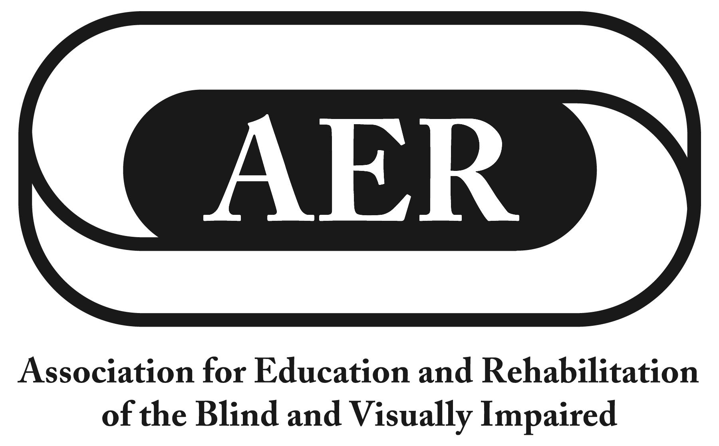
Resolution of the
Association for Education and Rehabilitation of the
Blind and Visually Impaired, July 2016

Advocacy for Appropriate Learning Media Assessments

Resolution Number 2016-2

Authors: Olaya Landa-Vialard & Kathryn Botsford

Whereas to meet the diverse literacy and learning needs of the heterogeneous population of students with vision loss, teachers of students with visual impairments (TVIs) must be prepared to provide instruction in and use of braille, instruction in print with or without optical and/or electronic devices, and instruction in dual media;

Whereas students who are blind or visually impaired (including those students who may have additional disabilities) should be appropriately evaluated to assess their individual learning media needs;

Whereas TVIs must have access to an array of assessment tools and techniques so that TVIs can tailor evaluations of students' learning media needs to students' unique characteristics, skill levels and other individual factors;

Whereas requiring the use of a single specific assessment would put students at risk inasmuch as TVIs' ability to tailor assessments for any particular student would be needlessly restricted;

Whereas assessments conducted by TVIs should be research-based, data-driven, and validated;

Whereas there are currently no assessments available to TVIs that meet these exacting scientific standards for evidence;

Whereas frameworks for learning media assessments commonly used by TVIs today are nevertheless based upon best practices in the field; and

Whereas the National Reading Media Assessment (NRMA) is fundamentally flawed because its administration requires that all students be evaluated in a standardized manner that denies these students access to the classroom and testing accommodations to which they are entitled by law; now, therefore, be it

Resolved, by the Association for Education and Rehabilitation of the Blind and Visually Impaired, in convention assembled on this twenty-third day of July, 2016, in Jacksonville, Florida, that this organization:

- urges the U.S. Congress and state legislatures to protect the integrity of assessments conducted by TVIs by rejecting calls which expressly or impliedly require the use of the NRMA or any other single specific assessment tool or technique to determine the learning or literacy needs of all students who are blind or visually impaired;

- encourages state chapters and divisions of AER to advocate for appropriate assessments that honor students' unique needs for reasonable accommodations and which recognize the diversity of learning and literacy characteristics inherent in the heterogeneous population of students with vision loss; and

- calls upon the U.S. Congress to promptly enact the Alice Cogswell and Anne Sullivan Macy Act which, among other critical policy objectives, would significantly increase investment in quantitative and qualitative research allowing our field to identify evidence­ based practices in assessment and instruction for students who are blind, visually impaired, deafblind, and who may have additional disabilities.

