# Accessible Pedestrian Signals (APS)

## For detailed information on APS and installation, see [www.apsguide.org](http://www.apsguide.org)

## APS_P1080324_cropped.JPGWhat is an Accessible Pedestrian Signal?

## The Manual on Uniform Traffic Control Devices (MUTCD) defines an Accessible Pedestrian Signal as “a device that communicates information about pedestrian signal timing in a non-visual format.” (Manual on Uniform Traffic Control Devices 11th ed., Section 1C.02)

***Why are APS needed?***

Changes in intersection design and signalization, as well as the presence of quiet cars, have affected the traditional street crossing techniques used by pedestrians who are blind or who have low vision, making the pedestrian phase harder to recognize without seeing the visual pedestrian signal. At many intersections, the pedestrian phase (the time during which pedestrians are allowed to cross) does not correspond with the green signal for the vehicles, for example where vehicles are allowed to turn left while pedestrians wait, and at leading pedestrian intervals (which give the pedestrians a head start) and exclusive pedestrian phasing (which allows pedestrians to cross while all vehicles have a red signal). Many locations require pedestrians to push a button to receive enough time to walk across the street. Pedestrians who cross without pushing the button are likely to still be in the intersection when perpendicular traffic begins moving. In many states, it is illegal to begin crossing during the flashing don’t walk (countdown) or don’t walk intervals of the pedestrian signal.

Figure 1: Photo of pushbutton integrated APS

APS provide the same information that is provided by the visual pedestrian signal to sighted pedestrians in an audible and vibrotactile format, making it possible for pedestrians who are blind to precisely identify the onset of the WALK signal.

## What guidelines and standards apply to APS?

As of the date of this document, February 2024, there are two Federal documents that specifically include APS. They currently differ in important ways, but it is anticipated that by 2025, they will be in agreement.  *Accessibility Guidelines for Pedestrian Facilities in the Public Right-of-Way*(PROWAG), was published by the US Access Board in August 2024 to provide guidance to implement the ADA in public rights-of-way. PROWAG contains requirements for when and where APS are required, as well as required technical specifications. The technical specifications for APS in PROWAG are largely based on the technical specifications in the*Manual on Uniform Traffic Control Devices 11th ed*(MUTCD 11th ed), published by the Federal Highway Department in 2023.

An important difference between PROWAG and the MUTCD 11th ed. Is that PROWAG requires APS at all crossings having pedestrian signals in new construction and alterations, and requires APS to meet technical specifications. The MUTCD often recommends APS, or recommends technical specifications, while the provisions of PROWAG are mandatory. When PROWAG is adopted by the US Departments of Justice (DOJ) and Transportation (DOT) it will be enforceable (expected in 2024). Therefore, jurisdictions are advised to install APS in new construction and alterations now.

Unfortunately, PROWAG does not specify what constitutes alterations that would trigger APS installation. When the DOT adopts PROWAG, it may include more information about qualifying alterations.

All Federal regulations are living documents, updated periodically, with opportunities for public comments. When needing to be sure about current APS regulations, be sure to consult the current standards.

## APS technical specifications

PROWAG and the MUTCD 11th ed. specify that all APS have an audible walk indication, a vibrotactile walk indication, a pushbutton locator tone, a tactile arrow, and automatic volume adjustment. Such APS are typically integrated into the pushbutton rather than having sounds that come from loudspeakers mounted on the pedestrian signal head.

A quiet locator tone, repeating once per second during the flashing and steady don’t walk, is required to provide information to travelers with vision disabilities about the presence and location of a pedestrian pushbutton. The locator tone must sound whenever the walk indication is not sounding. The locator tone must be adjusted to

APS are required to automatically adjust the volume of the walk indication, as well as the locator tone, in response to ambient sound levels. Locator tones must be adjusted to be audible 6 to 12 feet from the pushbutton or from the building line, whichever is less. APS are intended to be loud enough to be heard at the beginning of the crosswalk, and not across the intersection.

Holding the pushbutton down for at least one second provides any special features the APS has. Special features may include a pushbutton information message modeled after “Wait. Wait to cross Broadway at Grand,” increased volume of the walk indication and subsequent pedestrian change interval (flashing don’t walk) indication, APS beaconing to facilitate crossing within the crosswalk, longer crossing time, or additional information about intersection geometry or signalization.

## Installation requirements

Installation in the proper location and orientation in relation to the crosswalk is important for the use of APS. In new construction, two APS on a corner having two crossings, must be on separate poles, located as close as possible to the curb line, and as close as possible to the crosswalk line that is furthest from the center of the intersection. Minimum and maximum distances are provided in PROWAG and the MUTCD 11th ed.

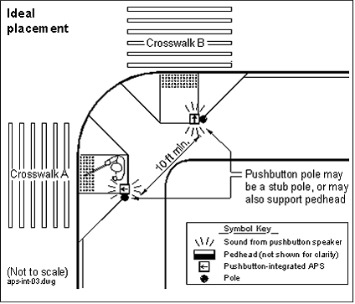In new construction, two APS on a corner must be at least 10 feet apart in order for pedestrians to easily distinguish which device is sounding. In alterations, where it is technically infeasible to install two APS pushbuttons on a corner on two separate poles at least 10 feet apart, they may be closer together, and even on a single pole.

APS tactile arrows must be aligned in the direction of travel on the crosswalks controlled by each pushbutton. The tactile arrow should be used to confirm which pushbutton is for the desired crossing. Tactile arrows are not a verty good cue for aligning to cross, because alignment with tactile arrows has been found to

Figure 2: Drawing from *APS: Guide to Best Practice* showing ideal APS installation locations on a corner. A ramp leads to each crosswalk. Each pushbutton is near the top of the ramp on the side of the crosswalk furthest from the parallel street

be only moderately accurate.

***APS Walk indications***

The default walk indication, required wherever APS are separated by at least 10 feet, is a rapid percussive tone. The percussive tone is highly localizable, and has been found to promote faster and more accurate recognition of which crossing has the walk indication than speech walk indications.

However, speech walk indications modeled after “Broadway; walk sign is on to cross Broadway,” are required where APS are not separated by at least 10 feet. Where speech walk indications are used, pushbutton information messages indicating the location of the intersection and the name of the street to be crossed are required.

APS are required to provide vibration (of either the tactile arrow or the pushbutton) during the walk interval. This benefits users who have hearing loss as well as a vision disability, and all users in situations where they have a hard time hearing the audible indication. This APS vibration is required even when it is not necessary to push the button to actuate the pedestrian phase.

***Adjustment of APS***

Proper placement of APS and careful adjustment of APS volume are critical, both for usability by pedestrians who are vision disabled and for neighborhood acceptance. The audible indications are supposed to be audible no more than 12 feet from the pushbutton.

## Additional information on features and installation is available at [www.apsguide.org](http://www.apsguide.org). A document on Common Problems Arising in the Installation of Accessible Pedestrian Signals is available on the Access Board’s site at https://www.access-board. gov/research/prow/common-problems-aps-installation/

## Requesting an APS

In the US the first and best course of action is to draft a letter with your student following the process outlined on the Orientation and Mobility Division website under the Environmental Access Committee resources.

Secondly, it can be useful to become connected with transportation planners and engineers in your area through Advisory Committees or Community Outreach Meetings. These connections can keep you in the loop about ongoing projects so you can provide information about APS (and other access issues) in the planning stages when budgeting is less of an issue.

## Installation examples

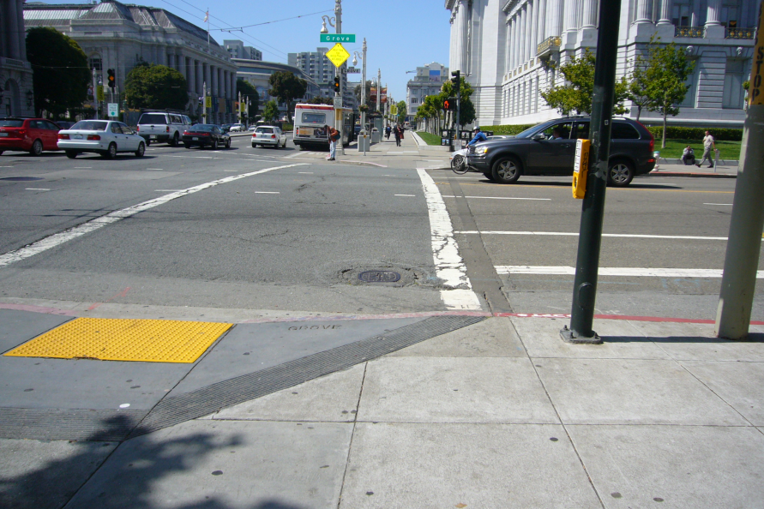

Figure 3: Photo of APS installed in San Francisco; the APS is on a pole near the street, in line with the crosswalk line



Figure 4: Photo of APS installed on stub poles, 10 feet apart, in Silver Spring, MD

The graphic below, Figure 6-2 from *Accessible Pedestrian Signals: A Guide to Best Practice*, illustrates the placement of APS pushbuttons when installed at corners with various typical curb ramps. The APS would be installed on separated poles, on the side of the crosswalk furthest from the parallel street. Obviously, in retrofit situations, this wouldn’t be possible in all cases, however, this is the installation goal and clients/students need to know about the new locations for pushbuttons.

******