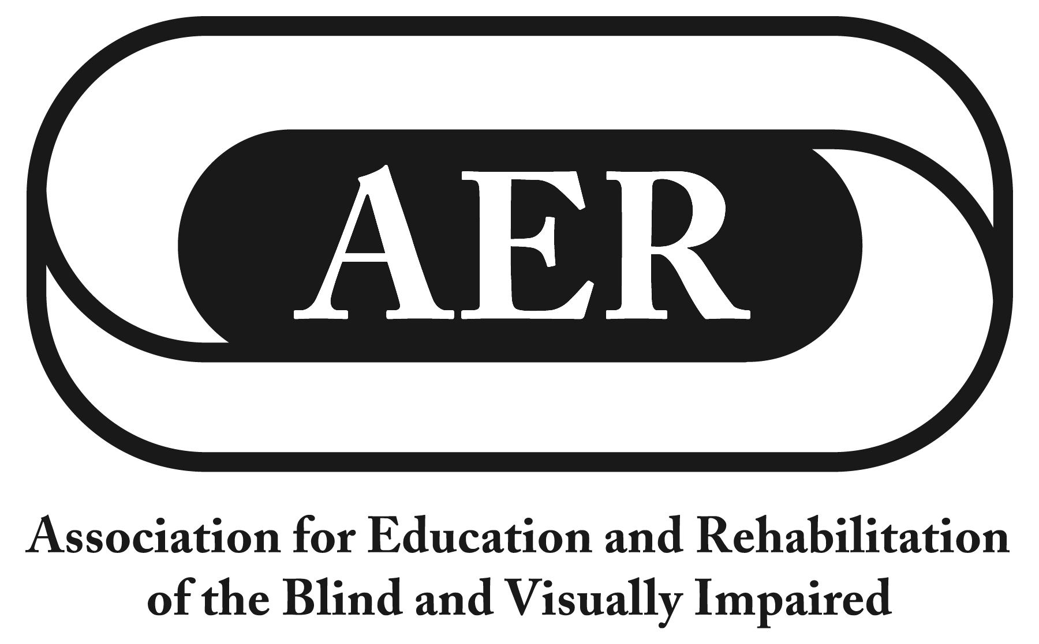

Resolution of the
Association for Education and Rehabilitation of the
Blind and Visually Impaired, July 2016

Accessing Third-Party Payment for Vision-Rehabilitation Professionals and Services

Resolution Number 2016 - 1

Authors: Dona Sauerburger & Mark Richert

Whereas the primary funding streams supporting specialized services to individuals who are blind or visually impaired are restricted to the special education and vocational rehabilitation systems;

Whereas the only national program intended to offer specialized services to those people who are blind or visually impaired who are not ordinarily served by the special education or vocational rehabilitation systems, namely the Independent Living Services for Older Individuals who are Blind (OIB) program, has been unconscionably under­ funded since its inception;

Whereas 6.9 million Americans 65 years and older reported having a significant visual impairment, according to the 2015 National Center for Health Statistics, National Health Interview Survey;

Whereas the services of many health and rehabilitation professionals are reimbursed by third-party programs such as Medicare, Medicaid, and private insurance carriers,

Whereas the services of most vision rehabilitation professionals qualified to provide specialized services to people who are blind or visually impaired are not currently reimbursable through third-party programs;

Whereas for the last several decades, coordinated advocacy for Medicare
Reimbursement for such services undertaken by organizations of and for people who are blind or visually impaired, including AER, has been unsuccessful;

Whereas expertise in health care management and administration is necessary for understanding the business of health care delivery and accessing third-party funding; and

Whereas this expertise in health care management and administration lies outside the preparation and experience of professionals, program administrators and others involved in the delivery of specialized services to people who are blind or visually impaired; now, therefore, be it

Resolved, by the Association for Education and Rehabilitation of the Blind and Visually Impaired (AER), on this twenty-third day of July, 2016, in the city of Jacksonville, Florida, that:

- this organization, through its President and Executive Director, shall reach out to the leadership and public policy staff of the major national, regional and community based organizations of and for people who are blind or visually impaired with whom AER may make common cause to invite them to participate in an “AER National Working Group on Third-Party Coverage for Specialized Services” (working group) to consider and implement strategies to achieve third-party funding for the specialized services provided by vision rehabilitation professionals;

- this national working group shall include the active participation of each of the AER divisions representing professionals for whom third­party coverage is being sought;

- this national working group shall seek the involvement of additional individuals and entities with expertise in health care management and administration to advise the working group concerning current reimbursement policy and process and how professionals can qualify for and access third-party funding; and

- the AER President or Executive Director and/or a representative that the President may appoint shall routinely participate in working group meetings, shall regularly report to the AER Board about such meetings, and shall put any working group recommendations before the AER Board for its consideration and approval prior to working group actions.

