Association for Education and Rehabilitation of the Blind and Visually Impaired (AERBVI)
Division 18 - International Services & Global Issues
Newsletter - July/August 2023

Welcome to the July/August edition of the AER International Services and Global Issues Division newsletter. For those in the U.S., I hope you’ve had time to enjoy the summer and balance professional development with time off. In this issue, several of our working group members share their summer professional development experiences in this newsletter.
Additionally, of note, we reviewed this year’s scholarship applications and are excited to share more about our scholarship recipients! Heba Nasser and Grace Amwe are graduate students in Egypt and Nigeria who are doing important work in our field. I hope you will join me in congratulating them!
We always welcome suggestions for improving the division. Please email us with your thoughts, comments, and questions at aer.global.division@gmail.com.

Cheers,
Katie Ericson, Chair, TSVI/COMS

Scholarship Recipients
The Division would like to congratulate the winners of the 2023 Scholarship! The Division annually presents two scholarships, now in the amount of $1000.00 (when funds are available), to students from outside the mainland U.S. and Canada who are pursuing post-secondary education in the vision field.
Heba Nasser is pursuing a master’s degree at Beni-Suef University in Egypt, studying to become a teacher of students with visual impairments. She has pursued training with Royal Dutch Visio and Baseera in order to better serve the students in her area. Heba also actively works and volunteers with students…
Grace Amwe (Nigeria) is working on her doctorate at the University of Jos, Nigeria. Her contributions to the field of visual impairment are many. She has taught and mentored students at many different grade levels, and she has been a vocal advocate for her students. As a PhD student, she has authored several academic articles and continues to advance the field.
We are so pleased to spotlight Heba and Grace’s efforts and achievements through this scholarship, and we wish them the best in furthering their education!
Thank you to our panel of dedicated judges who reviewed our many submissions.

“The History of Blind Tennis: Takei’s Dream”
As part of our Global Speaker Series, Ayako Matsui of Japan graciously recorded a webinar on the history and development of blind tennis. Importantly, the video features the words of Mr. Miyoshi Takei, the inventor of blind tennis. You can watch Matsui-San’s video here.

Upcoming Division Events
The Division will be hosting a webinar with Dr. Rachel Hewett of the University of Birmingham and Caireen Sutherland from the Royal National Institute of Blind People (RNIB) on 6 September 2023 at 12pm Eastern US time. Dr. Hewett will be discussing the recently adopted and implemented Curriculum Framework for Children and Young People with Vision Impairment (CFVI). Register for the webinar at this link: https://www.pathlms.com/aer/courses/56179/webinars/37722

Be on the lookout for an invitation to our inaugural division Sip ‘n’ Read, taking place virtually on 19 September 2023! Our Chair-Elect, Dr. Callie Brusegaard, will be leading a discussion of Oliver Sacks’ The Island of the Colorblind. The book is available on Amazon and on Bookshare. If you need support to purchase the book, please reach out to Callie at callie.brusegaard@umb.edu.
Join us at https://umassboston.zoom.us/j/92683055896

Other Important Dates
- Allied Independence is hosting the 2023 Online TVI Symposium virtually 21-22 September, 2023. Find more information and register on the conference website.
- The International Paralympic Committee’s VISTA Conference will be held in Cairo, Egypt from 31 October to 3 November, 2023. Read more on the conference website.
- The Getting in Touch with Literacy Conference will be held from 29 November - December 2, 2023 in St. Pete Beach, Florida, USA. More information on the conference website.
- The International Conference on Education for the Visually Impaired will be held in person in Beijing, China and online 3-4 December, 2023. If you are interested in presenting or attending this conference, please contact Mrs. Grace Chan of the Asian Foundation for the Prevention of Blindness (AFPB) at grace@afpb.org.hk.
- AER’s International Conference will be held 24-28 July, 2024 at the Le Meridien/Sheraton Hotel in Charlotte, NC, USA. The call for presentations will open soon, and registration will open in early 2024. Updates can be found at the conference website.

Job Postings
- Orientation & Mobility Specialist for Vision Australia. There are a total of five vacancies in the areas of New South Wales, Queensland, and Australian Capital Territory. For further details, please refer to their Vision Australia website.
- Teacher of Students with Deafblindness at Narbethong, Queensland, Australia. For information and to apply, please visit this website.

Other Opportunities
Applications for the 2024-2025 Fulbright U.S. Scholar Program are now open. The program provides opportunities for U.S. citizens to teach, conduct research, and implement other professional projects abroad. Find more information on their website. Deadline for applications is 15 September 2023.

As noted above, AER’s International Conference will be held in July 2024. Our division working group is currently collaborating with the Physical Activity and Recreation Division, O&M Division, and Psychosocial Division to host a full day, practical/hands-on pre-conference session. If you have additional ideas or suggestions for Division programming during the conference, please let us know!

Notes from the Field…
Our working group members share some highlights from their summer travels…

Past-chair Kevin McCormack Presents at the International Mobility Conference 18
This was the third IMC I presented at. Although IMC 18 was in Warsaw, Poland, I unfortunately could not attend in-person. However, the conference organizers were gracious enough to allow me to participate virtually. Because of the time difference, I presented at 3:30 in the morning. So I still got a sense of jet lag without the wonder of exploring a new (to me) country. Boo. I sincerely hope I can go in person to the next IMC. It is not only a good experience of presenting among colleagues from around the world, but the unique international connections and learning opportunities you get are ones you can only find at an IMC conference.
Note from the editor: IMC19 will be hosted by The Blind People’s Association in Ahmadabad, India in November 2026.

Chair Katie Ericson Presents at Vision 2023
I had the opportunity to present research on distance consultation/telepractice for vision professionals at the Vision 2023 Conference, hosted by the International Society for Low Vision Research and Rehabilitation (ISLRR). This was my first time attending and presenting at an ISLRR Conference, and I would highly recommend it to colleagues. Attendees and presenters represented many countries and many professional backgrounds (e.g., students, ophthalmologists, teachers, occupational therapists, engineers), and the hosts provided many opportunities for attendees to meet, network, and tour local facilities/agencies, such as the Anchor Center for Blind Children. For those interested, the next ISLRR conference will be held in Florence, Italy in September 2025. More information can be found on their website.

Chair-Elect Dr. Callie Brusegaard Travels to Micronesia
The island of Chuuk, in the Federated States of Micronesia (FSM), is located North Pacific and spans almost 47 miles. There are 16 inhabited volcanic islands with a total population of 40,756. For over 15 years, a teacher of students with visual impairments, Donna McNear, has been working in the FSM supporting children. She noticed an unusually high prevalence of microphthalmia in children. Donna connected with people from the medical field who were leaders in their knowledge about microphthalmia and invited them to Chuuk. In 2017, a genetic research team conducted a study to look at the prevalence of microphthalmia in Chuuk and discover the associated gene. The birth prevalence of Microphthalmia is 14 in 100,000. In Chuuk, the prevalence is 115 in 100,000, or eight times higher than normal. If you’re curious about the past project, there is a short video on YouTube. The last project allowed the team to give ophthalmologic care to over 30 children but did not uncover any new information about the gene(s). The team did find consistent maternal vitamin A deficiency. Thus, the team reconvened in June 2023 to return to Chuuk. Dr. Alex Levin is heading the project – he is the Chief Pediatric Ophthalmologist and Ocular Geneticist for the Flaum Eye Institute at the University of Rochester Medical Center. Dr. Tom Glaser is a Professor in the Department of Cell Biology and Human Anatomy at the University of California, Davis School of Medicine. He researches the genetic basis of anophthalmia and microphthalmia. Anne Slavotinek is the Director of the Division of Human Genetics at Cincinnati Children’s Hospital. Jenina Capasso is a Genetic Counselor at the University of Rochester. I joined as the cultural liaison and educational specialist. The medical mission focused on seeing children with Microphthalmia who weren’t seen in 2017 as well as gather blood samples from family members of affected children. We held a week-long clinic which included going to the island of Piispaneu, located on the edge of the atoll, to support the island with the highest prevalence. Another goal of this mission was to connect the local health officials with two ophthalmologists from the Philippines. Drs. Uy and Pormida provided pediatric and diabetic exams during the clinic. They will be able to sustain eye care on the island long term. The outcomes of the study could take up to a year to discover. A follow-up will be provided when results are available.
The education mission focused on supporting children who have specialized needs. The FSM uses the American school system as the basis for the structuring of their school system. Free education is offered from first to 12th grade and is compulsory for grades one through eight. Funding for schools comes mainly from the Compact of Free Association with the United States. However, funding for special education comes from the United States Office of Special Education Programs (OSEP). The FSM also has its own Special Education law that guarantees children with disabilities full access to education. However, often other factors can affect a child’s participation in education such as transportation and family attitudes. I met with any children that could possibly qualify for special education services and discussed with their caregivers what education can look like for a child with a visual impairment. Through my conversations, I found eight children who could receive special education services but were currently not enrolled in school or not receiving services. I was also able to make note of simple materials that could benefit the children and have recruited those materials from the accessible materials library in Massachusetts and the Vermont Association for the Blind and Visually Impaired. More collaboration, support, and training must occur to ensure that these children with visual impairments have equal access to education.

Photo 1: The team from the U.S., the Philippines, and Chuuk outside of the clinic in Weno, Chuuk.
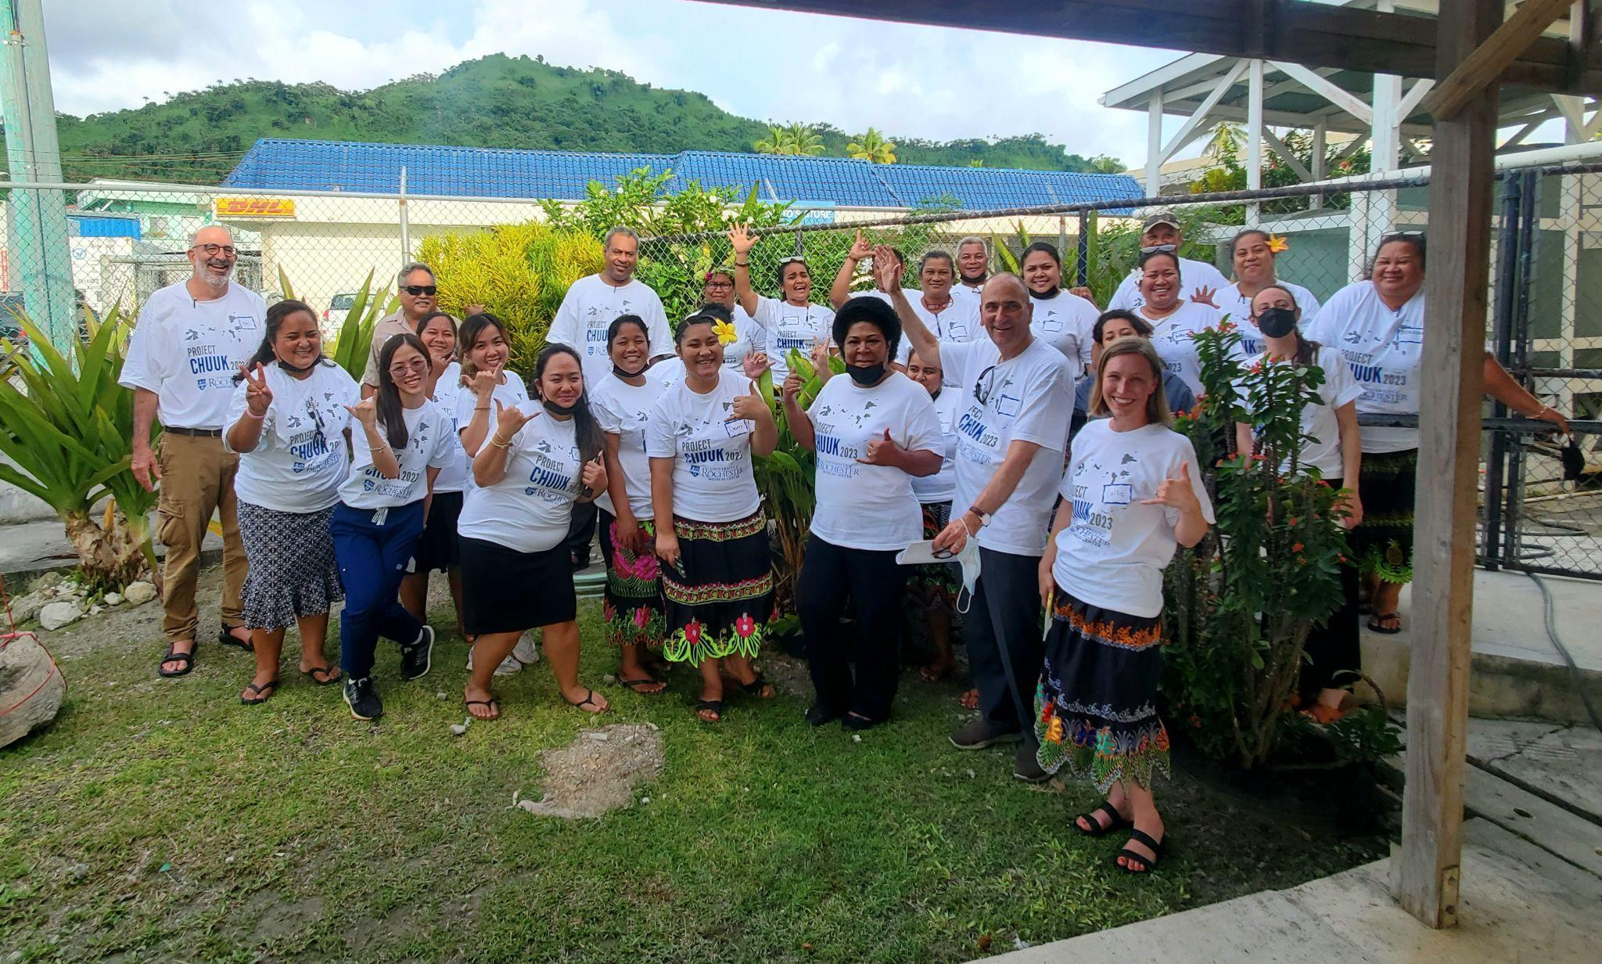

Photo 2: Dr. Callie Brusegaard meeting with a family about special education. She is wearing the local dress.
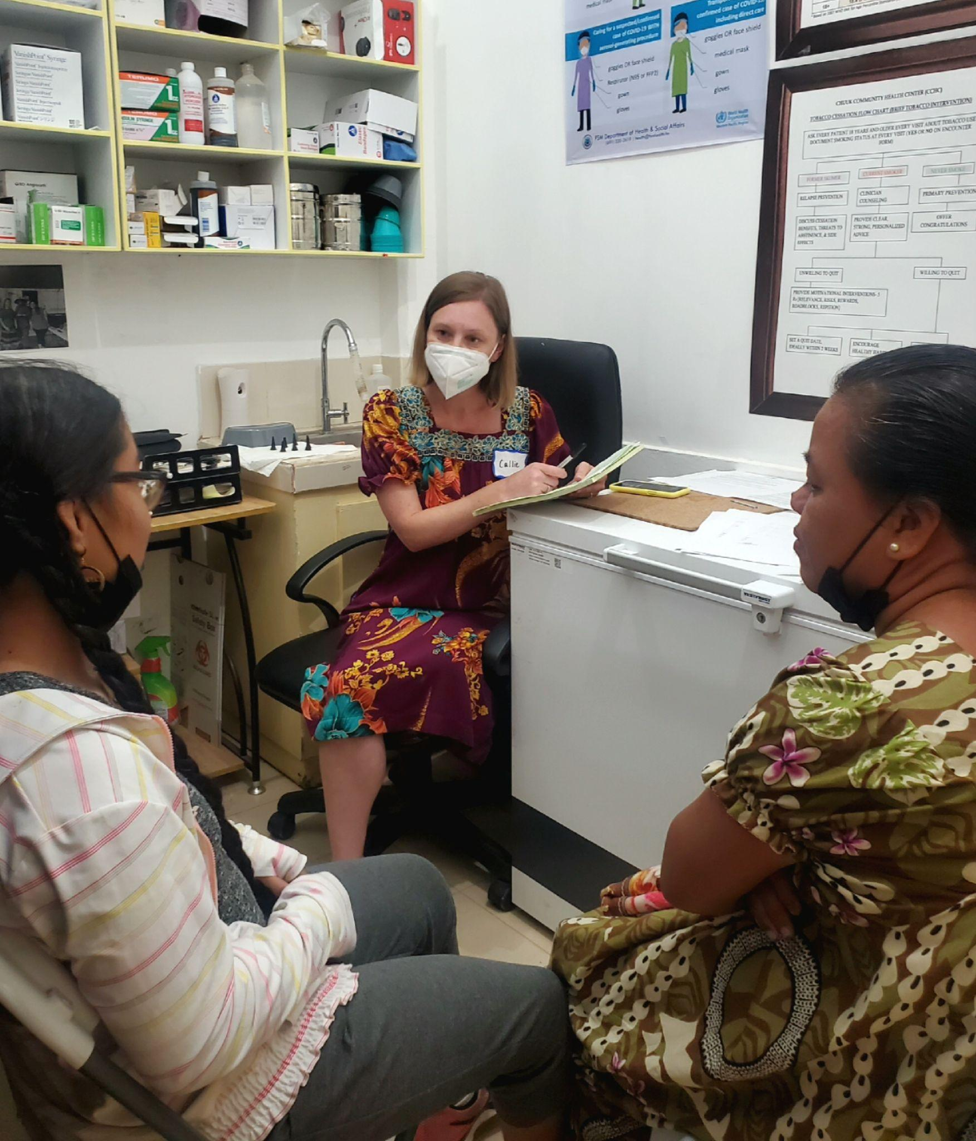

Next newsletter deadline: October 5, 2023 – submissions are welcome at any time!

