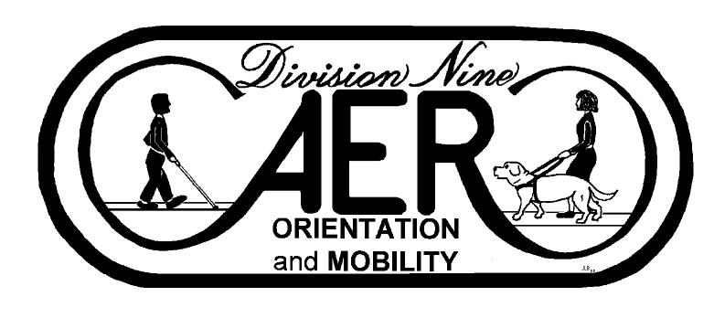
AER Orientation and Mobility Division Executive Committee Meeting Agenda
Thursday, September 28, 2023 7:00 pm EST
In Attendance:
Raychel Callary (chair)
Margaret Winn (chair-elect)
JoAnne Chalom (past chair)
Valery Kircher (secretary)
Megann Brousard (treasurer)
Angela Leavens (District 1)
Shay Utley (District 2)
Eric Shaw (District 4)
Tessa McCarthy (District 6)
Michael Lorento (student representative)

Absent:
Jennifer Duncan (District 3)
Kevin McCormack (District 5)

The meeting was called to order by Raychel Callary at 7:02 pm EST

The meeting’s parliamentary was Maggie Winn.

- Consent Agenda: Chair asked Executive Committee if there was anything to remove or discuss. Megann Brousard requested a clerical error correction. Hearing no further objections there was a motion to accept the Consent Agenda and June 2023 minutes made by Erich Shaw and seconded by Megann Brousard.
  - Approval of Meeting Agenda
  - Approval of June 22, 2023 Meeting Minutes
  - Treasurer’s Report
    - The Finance Committee met on September 22.
    - Reimbursements totaling $57.08 were received in September by Raychel Callary and Maggie Winn for Michigan AER Conference vendor table registration and promotional materials.
    - Approval for our 2023 Division Request for Funds was received August 2, including projected requests for 2024. This includes:
      - $450 for professional development awards and an outgoing chair gift, with purchasing and shipping of awards coordinated by the AER office.
      - $4000 for scholarships to be sent to the respective college/university.
      - $9,000 for the 2024 TRB conference to follow the AER travel policy. The division may raise funds to supplement AER’s support for conference participation.
      - $1,200 for tables at O&M association conferences.
      - $600 for webinar registration. Information will be shared with the division and if appropriate, the entire membership via an article in the Voice.
- Chair report
- A regular meeting of the Council of Division Chairs was held on 7/19. A special meeting took place 8/14 to discuss the progress of the Cogswell-Macy Act. A regular meeting is planned for October 2.
- Held meetings with AER Executive Director Lee Sonnenberg 7/10, 8/14, 9/11 to discuss AER and O&M division needs and activities.
- Participated in AER strategic plan execution meeting September 13.
- White Cane Day/Blind Americans Equality Day resource available on AER website. Please add to this resource!
- Attended July, August, and September AER Board of Directors meetings; presented division report in July.
- Attended Division 11 (VRT) community meeting and Division 15 (Aging) webinar.
- Met with Maggie Winn and Catherine Summ 9/7 to collaborate on a webinar for Division 1 on strategies to fill open O&M positions and justify the need for more staff.
- Provided annual strategic plan progress update in Sept. newsletter.
- Meetings took place 7/10 and 9/18 with the workgroup creating an AER position paper regarding qualified professionals for adult service provision. The next meeting is scheduled for October 16.
- Participated in Medicare Exploration Project kickoff meeting 9/15.
- Participated in O&M division Finance Committee meeting 9/22. Discussion took place regarding the changes in treasurer duties and whether the main remaining task of reviewing and submitting reimbursement requests could be completed by the secretary.
- O&M Division open forum will be held Tuesday, October 3 at 7 pm Eastern.
E. Committee Reports
Professional Issues:
- Meetings were held 1/17/2023 and 2/28/23 with the personnel preparation division focusing on collaboration on the issues identified in the strategic plan regarding recruitment and retention, student participation, and mentorship. We have created a folder where recruitment documents can be shared, we will create a database to focus on connecting mentors and students or new professionals. The next collaborative meeting will be held October 4th.
- Position Paper update:
The orientation and mobility assistant position paper is progressing.
- The support cane use draft has stalled and we are soliciting members to be part of the team. Please reach out to Maggie with any suggestions on who may be a good fit.

Program:
Maggie is chairing the symposium/educational session programming work group for the 2024 International conference committee. Divisions assist with the development of the educational session programming and providing reviewers for abstracts. This is typically done within each cluster as educational strands are developed. All the division chairs will be included in this work group.
Awards: Will begin to meet in January 2024.
Nominating and Elections: Chair will contact in October to initiate meetings in time for the call for nominations to be published by February 1, 2024.
Scholarship: Blasch Scholarship recipients were selected and were announced in the newsletter, the AER website, and on social media. A Chair is needed for 2024.
Strategic Plan: Committee met September 13. Discussion took place around completed, ongoing, and upcoming activities. Progress spreadsheet was updated. It was decided to provide recognition to Chris Tabb in the newsletter for the creation and upkeep of the O&M Outpost and the O&M Live Binders.
Environmental Access Committee: Committee met August 24. Planning began for a webinar to take place later this fall focusing on infrastructure trends. Discussions have begun about attendance and fundraising for 2024 TRB annual meeting in January.

Communications: Fall newsletter was sent to division membership from the central office on 9/19. Thank you to all who provided a newsletter submission. The next due date is 1/1/24. A volunteer to assist with posting on social media would be welcomed.

- District Director, Officer, and Student Representative Reports/Comments
- Action Items
    - Selection of 2024 Blasch scholarship chair: Eric Shaw agreed to be the Blasch Scholarship Chair for 2024. Maggie Winn encouraged the Executive Committee to participate as judges.
    - Policies and procedures manual update: Discussion was held by the Executive Committee and comments were reviewed and accepted. The Executive Committee agreed to table further discussion on comments until the December 2023 meeting. The Executive Committee reviewed up through the Officers and their Responsibilities section of the PPM.
      - Items of interest: Secretary and the historical version of the PPM, Tresure role now that O&M Division no longer has its own budget
        - Information and Discussion Items
- Professional Personnel Recruitment Committee Update (info below)
- 2024 AER International Conference presentations and planning: Maggie Winn will send out information with regards to reviewing submitted proposals. The last day to submit is December 1, 2023.
- Creation of an ad hoc committee to begin planning a virtual forum for organizations with a focus on orientation and mobility to increase knowledge about organizations, promote cohesion, and provide opportunities for professional connections (designated in strategic plan to take place by October 2023)
- District director title: A motion was made by JoAnne Chalom to table this discussion until the December 2023 Executive Committee meeting and Maggie Winn seconded this motion, all Executive Committee members were in favor.
- Creation of video for SWOMA conference in November: Raychel Callary asked the Executive Committee members present if someone would be able to create a brief video.
- Strategic plan annual review (info below): Raychel Callary stated that this was approved in November 2022, and will be an agenda item for the December 2023 Executive Committee meeting.
- Executive Session (if needed)
- Adjourn: There being no further business, Raychel adjourned the meeting at 7:46 pm EST.

