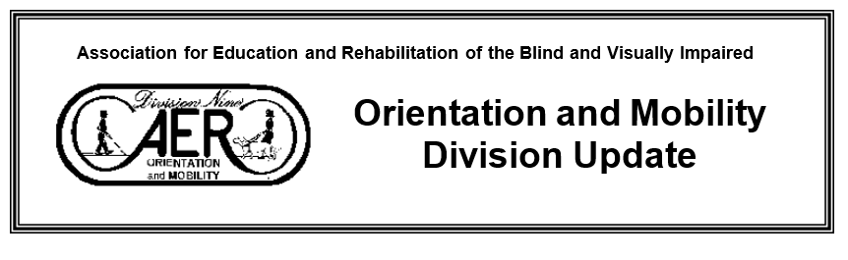
Winter 2022 Volume 25 No. 1

FROM THE O&M CHAIR JoAnne Chalom
Hello Orientation and Mobility Division,
Every year I write a holiday newsletter: it’s a time to reflect on the past year. This article is more focused, an annual summation of the work in progress or completed by the Orientation and Mobility Division. Spoiler alert, we have a lot planned for the new year. Consider this a State of the Orientation and Mobility Division of sorts.
Two students from AER approved Orientation and Mobility Programs received Donald Blasch Scholarships. Twenty-twenty one was the twenty-fifth anniversary of the scholarship, let’s celebrate the work of the scholarship committee that convened and reviewed applicant submissions.

Team members from the O&M Division have created, reviewed, revised six position papers. The AER O&M Division and the AER Board have approved them. I am very appreciative of all the time and dedication of the team members that worked on these position papers and the work that is ongoing for the position papers that are in various stages of development.
Look for these to be posted soon:
- Orientation and Mobility Specialist’s Role in Low Vision Driving.
- Teaching Orientation & Mobility Through Individual and Group Lessons.
- Teaching Street Crossings at Streets and Lanes Where There is No Traffic Control.
- Orientation & Mobility Assessments for Students in Education and Life Skills Settings.
- Orientation & Mobility in Natural Environments.
- University Personnel Preparation of Orientation & Mobility Specialists.

By the time this newsletter arrives in your inbox, the voting period for two more position papers has been extended to February 22: Teaching Street Crossings at Signalized Intersections and Use of Visual Occlusion in Orientation & Mobility Instruction. Please check these out & vote. Email comments to aeromdivision@gmail.com .
We have started working on revisions to the Orientation and Mobility Strategic Plan 2017-2022. Our first action item was sending out a survey to discover what you perceive as our highest priorities for the O&M Division. We want to hear from you!
Based on the information gathered from the survey we will start to create potential goals for the Strategic Plan for 2022-2027. We have submitted a proposal in the hope of presenting at the AER conference in St. Louis, Missouri, this summer.
Time does fly, it’s time to think about sharing your expertise, time, and leadership with the division. Mark Carter is leading the charge as chair of the Nominations and Elections Committee. If you have questions or are interested in making a difference in our profession more information is included in this newsletter. For questions about the roles and responsibilities of chair-elect, secretary, treasurer, and district directors please reach out current board members or Mark Carter at markcarter1211@gmail.com.
It’s also time to celebrate individuals that have made extraordinary contributions to the field. If you know of someone that reflects the qualities described for one of the awards please listed below reach out to Nick Leon at nickleon86@gmail.com. Stay tuned for more information about the awards, Nick Leon has all the details about the criteria for potential awardees.
- The Lawrence E. Blaha Award
- The Sandy Kronick Distinguished Service Award
- The Orientation and Mobility Citation of Excellence for Direct Service Award

We have added another award in the spirit of the late Janet Barlow, It will celebrate those individuals that continue the work. The initial Janet Barlow Environmental Access Service Award will be presented to Janet, posthumously. Her family will be presented with it at the awards ceremony at the AER Conference this summer to help us celebrate her life, work friendship, mentoring in the field of O&M and Environmental Access.

We also had a small but mighty group of people from the Environmental Access Committee (EAC) attend and advocate at the Annual Meeting of the Transportation Research Board in Washington, D.C. We will have a detailed report for you at a later date. We would like to extend out thanks to AER and Polara Engineering for their continued support.
Thank you for being a part of the AER Orientation and Mobility community and working together to learn and grow. If you have news related to the division to share, please reach out to Meg Robertson, Newsletter Editor at mobilitymeg@aol.com
I welcome questions, suggestions, comments, or any topic related to Orientation and Mobility, you can reach me at aeromdivision@gmail.com. Thank you for the opportunity to serve the AER Orientation and Mobility Division.
JoAnne Chalom COMS

Division Announcements

O&M Nomination Committee: Are you interested in making a difference in the O&M profession? Does it sound like fun to engage with colleagues working to lead our profession? Consider serving as an O&M Division board member and being part of the O&M Executive Committee. There are six regional divisions and each one has a District Director. The Nomination and Election Committee is soliciting nominations for all leadership positions.
Applications and additional information about Chair-Elect, Treasurer, Secretary, and District Director positions can be found here: https://aerbvi.org/about/divisions/orientation-mobility-division/
Descriptions of these positions are available in the policies and procedures manual. https://aerbvi.org/about/divisions/orientation-mobility-division/executive-committee/
Please submit an application by March 1st, 2022. Feel free to reach out to the person currently holding the position you are considering if you have questions about the role, or to Mark Carter at markcarter1211@gmail.com for more information about O&M division leadership.

Environmental Access Committee Report
JoAnne Chalom COMS, current OM AER Chair, EAC Member, has been serving since 2019 as a panelist for the National Academy of Sciences’ TCRP B-47 “Impact of Transformational Technologies on Underserved Populations." This research is under the umbrella of the Transit Cooperative Research Program (TCRP). The project will examine how new and existing technology-enabled mobility services impact a community’s capacity to meet the mobility needs of all residents, with a special focus on how a community can ensure traditionally and newly underserved residents will benefit from those technology-enabled mobility services. The project will develop a playbook and associated products to inform transportation policymakers at planning organizations, and at public and private transportation entities with guidance on how technology has excluded or marginalized mobility options historically, and should emphasize current initiatives and strategic plans on how to include underserved populations in mobility enhancements including smartphone apps, vehicle automation, and shared on-demand mobility.
At the conclusion of the project a report with a playbook will be distributed widely. Results are shared in modalities such as workshops, webinars, websites, and publications. The audience for these reports are transit agencies, service providers, and practitioners in related fields.
The main objective of Transit Cooperative Research Program (TCRP) projects is to serve as one of the primary methods by which the public transportation industry and related fields can develop innovative solutions.
For a description of the project click on this link:
https://apps.trb.org/cmsfeed/TRBNetProjectDisplay.asp?ProjectID=4686

Meg Robertson COMS, EAC Chair has served on the following TRB panels:
NCHRP 2237- Development of a MASH Barrier to Shield Pedestrians, Bicyclists, and Other Vulnerable Users from Motor Vehicles (On going)
ACRP 01-31- Innovative Solutions to Facilitate Accessibility for Airport Travelers with Disabilities. Completed https://www.trb.org/ACRP/Blurbs/180345.aspx
TCRP Project A-33 “Communications with Vulnerable Populations: A Transportation & Emergency Management Toolkit” Completed https://www.trb.org/Publications/Blurbs/166060.aspx
The Transportation Research Board/TRB typically has more than 200 active research projects and studies under way at any given time.
The majority of these research projects are administered by TRB’s Cooperative Research Programs, which include the National Cooperative Highway Research Program (NCHRP), the Transit Cooperative Research Program (TCRP), the Airport Cooperative Research Program (ACRP), the National Cooperative Freight Research Program (NCFRP), and the Hazardous Materials Cooperative Research Program (HMCRP). Under all of these programs, TRB organizes panels of experts to provide guidance on technical aspects of the research. For more information on these projects, or to nominate yourself for a panel member go to https://www.nationalacademies.org/trb/programs/cooperative-research-programs
Check out TCRP publications at www.trb.org/tcrp
New FY 2022 projects panel nominations due on Friday, February 4, 2022. Those interested in serving on a specific project oversight panel should complete a nomination form by going to https://volunteer.mytrb.org/Panel/AvailableProjects
  - B-50, Public Transportation Information Systems for Passengers who are Vision Disabled, is one that COMS may be interested in applying for.
Panels may last 1-2 years, In-person meetings have not occurred due to COVID but may start up again. Most of the panel work is done via email. For in-person meetings, travel costs and hotel will be covered by TRB. Meetings may occur 1-4 times during the project duration. If you want more information, please contact Joanne or Meg.
Transportation Board Meeting/TRB Updates: EAC committee members, Joanne Chalom, Raychel Callary, Marybeth Cleveland, Lukas Frank and Meg Robertson, were able to attend The Transportation Research Board Annual Meeting in Washington DC, this past Jan. Funding for EAC members to attend, was provided by the AER OM Division, Polara, The Seeing Eye and an Anonymous in-kind donation. The meeting program covered all transportation modes, with sessions and workshops addressing topics of interest to policy makers, administrators, practitioners, researchers, and representatives of government, industry, and academic institutions. It is an honor to attend and be in the ‘room where it happens’, decisions, research on public right of ways and transportation and the development of policies which impact pedestrians who blind, deafblind and vision loss.

Comments from our EAC newest member who was able to attend: “This was my first time to attend TRB, and I want to thank AER for sponsoring us, and to the members of the EAC for guiding me through this large conference, complete with its own app used to navigate to the different sessions! It was exciting to see all the traffic related professions come together to discuss design and safety. The TRB conference had poster sessions where you could talk directly to the researcher and encourage them to include pedestrians with vision disabilities in their research. My favorite session was the pedestrian committee meeting that included a beautiful tribute to Janet Barlow. It was inspiring to hear people from different professions who knew Janet and connected with her, and what she has done for our profession and blind pedestrians. I also attended a meeting where EAC member, Joanne Chalom did a great presentation about bus islands and bicycle lanes; it was especially interesting to see the reaction of the people in the room who have not considered how someone with a visual disability might navigate a bus island or cross a bicycle lane. As an O&M Specialist at the TRB conference, I found it a great way of educating and making connections with people who design the streets as well as learning engineering terms and the how and why of certain designs.

Marybeth Cleveland, COMS, A to B and Back, Orientation and Mobility Services, LLC, 301-412-4224

From JoAnne Chalom: This year the Annual Meeting of the Transportation Research Board (TRB) felt palatably different on several levels, the pandemic had influenced the ability of many international and domestic attendees to travel to Washington DC, other individuals who planned to attend were snowed in, had flights cancelled, delayed, or rescheduled. Attendance required proof of vaccination status, N95 masks were required as social distance was attempted changing the vibe of the typically chaotic jam-packed experience known as TRB.

We all missed having Janet Barlow there and were grateful that that the Pedestrian Committee planned a memorial service to honor her legacy and gave members and friends an opportunity to share some thoughts. Lukas Franck, Raychel Callary, and I all honored her legacy and shared how we will continue to advocate for the built environment.

The Orientation & Mobility Division has established an award, The Janet Barlow Environmental Access Service Award, which will be awarded biennially at AERBVI Conference, only when a when a worthy nominee has been nominated. The initial award will be presented to Janet’s family, in Janet’s honor.

I had the privilege of presenting twice at TRB, on Sunday and Tuesday, respectively. The lightning speed of the Sunday workshop, Livability Versus Safety Trade-Offs in the Urban Road Design Context enabled presenters to share their thoughts for five minutes with time for one or two questions. I focused on the challenges of pedestrians with visual impairments traversing the built environment. Some of the areas of my presentation included Exclusive Pedestrian Phases, Leading Pedestrian Intervals, Accessible Pedestrian Signals, Bike lanes, traversing parking lots without pathways, and snow removal on sidewalks. I will admit that I relied on my colleague, Meg Robertson, to provide guidance on issues such as snow removal. It is not typically something that is frequently addressed in Florida.

During the AME50 Committee on Accessible Transportation and Mobility (https://www.trbaccessmobility.org/ ) four individuals presented on topics related to the scope of the Committee on Accessible Transportation and Mobility: “To study problems relating to the transportation disadvantaged and the services that various modes of transportation should provide for them as well as an assessment of the impact and value of programs directed at improving their mobility.”
I was able to present for ten minutes on Floating Bus Stops: Challenges for Vision Disabled Travelers. During this summative presentation differences between standard bus stops and floating bus stops were discussed which included identifying standard bus stops as typically, parallel to the sidewalk near or within walking distance to intersections with traffic controls and the ability to enter and exit near sidewalks. Floating bus stops pose several challenges including potentially not knowing where you are in space when exiting the bus. One case in the province of British Columbia may be of interest, Victoria’s Visually Impaired Community Wins ‘Floating Bus Stop’ Case Against City and B.C. Human Rights Tribunal rules City of Victoria must install audible flashing signals, https://www.vancouverislandfreedaily.com/news/victorias-blind- community-wins-floating-bus-stop-case-against-city/.
Appreciation goes out to Lukas Franck and Marybeth Cleveland for their help and insight in the creation of this presentation.
The biggest takeaway from this 101st Annual Meeting of TRB is to take those impromptu opportunities to share information with a diverse group of people in the hope of having some aha or head nodding moments.
Meg Robertson: At TRB I was able to attend meetings on Winter Maintenance, (raising the issue of snow removal from sidewalks), Traffic Control Devices (Work Zone Committee member), Transportation in Military Communities, Bicycle Committee, Pedestrian Committee are a few attended. One of the reasons, I attended the Meeting on Transportation in Military communities, is that I have worked with a number of clients, who have jobs on Military bases but can not get transportation around the base due to security restrictions. Public transit, shared ride (Uber/Lyft) do not go on base but will leave workers at the gate, which is often not near their work location. If you have worked with a n individual with the same issues, I would like to hear from you. (Mobilitymeg@aol.com)

Victory for Accessible Pedestrian Signals in NYC! Rev. Dr. Gene Bourquin, COMS and Janet Barlow COMS (before her death) were involved in a lawsuit filed against in New York City to provide access to pedestrians who are blind to access to street walk signals.
On June 27, 2017, a class action lawsuit against New York City. The New York Times reported, “New York City maintains thousands of traffic signals, according to the state Department of Transportation’s website. Only 317 are equipped with accessible pedestrian signals [APS], and the city has been adding only about 75 each year, according to Disability Rights Advocates [DRA], which filed the class-action lawsuit on behalf of the American Council of the Blind of New York, Mr. Golfo and Christina Curry, a Bronx resident with hearing loss who is also legally blind.”

Disability Rights Advocates’ New York legal office represented the plaintiffs, individuals from the American Council of the Blind Of New York, the organization, and the class of blind and low vision residents. With the expert help of Ms. Janet Barlow, pioneering O&M specialist, researcher, and advocate, and much input from community members and organizations, Paul A. Engelmayer, Federal District 2 court judge, ruled that New York City (NYC DOT) had indeed violated the Americans with Disabilities Act, and that the Department of Transportation had not provided “meaningful access to those intersections and the pedestrian grid, in violation of the ADA . . .”

After the passing of Ms. Barlow, and the court’s findings, DRA asked Gene Bourquin to join the case as an expert witness. At that point, both parties to the lawsuit had submitted initial testimony and then amended statements on how the judge should address APS in NYC. The judge required that plaintiffs and defendants provide further input into designing a plan to remediate the violation of law at a hearing in October. The essentials of the defendant plan, NYC DOT, where to fit APS at all pedestrian signalized intersections, beginning in ten fully installed “accessibility zones” or zip codes, over a thirty year period with 500 installations per year. Their plan only partially prioritized the installations at the most dangerous crosswalks, the 5,500 with exclusive pedestrian phasing (EPP) and leading pedestrian signals (LPI).

Gene and DRA proposed a 10-year plan, first prioritizing requests, then intersections with EPPs and LPIs, and then using factors weighed heavily in the NYC APS Prioritization Tool for planning the remaining intersections. They urged the court not to stretch the remediation over two generations of pedestrians.

Closing arguments were held on November 9th. The judge seemed impressed with the testimony of the DOT’s expert witness, Assistant Commissioner Josh Benson, regarding the arduousness of APS installation and the needs for substantial time, flexibility, and resources. The court also indicated that the result would issue a robust plan, while noting his findings should not be interpreted as an order that all crosswalks have APS; his order meant to address “meaningful access to the grid” for blind pedestrians.

On December 27, 2021, the judge hand out his decision of the remedial plan, giving a near-total victory to the plaintiffs and blind pedestrians of New York City. The remedy ordered a two-phase plan. Phase One: the city must install 9,000 (for a total of 10,000) APS over the next 10 years. Phase Two: Must make grid fully accessible by 2036 (15 years) but after 2032 the city can move to terminate the order earlier if it so chooses and wants to say they have done enough.

DRA attorney Tori Atkinson exclaimed to supporters, “I am absolutely delighted to let you all know that the Court in the APS lawsuit issued its decision today ordering a remedial plan that largely tracks what Plaintiffs asked for in this case. The decision is more than 90 pages …each and every one of you should be proud of this monumental victory. There has never been a decision like this before.”

Members of EAC:

Meg Robertson, Mass./New England- EAC Chair: Mobilitymeg@aol.com
Beezy Bentzen, Alaska Gene Bouquin, New York
Raychel Callary, Washington JoAnne Chalom, Florida Lukas Franck, New Jersey
Jen Graham, Michigan Melanie Hughes, Virginia
Laura Park Leach, Missouri Claudia Libis, New Hampshire/New England
Linda Meyers, California Elizabeth Robertson, Colorado
Dona Sauerburger, Maryland Marybeth Cleveland, Maryland

________________________________________________________________________

District Director Reports

District 3 Illinois, Indiana, Michigan, Minnesota, Ontario and Wisconsin – Maggie Winn
Illinois: Second Sense, Make sure to check out the upcoming events for clients at Second Sense at 65 E. Wacker Place Suite 1010 in downtown Chicago. https://www.second-sense.org/calendar/
Indiana: Indiana AER For information on the upcoming 2021 Indiana AER conference, follow the link below to receive updates. https://www.in-aer.net/2121-conference
Bosma Enterprises: Bosma has a position opening for an Orientation & Mobility Specialist. Applications can be submitted online at Bosma.org or by mailing your cover letter and resume to: Bosma Enterprises, Attn: Human Resources, 6270 Corporate Dr., Indianapolis, IN 46278
Summer Experience Camp at Leader Dog will be June 26–July 2, 2022
Application Deadline: Friday, April 1, 2022, at 5 p.m. EST
Visit https://www.leaderdog.org/programs/summer-experience-camp/ to learn more.

Michigan: Michigan Department of Education-Low Incidence Outreach
On February 8th, join MDE-LIO Education Consultants Beth Brabbs and Amanda English as they discuss strategies, tools, and assessments for orientation and mobility during a free virtual session. Follow the link to register.
https://mdelio.org/events/live-lio-orientation-and-mobility-0

Michigan AER 2022 Annual Conference
The Michigan Chapter of AER will hold their 2022 conference on April 21 and 22. This virtual conference will be a place for professionals to share their expertise, effective practices, innovative programs, employment strategies, and research results with their colleagues.
- April 21, 2022
- 8:30 am – 4:00 pm EST
- April 22, 2022
- 8:00 am – 4:00 pm EST
- Open to all! Online Virtual Conference
https://michiganaer.com/conference colleagues.

Leader Dogs for the Blind in Rochester MI is accepting applications for Orientation and Mobility and Guide Dog Training. For current application information contact Client Services at (888) 777-5332 or clientservices@leaderdog.org. To obtain an online application, visit https://www.leaderdog.org/apply/
Leader Dogs for the Blind now offers free virtual learning opportunities for prospective clients, graduates, family & friends and Blind Rehabilitation Professionals (ACVREP CEUs available. Check out these options at www.leaderdog.org/resources/virtual-learning/
Summer Experience Camp at Leader Dog will be June 26–July 2, 2022
Application Deadline: Friday, April 1, 2022, at 5 p.m. EST
Visit https://www.leaderdog.org/programs/summer-experience-camp/ to learn more.
Minnesota: Minnesota AER- AER is looking for members to serve as Chapter President, Treasurer and Secretary for Minnesota. If you are interested, please send an email to aer@aerbvi.org.

District 4: Claudia Libis, Northeast U.S. Connecticut, Massachusetts, Maine, New Brunswick, Newfoundland, New Hampshire, New York, Nova Scotia, Prince Edward Island, Quebec, Rhode Island, Vermont

It's hard to believe that 2022 is upon us and underway! In November 2021, the AER Northeast CHAPTER held its first remote conference, hosted by vision professionals in the state of CT. By the time this newsletter is published it will be too late to log on to watch any last minute sessions, but suffice it to say that there was a plethora of valuable information presented, quite a few sessions relevant to the O&M specialist. A nice aspect of having the conference be remote was the ability to include several speakers from other parts of the country who normally would not be able to travel to Connecticut. I suppose we are all getting used to remote conferences, but I think we all agree, we look forward to someday being able to gather with each other again.

As always, the O&M Division met during the conference but perhaps was not as well attended as usual. Scheduling of workshops sponsored by the Chapter was discussed, as were topics and speakers that might be of interest to the group.

Two important agenda items were brought to the group.
-A Chairperson for Northeast AER's O&M division is needed, as the current chair has moved to the west. Anyone interested in this position might want to discuss what is involved with current chair Meg Robertson, mobilitymeg@aol.com. Then contact Faith Horter, president, for the next step.
-A District Director for Division 4 is also needed. To find out more about this opportunity and what is involved, contact Claudia Libis, clibis13@gmail.com. Following that, Mark Carter, markcarter1211@gmail.com of the Nominations Committee will instruct you on getting on the ballot.

These are two wonderful opportunities to get a little more involved in your profession, and exchange ideas on many topics that impact us in our field. I hope you will take advantage.

DISTRICT 6 - Delaware, Maryland, New Jersey, Ohio, Pennsylvania, Virgin Islands, Virginia, West Virginia, Washington D.C. Valery Kircher

This past year has been a challenge for many because of the pandemic, global warming, politics and other major events. Virtual instruction continued and continues to be the new norm; with webinars, zoom/google meets, and other innovative technology keeping us connected to students, consumers, colleagues, friends and family. As we move into a new year, I wish each of you a more hopeful year where we will once again be able to gather with loved ones, instruct in person, attend a concert without a mask or social distancing and be able to not live in fear of illness.

This upcoming year brings promise on the conference side with both virtual and in person conferences to keep you up to date on best practices in the field. On March 11, 2022, the DC-MD AER chapter plans to have an in person conference in Linthicum, MD (https://sites.google.com/dcmdaer.org/dc-mdaer/home ). The Penn-Del AER may be a virtual conference, and will be held from April 27–29, 2022. (http://www.penn-delaer.org/professional-development/annual-conference.html ). Virginia will host a virtual conference March 17-18 2022. (https://aerbvi.org/about/chapters/virginia/conferences-event/ ). Other chapters have had their annual conference including the NE-AER Chapter, and the Ohio AER Chapter. As a former AER chapter Conference Chair I appreciate how much time, planning and enthusiasm goes into putting together a conference; so a huge thank you to all the professionals who were involved in the planning, volunteering, hosting, and donating of their time and talent to create these gems of professional development!

This past year has seen a number of professionals retiring, changing careers, and changing jobs; perhaps due to the pandemic, perhaps due to salaries, or other reasons. However this has put a strain on all who work in the field as well as the students and consumers we serve. I was recently in touch with a TVI in the Virgin Islands who stated there is no O&M services in St. Thomas! Sadly this is not a new or surprising situation and a contracting company is looking for a TVI but preferably a dually certified professional to work there. This brings up a good point though…. How do we as professionals deal with shortages in 2022 and beyond?

________________________________________________________________________
White Cane Day Activities
Massachusetts: The Massachusetts Commission for the Blind (MCB)’s Orientation and Mobility team hosted its second virtual White Cane Awareness Day Celebration on October 15, 2021. This event has historically been held in person at the MA State House in Boston. Speakers and low vision groups from around the state were able to join and participate virtually in the event. MCB also presented its first annual Meg Robertson Mobility Award to three Massachusetts residents in their respective categories: Children, Adults, and Deaf Blind Extended Supports (DBES). The winners were nominated by the COMS statewide and recognized for the outstanding O&M skills. (Submitted by Ally Bull COMS, O&M Director, Mass. Commission for the Blind)
MCB also has public service announcements which run on the Electronic Billboard Outdoor advertising Billboards, throughout the state during in the months of September and October, raising drivers’ awareness of the White Cane law around the state. The photo below shows the graphics of what is displayed on the electronic billboards around the state. (Photo of 2 different signs for a billboard to highlight White Cane Day: Top one states: It's the Law! Stop for Pedestrians with White canes & guide dogs. With a photo of a man walking with a long cane, in a crosswalk, with a stop sign overlay on him. The 2nd one as the international sign of blindness, a stick figure walking with a long cane and states October is White Cane Awareness Month: Stop for Guide Dogs & White Canes. It is the Law!
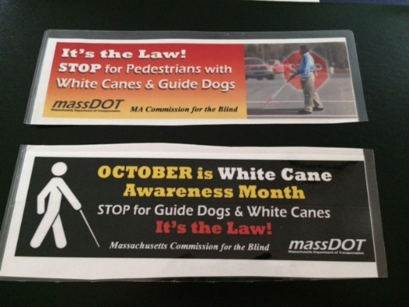

Vermont: Vermont Association for the Blind and Visually Impaired: Walk Your Own Path Mural project: “The gift of the mural is that it is an invitation to start a conversation, and what we want most is for sighted people to treat us as equals and engage with us.”
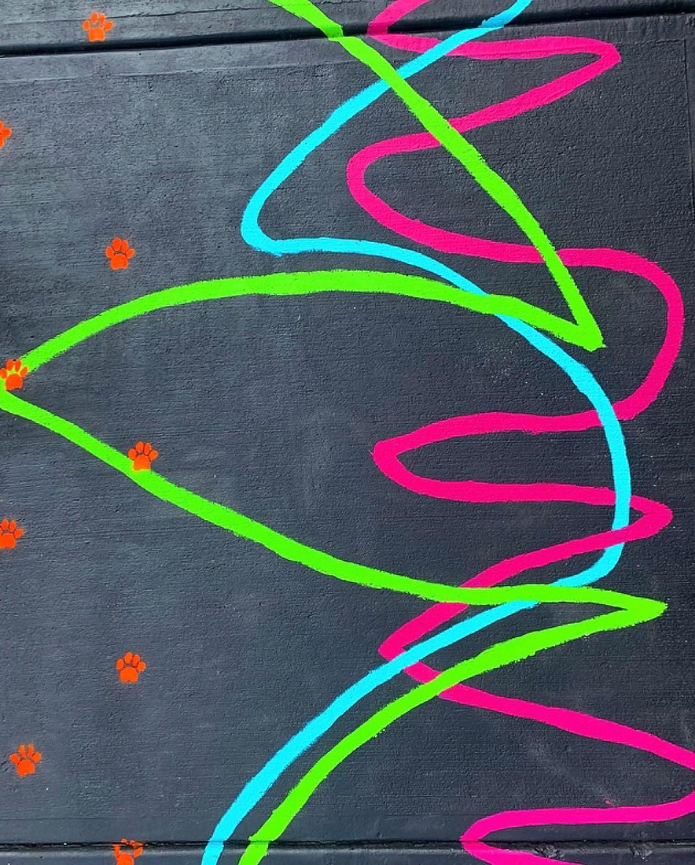
Photo of Brightly colored cane strokes and pawprints create a high contrast design on a black painted sidewalk.
Walk Your Own Path is a sidewalk mural made from cane strokes and guide dog paw prints. To create visual art from invisible mobility aid tracks, a half-block of sidewalk was painted black overlayed with fuchsia, green, blue and orange strokes and paw prints. The cane lines and paw prints are each painted a different color, representing the different participants. Next to the mural, a large print and braille sign describes the project, with a visual description thereof and instructions on how to orient to the mural. Shelby Glass, a Certified Orientation and Mobility Specialist (COMS) from Vermont, and two young artists who are visually impaired, created the piece. The mural is located in the Old North End of Burlington, Vermont.
Since the mural’s debut on White Cane Awareness Day this year, it has attracted the attention of communities across the country and was featured on New England Cable News (https://www.necn.com/news/local/new-mural-spotlights-experience-of-blind-visually-impaired-vermonters/2587788/) as well as in other online news periodicals. With the mural’s simple design, the concept can be easily replicated. There is interest amongst COMS and various disability advocacy groups, to learn how to replicate the project in their communities. So far, Shelby has connected with COMS from the Division for the Blind and Visually Impaired in Portland, Maine and COMS from Leader Dogs in Rochester Hills, Michigan to teach them how to create a mural of their own.
Recently, Shelby shared the story of the evolution of the mural with a peer-assisted, learning and support group for older Vermonters who are visually Impaired. After the presentation, Shelby asked the participants how the project impacted them. One participant shared that she liked the mural because “it depicts disability in a positive light.” Another person expressed, “by appreciating the beauty of a cane and creating art from it, sighted people might view visually impaired people as more approachable”. An additional individual said, “the gift of the mural is that it is an invitation to start a conversation, and what we want most is for sighted people to treat us as equals and engage with us.” By creating public art that is not only attractive and interactive, but also celebratory and accessible, this project enriches the culture of community while attempting to mend the disconnect between the visually impaired and sighted world.
In addition to conversations around isolation and mutual respect, the mural has sparked discussion around accessibility as well. One person who reached out to Shelby was her high school’s AP art teacher in New Jersey. She saw the mural on the news and asked Shelby to give a presentation to her students about wayfinding and universal design in high schools because her students are proposing projects to make their school more accessible. Shelby asked her student to co-lead this with her. He shared his experience around the challenges of navigating schools and solutions to enhance access for people who are visually impaired. The class’s favorite part was having the opportunity to ask him about what it is like being a high schooler who got diagnosed with a visual impairment his freshman year.
Over the next few months, Shelby will prepare a presentation explaining how she executed the project from start to finish. She will offer tips and advice on what to do, what not to do, supplies to use, and what changes could be made to enhance the project. Furthermore, she will facilitate a discussion on how public art can be an effective tool in sparking conversations about disability awareness. Shelby hopes that murals in other states can spark similar conversations to the ones that have already been started in the Northeast. Together as COMS and clients, we can play an active role in mending the disconnect between the sighted and visually impaired world.
If you are interested in learning more about how to bring this project to your community, please email Shelby at sglass@vibvi.org
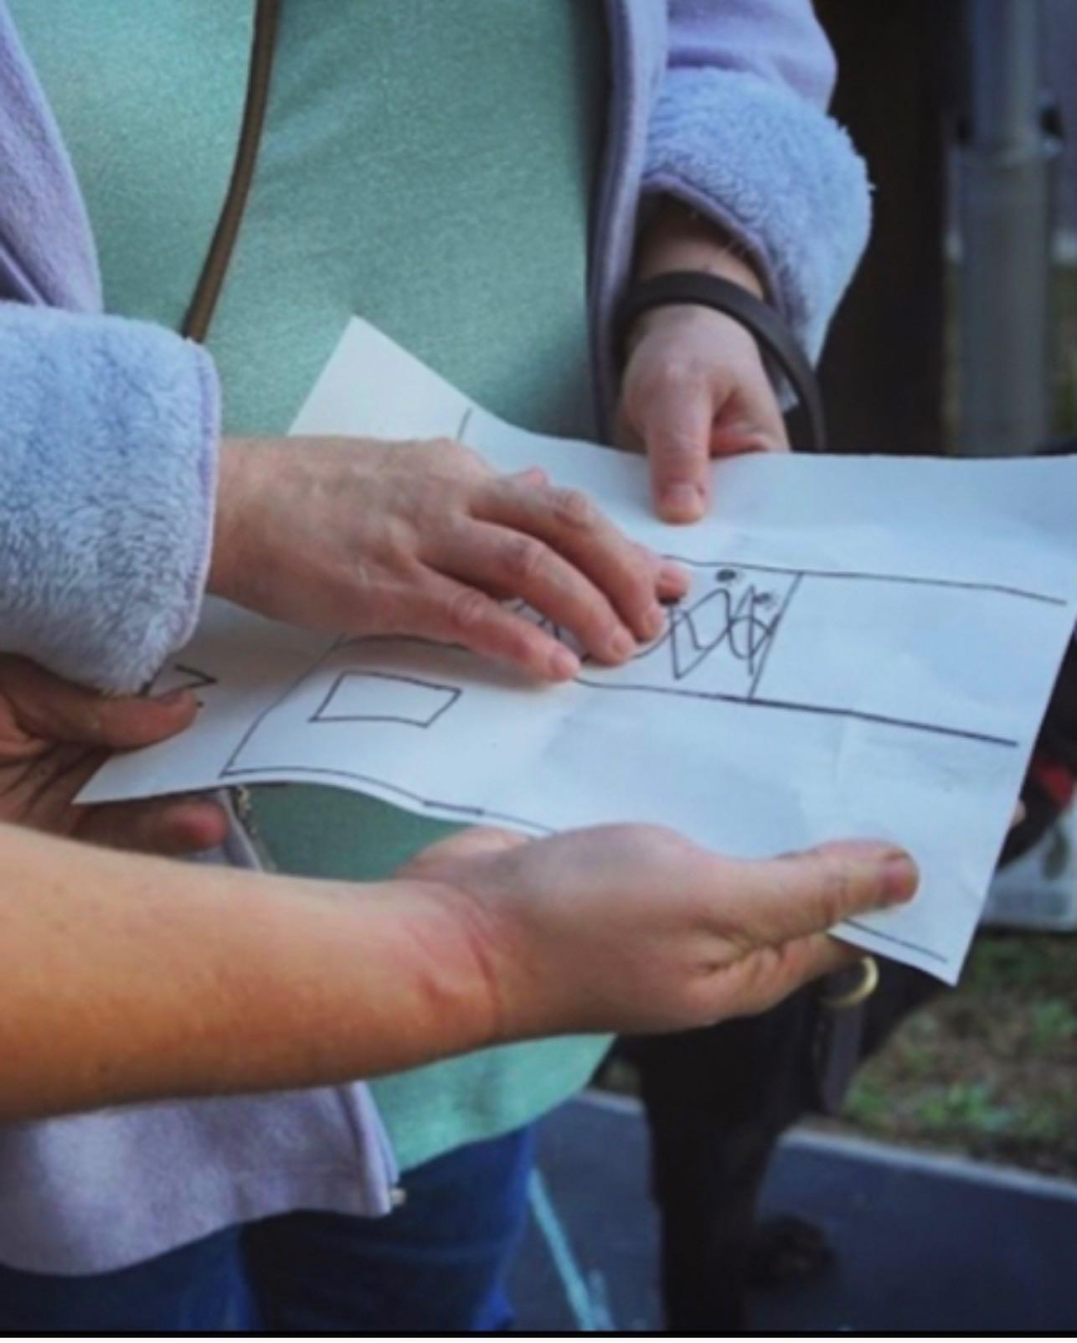
A.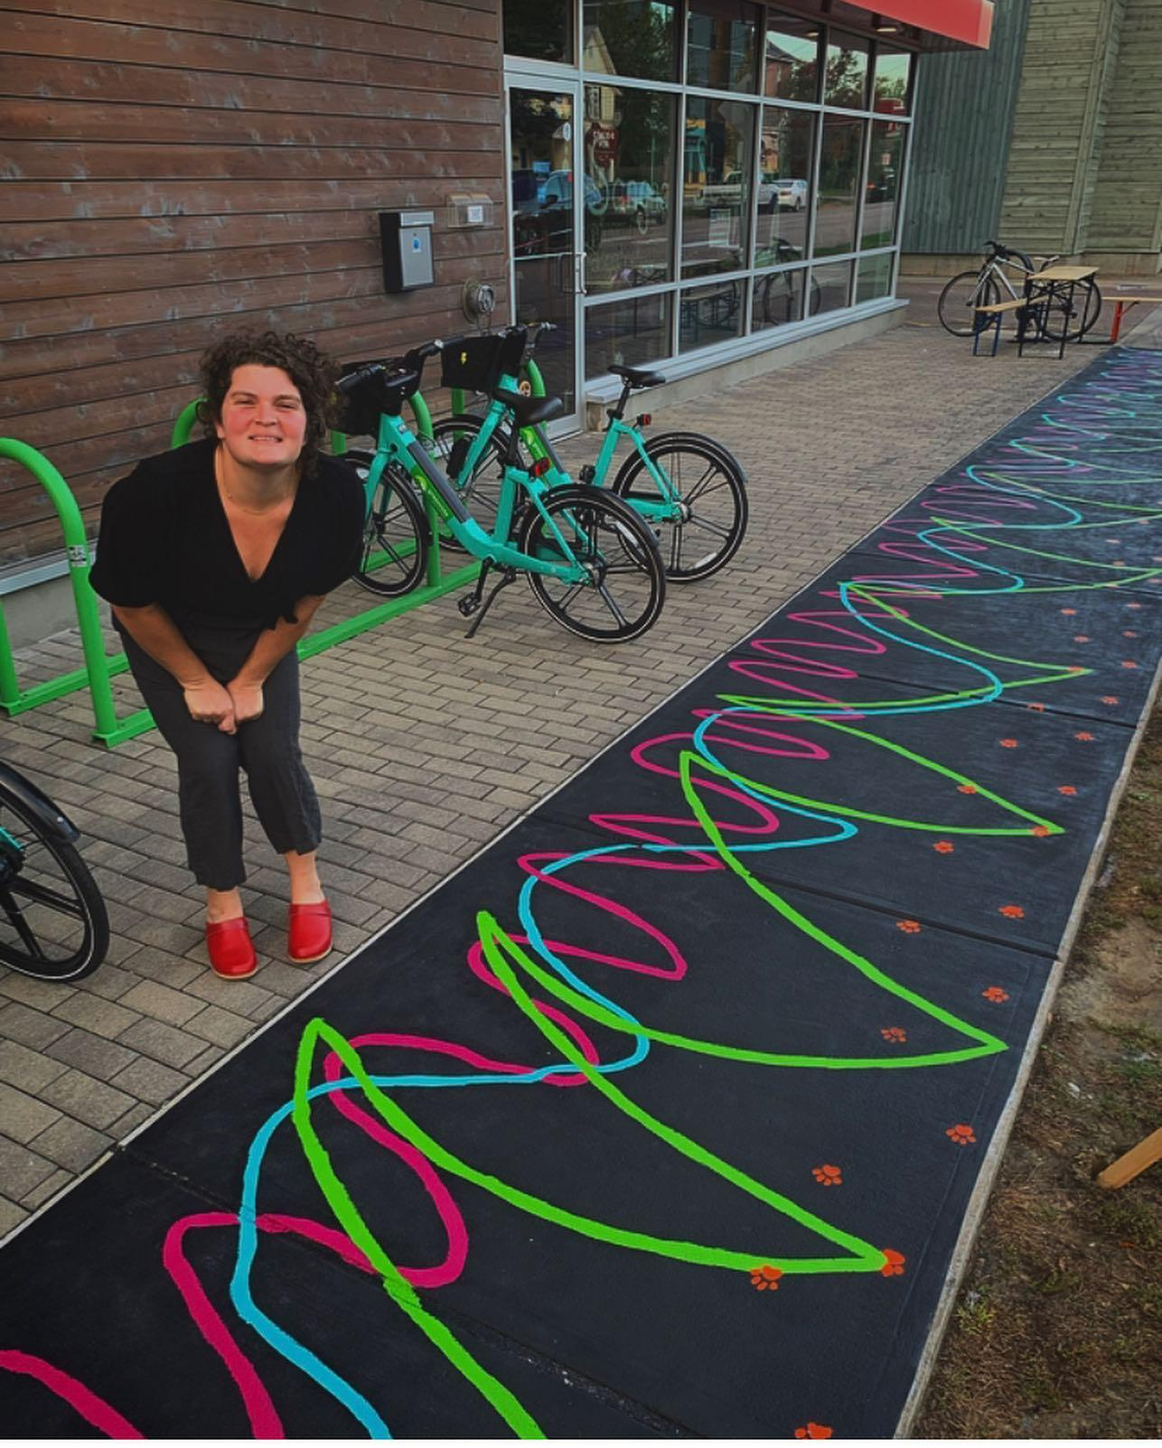 B.

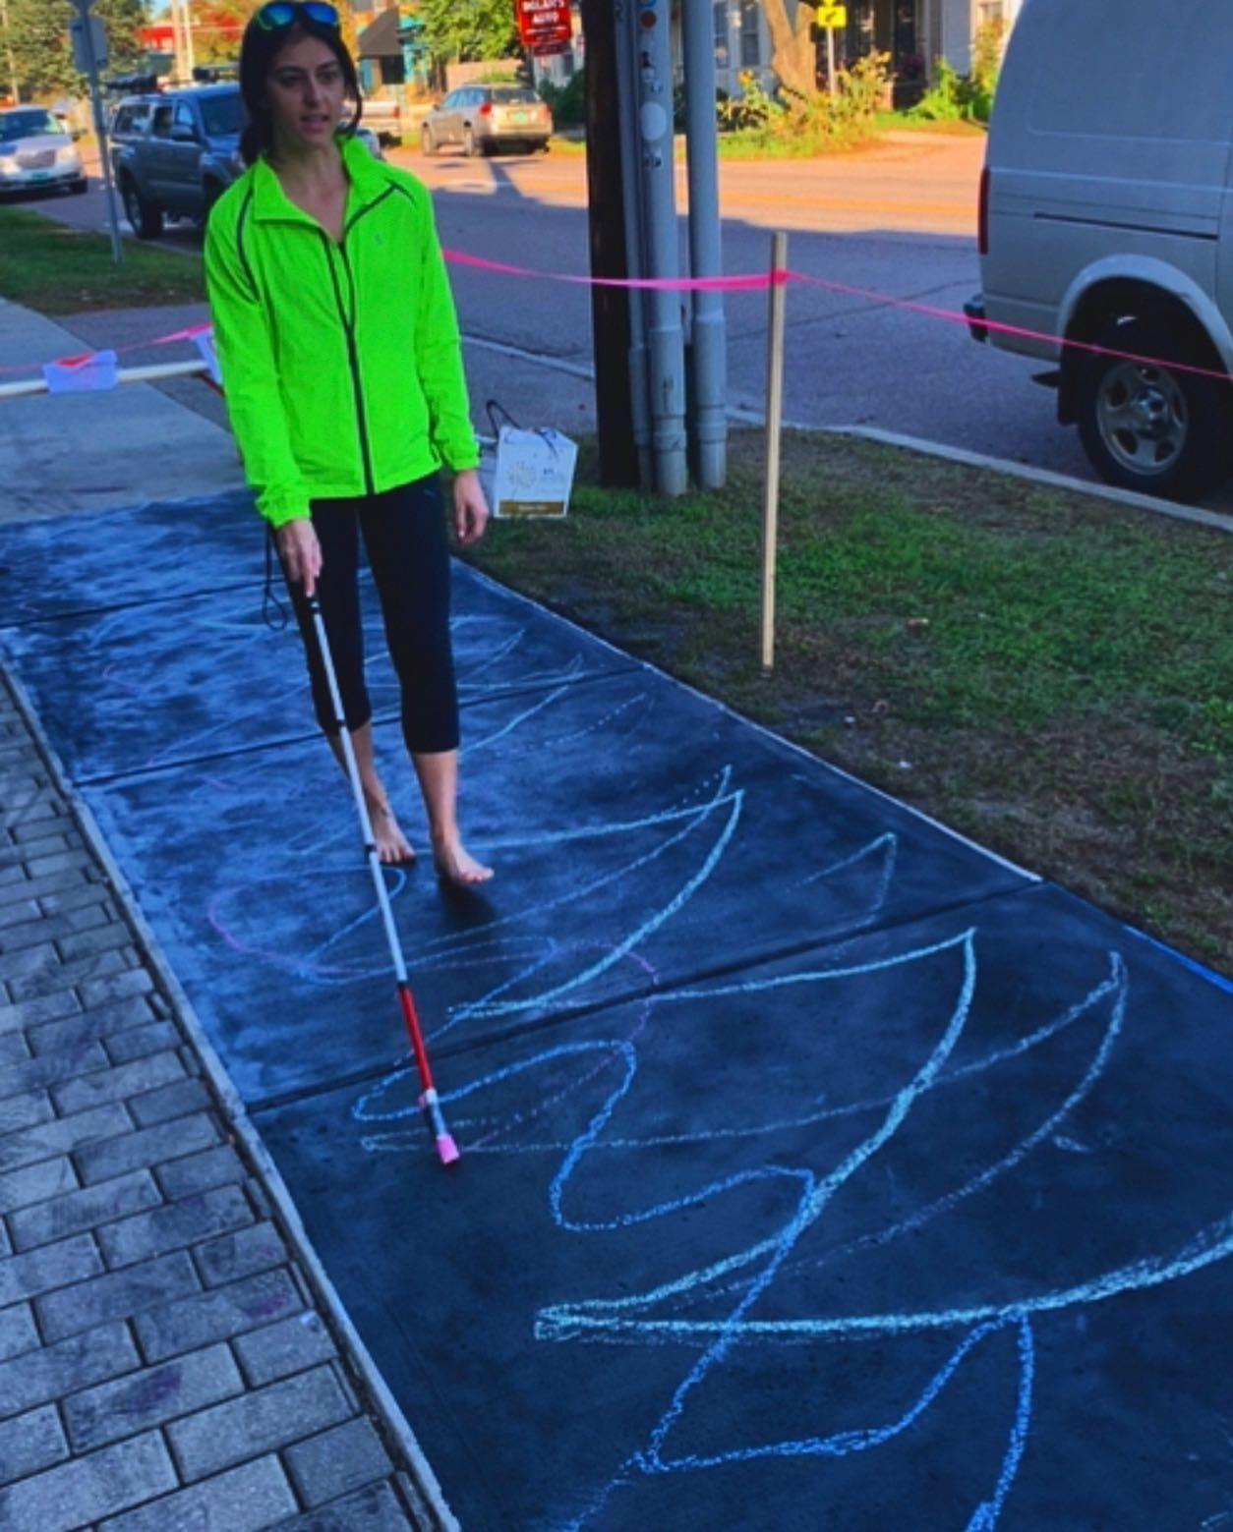
.C

D. 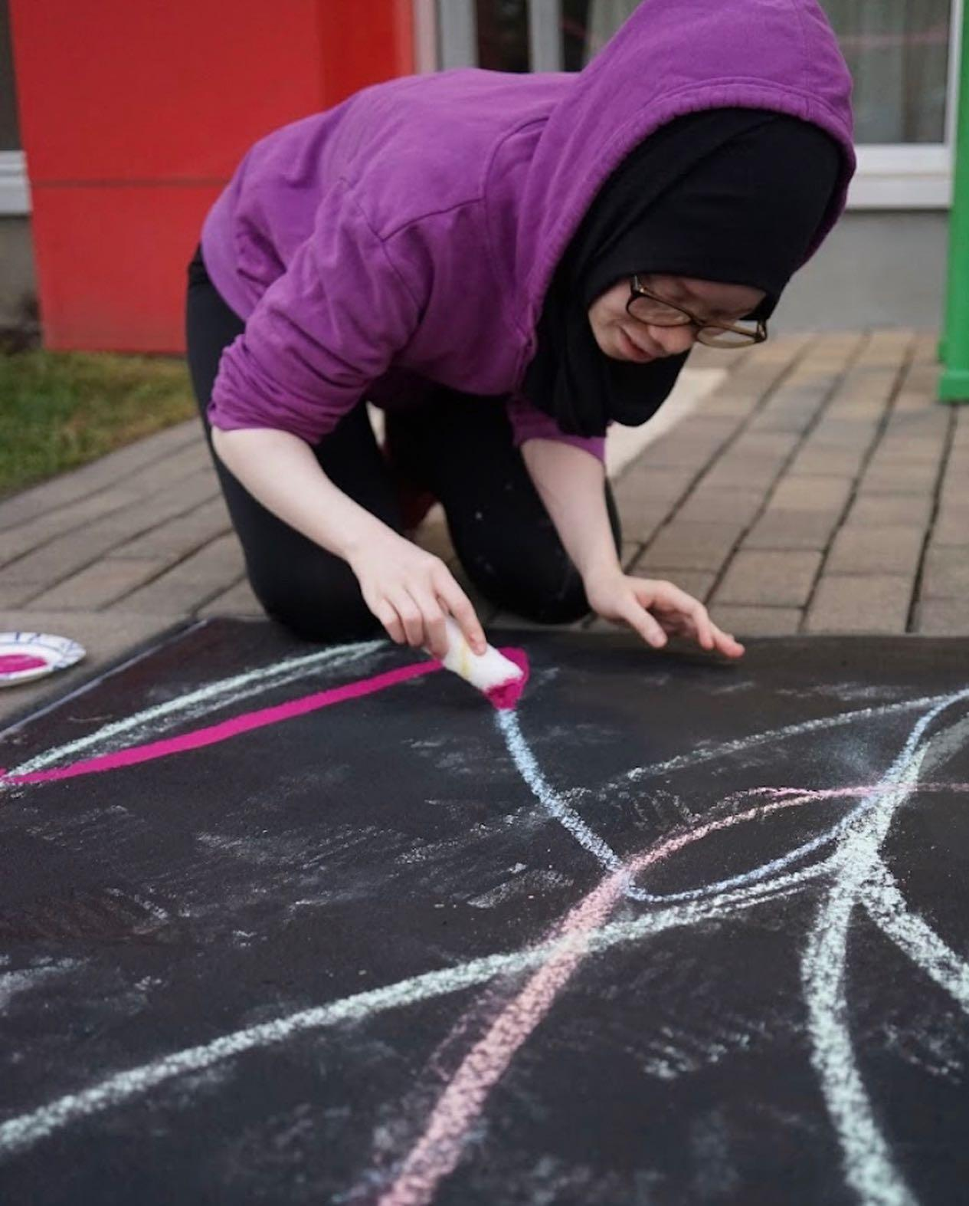

- Shelby stands proudly next to her finished mural. The mural spans 11 squares on the sidewalk
- A large print and braille sign describes the project and how to orient to the mural
- A cane user walks on the black sidewalk with chalk attached to her cane. As she walks she leaves a visual trail of where her cane has swept
- An artist traces over the chalk tracks in fuchsia paint
Additional 2021 White Cane Events:
Rhode Island celebrated White Cane Day on October 15th, 3-5 pm with an in-person outdoors event at Garden City Center, Cranston RI. For more information contact https://in-sight.org/
Texas School for the Blind had an in-person event with a virtual live broadcast. www.TSBVI.org
Wisconsin had a White Cane Day event in Milwaukee for more information contact WisconsinWCD@gmail.com.
Ideas for White Cane Outreach Activities: (Please send more suggestions)
Encourage students to write a letter to the local paper or send a press release educating them on the State White Cane Law, O&M training and/or pedestrian issues which impact individuals with vision loss.
Develop a presentation to present at a local Lions Club meeting.
Work with local/state blindness agency to organize a White Cane Walk or activity during the month of October or on White Cane Day.
Invite engineers, community leaders, consumers and the community into the field with you, either to highlight a specific intersection or to participate in a walk audit.
This newsletter is a good resource to submit your White Cane Activities and events. What are your plans for 2022? White Cane Day falls on Sat. October 15 this fall. Start planning now!
_______________________________________________________________________

A Fund honoring the legacy and work of Janet Barlow has been established by the Barlow Family. The Orientation & Mobility Specialist Association/OMSA has been selected as the agency to house these funds. The purpose of this fund is to carry on Janet’s work to further cooperation and mutual understanding between the orientation and mobility and the traffic engineering/urban planning professions. The fund will reimburse expenses associated with created educational opportunities that bring members of these professions together as approved by the OMSA Board. If you wish to make a donation to the Janet Barlow Legacy Fund visit the OMSA website at usomsa.org.
________________________________________________________________________

Resources from the New Mexico School for the Blind and Visually Impaired: http://www.nmsbvi.k12.nm.us/ominventory.htmlO&M Inventory Document Downloads

O&M Inventory 6.0m - Excel Document (for academic students 6 years and older)
O&M (M)Inventory 2.0 - Excel Document (for students with multiple impairments)
O&M Inventory Assessment Checklist - Word Document
Wheelchair O&M Inventory - Excel Document
O&M Inventory Eval Shell - Word Document

Call for Abstracts - Papers, Slideshows, and Poster for the 16th International Conference on Mobility and Transport for Older Adults and People with Disabilities (TRANSED) & 5th International Conference on Demand Responsive Transport (DRT) (TRB) which will now held virtually in September 2022.

Division Executive Committee

CHAIR: Joanne Chalom PAST CHAIR: Chris Tabb
EMAIL: aeromdivision@gmail.com EMAIL. chris@sensorytravel.com

CHAIR ELECT: Raychel Callary SECRETARY: Jennifer Duncan
EMAIL: raychelcallary@gmail.com EMAIL: duncanj@d62.org

TREASURER: Robert Alminana
EMAIL: robert.alminana.56@gmail.com
DISTRICT 1: Loana Mason EMAIL: loanam@nmsu.edu
(Alaska, Alberta, Arizona, British Columbia, Colorado, Hawaii, New Mexico, California, Nevada, Idaho, Montana, Wyoming, Northwest Territories, Oregon, Utah, Washington, Yukon Territories)

DISTRICT 2: John McAllister EMAIL: jwmcallister@ualr.edu
(Arkansas, North Dakota, South Dakota, Iowa, Kansas, Louisiana, Manitoba, Missouri, Nebraska, Oklahoma, Saskatchewan, Texas)
DISTRICT 3: Margaret Winn EMAIL: margaretkwinn@gmail.com
(Illinois, Indiana, Michigan, Minnesota, Ontario and Wisconsin)
DISTRICT 4: Claudia Libis EMAIL: clibis13@gmail.com
(Connecticut, Massachusetts, Maine, New Brunswick, Newfoundland, New Hampshire, New York, Nova Scotia, Prince Edward Island, Quebec, Rhode Island, Vermont)

DISTRICT 5: Amanda Stolz EMAIL: argordon08@gmail.com
(Alabama, Florida, Georgia, Kentucky, Mississippi, North Carolina, South Carolina, Puerto Rico, Tennessee)

DISTRICT 6: Valery Kircher EMAIL: valeryherring@yahoo.com
(Delaware, Maryland, New Jersey, Ohio, Pennsylvania, Virgin Islands, Virginia, West Virginia, Washington D.C.)

Visit the O&M website for a list of Committees: https://aerbvi.org/oandmdivision

Editor Meg Robertson COMS- please contact if any errors.

A newsletter needs news, so if you have something that you wish to share with the OM members, or ideas for the newsletter, please email Meg at Mobilitymeg@aol.com

Next deadline: March 1, 2022

Association for Education and Rehabilitation of the Blind and Visually Impaired
5680 King Centre Drive, Suite 600, Alexandria, VA 22315
aer@aerbvi.org ■ www.aerbvi.org ■ https://aerbvi.org/oandmdivision

