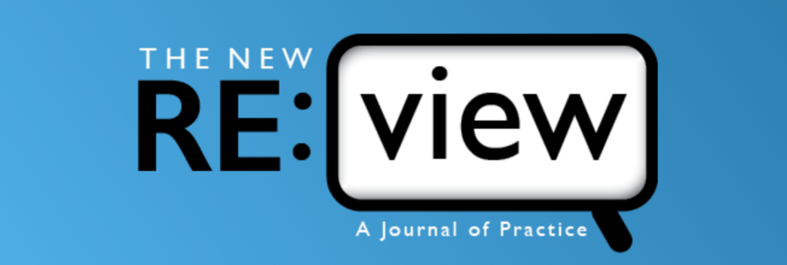

Would you like to be an author?
Send us your best ideas!
Professionals who work with children and adults with visual impairments regularly contribute to the success of their students. They may assume that others use the same approaches as they do, but many instructors don’t have time to talk with others about successful teaching strategies or to observe others at work. One way to share new methods is through writing about effective practice.
The New RE:view (TNR) is seeking original articles written by practioners who work with people who are blind or visually impaired. Whether your article is about motivating activities for teaching braille to teenagers, ways of organizing financial information, or assessment of vision changes in children with CVI, putting your experiences in writing can advance learning and encourage colleagues to try new solutions to teaching challenges.
The New RE:view’s emphasis on applied practice allows us to include a variety of writing forms in the new journal. Evidence-based analyses can be presented as practice reports or applied research reports. Well-supported opinion pieces may be featured as editorials or reader opinions. Factual information of interest to the profession will be featured as news from the field or book reviews. Within these categories, authors can present their ideas in formats that are useful to readers. New authors may want to ask one or two colleagues to read a draft of their work and to provide feedback before they submit it for consideration by the journal.
The website on Submission Guidelines provides detail about manuscript length and style, based on the Publication Manual of the American Psychological Association, Seventh Edition. Once the manuscript is submitted, it will be read by an Associate Editor who has expertise related to the topic of the paper. It will then be reviewed by two peer reviewers, who are professionals with experience related to the topic. They will make a recommendation to the Associate Editor about whether to publish the article. Authors are often asked to make changes that can make an article more relevant for readers. Our goal is to transmit your ideas to others, who can use them to enhance learning of the people they serve.
So, send us your best ideas and share them through The New RE:view!

