**Annual Impact Statement 2024**

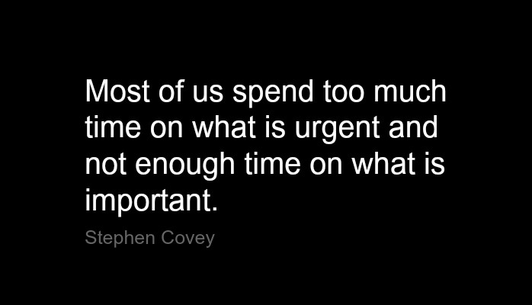

*-* Steven Covey, *The* *Seven Habits of Highly Effective People*

March 2025

**MESSAGE FROM THE CHAIR OF AER ACCREDITATION COUNCIL – Lee Sonnenberg**

In 2024, the AER Accreditation Council completed updates to standards, revisions and additions to policies and procedures, and outreach to organizations and programs that are not currently accredited. In this way, the Accreditation Council addressed Stephen Covey’s quote on the cover of this Impact Statement. The Council spent time on what is important, namely protecting the consumers in our field—both the people who are blind or have low vision, and the students who will become future professionals.

The Council and its two Commissions (OSAC and HEAC) attended the practical business of supporting programs during their self-studies, forming and facilitating review panels, reviewing accreditations, and rendering decisions. Yet, we never neglected the primary purpose of accreditation, “to advance excellence in the field of blindness and low vision services…by ensuring consumers are provided quality services in accordance with best practices in management and program delivery, and in curriculum.”

***Updates to Standards:***

As promised in the Annual Impact Statement for 2023, AER Accreditation Council approved recommendations to update 10 of the 29 rubrics for Organizations and Schools Standards. Only four standards are still scheduled to be reviewed in order to maintain the goal of reviewing standards every 3 years. Public Comment is routinely invited and announced in *The Voice*, and this input is incorporated when the Council approves. AER Divisions also are invited to comment during the scheduled reviews. All Higher Education Accreditation standards were thoroughly updated in 2023, however the curriculum maps that aid in tracking the various pieces of evidence for each standard are going to be reviewed this year.

***Updates to Policies and Procedures:***

AER Accreditation Council also updated several of the Council’s policies and procedures. As always, the *AER Voice* reported these changes so that all of AER’s constituents and stakeholders would have an opportunity to comment. The Survey of all Reviewers just completed (see below) also solicited feedback on all the policy changes. The Council considers, appreciates and makes adjustments based on the thoughtful input it receives.

***Outreach at National Meetings:***

The Council contributed training and shared information about accreditation at national meetings in 2024. At the Council on Schools and Services for the Blind meeting in Louisville, KY there was a lot of interest in blindness-specific accreditation standards. The Council is working on coordinating with CEASD and COGNIA, two general accreditation services the schools already use, so that AER’s specialized accreditation concerning specific blindness-related services can be integrated and duplications avoided.

At the AER International Conference in Charlotte, NC presentations were well-received for higher education personnel preparation programs and for direct services by schools and organizations.

***Reviewer Survey provides important feedback to the Accreditation Council***

A total of 94 surveys were sent to the current roster of Accreditation Reviewers. Some reviewers have served for many years and built a profound awareness of the process. All professionals added since 2020 also successfully passed a multiple choice test based on the Standards, and Policies and Procedures.

The test and the support documents are linked here: <https://www.aerbvi.org/become-a-reviewer>

Forty (40) responses to the confidential Survey Monkey were returned (42% return rate). In addition to the usual Likert scale of choices on questions, space was provided for written comments on Reviewer Training, the Standards, the Review Process, the Complaint Process, and new Policies and Procedures including those required by CHEA (the Council on Higher Education and Accreditation which now recognizes AER Accreditation Council). The aggregated responses on the Likert scale are linked here: [Survey Monkey Aggregate Responses.pdf](https://aerbvi-my.sharepoint.com/:b:/g/personal/elly_aerbvi_org/EQCIMfupg41HpdPYQgWn7R4B9glspID43AyrPigPAjohzg?e=TPtUa5)

The next issue of AER *The Voice* will report on the written comments.

**Accomplishments achieved in 2024**

AER Accreditation Council, now completing its seventh year, proudly shares the following

*Accreditations completed:*

Montana School for the Deaf and the Blind, Great Falls, MT

Children's Center for the Visually Impaired, Kansas City, MO

Lighthouse for the Blind of the Palm Beaches, West Palm Beach, FL

University of Pittsburgh, O&M and TVI programs.

A full list of all accredited programs and their expiration dates are listed here:

* HEAC: <https://www.aerbvi.org/personnel-preparation>
* OSAC: <https://www.aerbvi.org/organizations-agencies-and-schools-for-the-blind->

As we enter 2025, 12 organizations/schools for the blind are in the process of completing their accreditation process, and 8 University programs have applied and begun their process.

Please read below the names of the individuals who dedicated themselves to excellence in the provision of services to people who are blind or visually impaired.

**Lee Sonnenberg**

**CHAIR, AER Accreditation Council**

**WE WISH TO CONVEY OUR HEARTFELT GRATITUDE TO:**

**AERAC Members 2024:** Chair Lee Sonnenberg, HEAC Chair John McAllister, OSAC Chair Kathy Mullen, Kathy Beveridge, Tim Hornick, Kassandra Maloney, Natalie Martiniello, David Presley, Ian Shadrick, and Kaleb Stunkard.

**HEAC Members 2024:** Chair John McAllister, Dawn Anderson, Brooke Kruemmling, Dorinda Rife, Lacey Long, Dan Norris, Richard Oliver, Lachelle Smith, Sean Tikkun, and Rachel Sessler Trinkowski.

**OSAC Members 2024:** Chair Kathy Mullen, Dr. Alan Chase, Ronee David, Larissa DeZayas, Paul Furthmyre, Angelina Hollingsworth, Jerry Miller, and Sylvia Perez.

**HONORING REVIEWERS IN 2024**

Sarahelizabeth Baguhn Alison Brewer Callie Brusegaard

Irene Brown Leanne Grillot Julie Hapeman

Jerry Hillyer Sarah Moreau Samantha Morris

Susan Phillips Samantha Picciano Donna Sue Sullivan

Lindsey Van Straten Erin Weaver Luke

We could not do it without you!

**Do you want to join your peers on a review team?**

**Visit:** <https://aerbvi.org/become-a-reviewer>

**Call:** 703-671-4500

**Email:** [accreditationinfo@aerbvi.org](mailto:accreditationinfo@aerbvi.org)