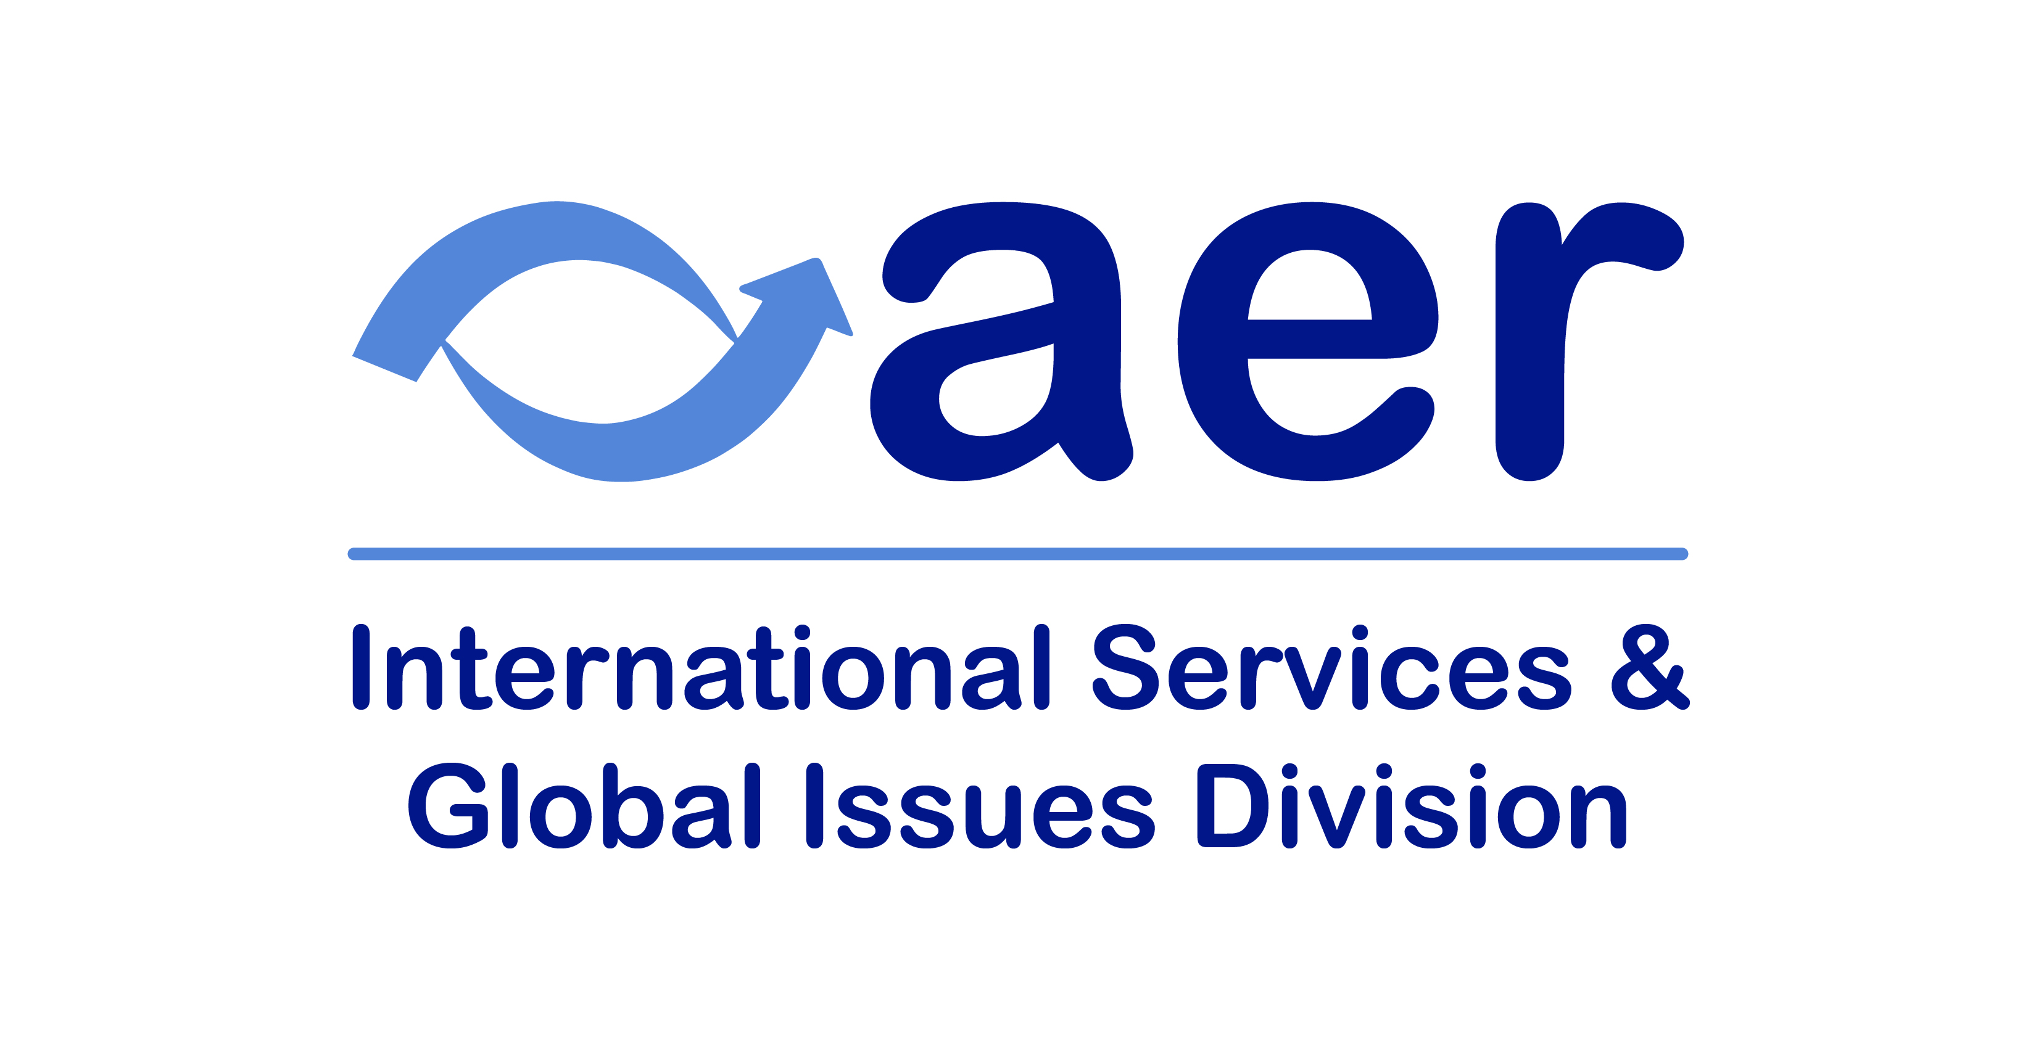

**Past Scholarship Winners**

The International Services and Global Issues Division is excited to offer our annual scholarship to two international members of AER. The scholarship recipients will receive a stipend of $1,000 towards post-secondary education to serve individuals with visual impairments.

**2023 Scholarship Winners**  
**Heba Nasser**, Egypt  
**Grace Amwe**, Nigeria  
  
**2022 Scholarship Winners**  
**Alejandra Sierra Santeley**, Honduras  
**Olani Wakjira Fufa**, Ethiopia  
  
**2021 Scholarship Winners**  
**Siomiris Albarran-Afanador**, Puerto Rico  
**Adonis Ovbigie**, Nigeria  
  
**2020 Scholarship Winners**  
**Isaiah Anaeze Makam**, Nigeria  
**Tracey Joubert**, South Africa  
  
**2019 Scholarship Winner**  
**Innocent Igba**, Nigeria