Modern Traffic Signals
AER’s O&M Division’s Environmental Access Committee

Traffic Patterns / Signal Phases
Permissive left turn - Left-turning drivers yield to opposing traffic:
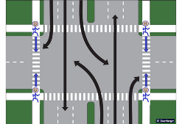
Protected left turns - There are two kinds of protected left turns where left-turners have the right of way with a green arrow:
- Split phase
Phase 1 Phase 2
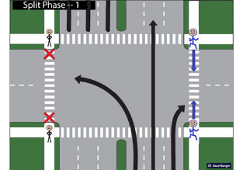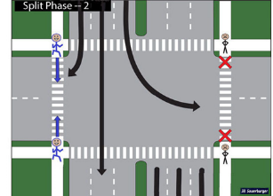
- Exclusive Left turns
Phase 1 Phase 2
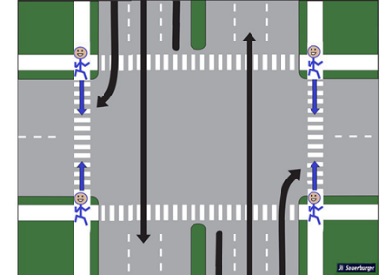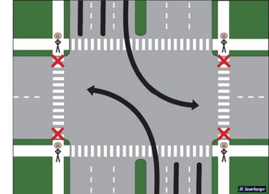
What does this mean for O&M?
Need to cross when WALK signal is on.
If the signal is not accessible:
NEAR-LANE PARALLEL SURGE (as shown below) can be a cue (with exceptions listed below) that the WALK signal is on if you’ve pushed the pedestrian button when the signal showed “don’t walk.”

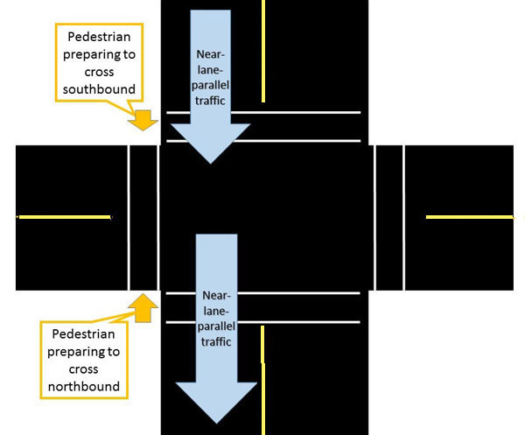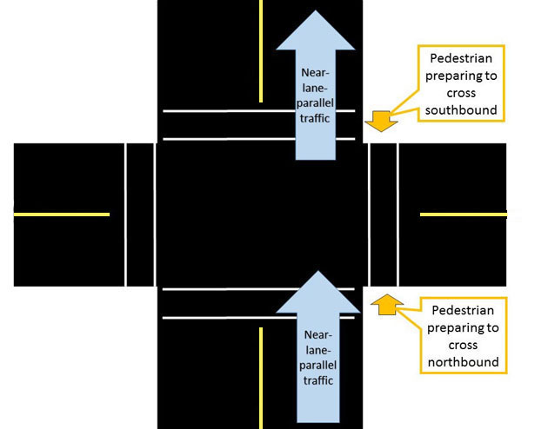

NEAR-LANE PARALLEL SURGE - traffic in the parallel street surging to go straight in the lanes nearest to the pedestrian’s crosswalk
EXCEPTIONS (explained here,)
- Protected right turns
- When vehicles get a green signal but pedestrians do NOT get the WALK signal (can happen in coordinated systems)
- leading pedestrian interval or exclusive pedestrian phasing
- Emergency preemption
Signal Timing

Actuation – signals vary in time and in pattern depending on the presence of detected traffic (usually vehicles in the secondary / side street and left-turning lanes, as well as pedestrians). Commonly found in suburbs and rural areas.
Fixed-time - signals don’t vary from one cycle to another (although their fixed-timing pattern can change at predetermined times during the day or can be adjusted temporarily from the traffic engineer’s office to handle unexpected traffic jams). Commonly found in cities.

NOTE: At actuated signals, you can’t predict how long the next cycle will be by observing how long it is now!

At actuated signals, pedestrians have to (1) be detected by the computer (press the pushbutton!) and (2) cross when the computer gives them the right of way AND sufficient time to cross (WALK signal).

Timing for actuated signals:
Main street:
- has a minimum time for the green signal before actuated lanes can have a turn (often 30-60 seconds)
- May have a maximum time set in certain conditions, otherwise may stay green until a vehicle or pedestrian is detected wanting to cross.
Minor lanes and streets:
- have a minimum time for the green signal just long enough for one vehicle to get through (3-5 seconds after vehicle enters the intersection, plus yellow light) - not long enough for pedestrians to cross!!
- has a maximum time (maybe 20-30 seconds)
Pedestrians:
- Minimum timing is set for flashing don’t-walk (clearance interval) to provide enough time for a pedestrian walking 3.5 feet/second to complete the crossing.

PEDESTRIAN SIGNAL:

WALK signal (similar to vehicles’ green light)
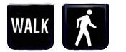

Meaning? (1) You have the right of way
(2) You have time to cross if you start while the WALK signal is on
Timing? Doesn’t matter except it must END when there’s no longer enough time to cross

Flashing don’t walk (pedestrian change interval / similar to vehicles’ yellow light)
may be with countdown
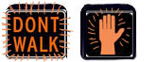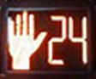

Meaning? (1) It’s too late to start crossing (not enough time)
(2) If you’re already in the crosswalk, you should have enough time to finish.
(countdown may indicate how many seconds before end of pedestrian phase)
Timing? Must be long enough to allow someone walking 3.5 feet/second to cross (traffic engineer can make it longer if requested).

Solid don’t walk (similar to vehicles’ red light)
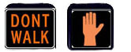

Meaning? You should not be in the crosswalk – vehicular traffic that crosses this crosswalk has the right of way!
Timing? This signal is on for as long as the pedestrians do not have the right of way.

APS BUTTON:
- Activates the accessible pedestrian signal for the next cycle

PEDESTRIAN PUSHBUTTON:
- Pedestrian “detector”
Where there is a pedestrian pushbutton at actuated signals, it must be pressed to inform the computer and get the WALK signal (which provides the right of way AND enough time to get across the street).
NOTE: The pedestrian detector is usually a pushbutton, but there might be passive detection, in which pedestrians are detected by microwave, video, etc. in the area that pedestrians are expected - which may not coincide with where pedestrians who are blind actually wait to cross.
- If you push the pedestrian button when the WALK signal is on, the computer assumes you’re already crossing, and will not give you another WALK signal at the next cycle.
- With a few exceptions (listed below), if you push the pedestrian button when the “don’t walk” sign is on (flashing or solid), the WALK signal will start at the next surge of the near-lane parallel traffic.
  - Exceptions (described here)
    - Protected right turns
    - When the controller gives a green signal for vehicles but not the WALK signal for peds (can happen in coordinated systems)
    - leading pedestrian interval or exclusive pedestrian phasing
    - Emergency preemption
- How to ensure you are pushing the button when the “don’t walk” sign is on? Answer: push it when the perpendicular traffic is moving!
- ALIGNMENT - when you need to press the button, you may not be able to use traditional alignment strategies – click here for solution

RESOURCES AND REFERENCES

Self-Study Guide: Crossing at Modern Signals - free course providing information blind pedestrians need for crossing at modern signals (5 hours of ACVREP credit)

Environmental Access Committee of AER’s O&M Division -

Leading Pedestrian Interval – the need for APS explained
- Barlow, J and Chalom, J. (2018) Need for Accessible Pedestrian Signals when Leading Pedestrian Intervals (LPIs) and Exclusive Pedestrian Phases are installed
- Sauerburger, D (2023): VIDEO - Why Accessible Pedestrian Signals are Essential for Leading Pedestrian Intervals
- Bourquin, E., Bieder, J., Wall Emerson, R., & Franck, L. (2023). Leading Pedestrian Intervals at Urban Crosswalks: Effects on Safety for Travelers Who are Blind. Journal of Visual Impairment & Blindness, 117(1), 30-39

Crossing Strategies Applied
- Sauerburger, D (2023): VIDEO - Training and applying eccentric viewing skills in O&M (last 2 minutes shows her using skills to cross street)

Alignment
- Strategy
  - Strategy for lining up when having to push pedestrian pushbutton (includes video)
- Engineering design
  - Bentzen, B.L., Scott, A.C., Barlow, J.M., Wall Emerson, R, and Graham, J. (2022) A Guidance Surface to Help Vision Disabled Pedestrians Locate Crosswalks and Align to Cross

Accessible Pedestrian Signals
- Harkey, D.L., Carter, D.L., Barlow, J.M and Bentzen, B.L. (NHCLP), Accessible Pedestrian Signals / A Guide to Best Practice
- Environmental Access Committee of AER’s O&M Division - Accessible Pedestrian Signals

Extension activities to use with your students
- If An Accessible Pedestrian Signal Could Talk, What Would It Say?

- If A Pedestrian Pushbutton Could Talk, What Would It Say?

