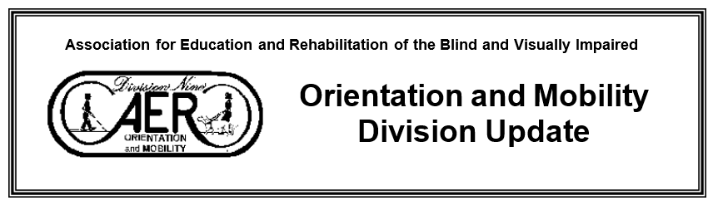
Fall 2022 Volume 25 No. 3
Association for Education and Rehabilitation of the Blind and Visually Impaired
aer@aerbvi.org ■ www.aerbvi.org ■ https://aerbvi.org/oandmdivision

Editor’s note: I have always felt the year had two beginnings, one in January and one in September.
“For last year's words belong to last year's language
And next year's words await another voice.
And to make an end is to make a beginning."
― T.S. Eliot
There is always time to make a new beginning and say goodbye to an old new beginning! Best wishes to all for the Fall Season.

From the Chair:

Dear Valued O&M Division Members,
It is a great honor to take on the role of chair of the division. I am grateful to have past chair JoAnne Chalom and chair-elect Maggie Winn as teammates, support from AER staff, and collaboration with as many of you as possible.
It was wonderful to gather with colleagues at the international conference in St. Louis in July and to welcome Lee Sonnenberg as our new Executive Director. The inaugural Janet Barlow Symposium Day “Help! It’s getting harder and harder to teach street crossings” was a great success. Janet was certainly missed since her passing last year, and it was fitting to honor her through this event and through the presentation of the Janet Barlow Environmental Access Service Award to Janet posthumously.
Several items of note took place at the division business meeting at the conference:
  - 2022-2024 officers and division directors were installed. This seems like a great team, and I am so thankful to those who volunteered.
  - We discussed the recent addition of a student representative, to be a resource for students in O&M programs. More information will be posted, but students can send a brief bio and a paragraph explaining their interest to the email below.
  - A discussion took place regarding new interest in the possibility of O&M assistants. A position paper existed years ago but was determined not to be pertinent at the time. The division voted to create a position paper on O&M assistants and role release. Chair-elect Maggie Winn will facilitate the creation of this paper as chair of the professional issues committee.
  - We learned about The New RE:view–A Journal of Practice, a practitioner-oriented professional resource which will be available soon. A desire for practitioner participation was emphasized. This could be a great way to share your ideas!
Based on input received through the Strategic Plan survey and during our conference session “Updating the O&M Division Strategic Plan: Looking ahead to 2027”, members of the Strategic Plan Committee created and presented a draft to the membership for comment. This closed on September 2 and a revised draft will be presented for a vote after comments are considered. The Strategic Plan provides guidance for the activities and focus of the division and executive committee and includes a schedule for monitoring and revising as well as for reporting to the membership.
It seems that some may not have been added to divisions when their membership was renewed. We hope you will check with colleagues if they are receiving communication from the division. If people intend to be division members but have not received messages, they can contact Michele at the AER office at michele@aerbvi.org to check their status.
We are starting work on updating the division page on the AER website, including more information about division committees. There are several committees with short-term or long-term projects, and we would love to connect interested volunteers with the right committee.

We are close to completing a large round of updated and new position papers. The comment period ended recently for “O&M Specialists and the Provision of Travel Instruction to Individuals with Nonvisual Disabilities'' and “Orientation and Mobility Specialist Roles, Responsibilities, and Qualifications''. Comments were provided to the writing teams and reviewed, and the revised drafts will be available through the end of September for a vote. A paper considering the O&M instructor’s role regarding support canes is in the process of being drafted and will be presented for comment when a draft is complete. I am so grateful to those who have given their time and effort to create and revise our division’s position papers. Papers approved by the division membership and the AER board will be available soon on the AER website.

I’m very excited to begin serving as the chair of the Council of Division Chairs. This forum consists of the immediate past chairperson, the chairperson, and the chairperson-elect of each division. The CDC Chair is a liaison between AER divisions and the board of directors, and assists the divisions in developing division activities. I plan to increase collaboration among divisions, and hope that by working together divisions are able to advance the needs of the field.
Thank you for being a part of the AER Orientation and Mobility community. If you have news related to the division to share, please reach out to Newsletter Editor Meg Robertson at mobilitymeg@aol.com. I welcome any communication related to Orientation and Mobility or the needs of divisions at aeromdivision@gmail.com. Thank you for the opportunity to serve the AER Orientation and Mobility Division!
Raychel Callary, COMS

Welcome to the 2022-2024 Biennium Executive O&M Committee

Chair: Raychel Callary Chair Elect: Maggie Winn
Past Chair: JoAnne Chalom Treasurer: Megann Brousard
Secretary: Valery Kircher

District 1: Angela Leavens District 2: Shay Utley
District 3: Jennifer Duncan District 4: Eric Shaw
District 5: Kevin McCormack District 6: Tessa McCarthy

Quick Bios on the some of the new OM Committee:

Raychel Callary, Chair: I am a Northern Illinois University graduate. After building the early part of my O&M career at an agency serving older adults in eastern Washington state, I am preparing to launch a solo practice providing O&M instruction to adults in the inland northwest. I am an adjunct professor and university supervisor with the Portland State University Orientation and Mobility program, and I promote accessible infrastructure locally and as a member of the AER Environmental Access Committee.

Margaret "Maggie" Winn, Chair Elect: I have been a COMS for 11 years and am a Western Michigan University graduate. I work for Oakland Schools in Metro Detroit with students in 11 districts, ages 0-26. I previously worked with nonprofits in Metro Detroit, Chicago, and Pittsburgh serving clients across the lifespan. I have served clients as an independent contractor with the State of Michigan. For the past 6 years I have served as the AER O&M Division District 3 Director and have more recently joined the O&M Division Awards Committee and moved into the role of chair of the Blasch Scholarship Committee.

JoAnne Chalom, Past Chair: I am President of In Focus Mobility providing diverse levels of service to individuals, organizations, and agencies. Our services include providing services in orientation and mobility, environmental analysts, and workshop facilitation.
As Past Chair of the Orientation and Mobility Division of AER my role is to support the chair, which entails providing guidance and some acquired wisdom in the leadership roles I have fulfilled over the past four years. I am also involved as a member of the Orientation and Mobility Division Environmental Access Committee (EAC). I am looking forward to helping the profession learn and grow.

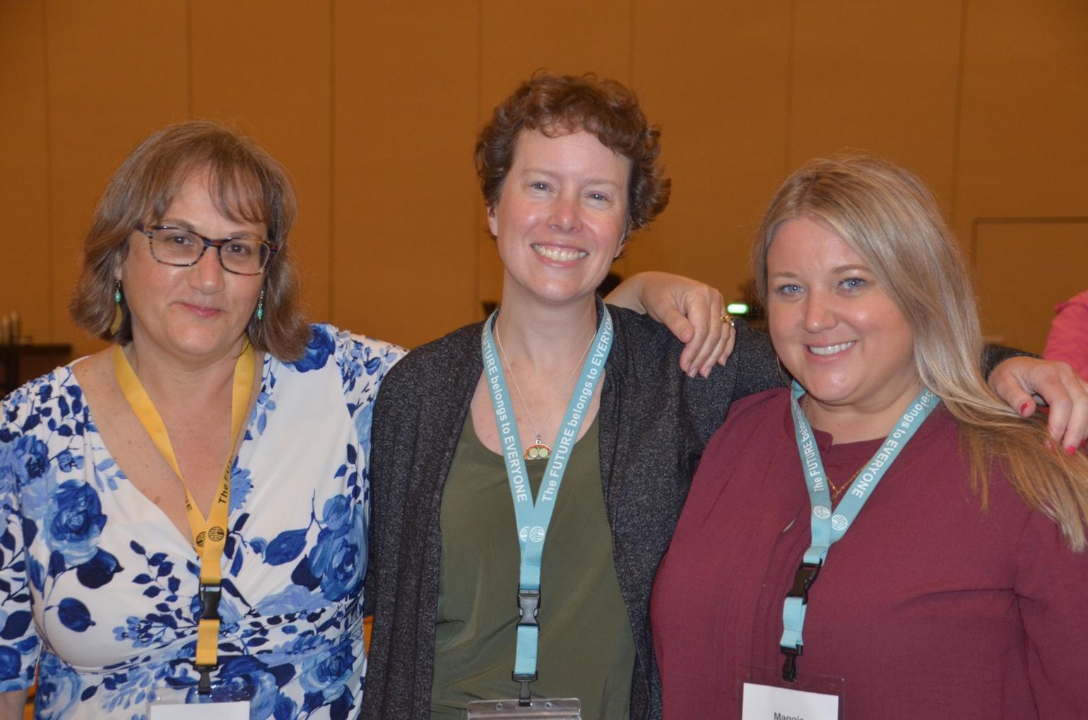
Photo of O&M Chairs: JoAnne Chalom on left, Raychel Callary in the middle and Maggie Winn on the right.

Megann Brousard, Treasurer: I am the Lead Orientation and Mobility Specialist at Colorado Division of Vocational Rehabilitation. I grew up in Traverse City, Michigan and earned my master’s degree from Western Michigan University in 2016. In my current role, I mentor colleagues statewide and provide direct services to individuals with employment goals. I also provide direct services to seniors through iSight Connections, a local nonprofit organization. I live in Colorado Springs and enjoy traveling and spending time with my husband and two cats. I look forward to being more involved with AER and am excited for the opportunity to work closely with other O&M professionals in the field.
District Directors
Ms. Shay Utley, District 2 (Arkansas, North Dakota, South Dakota, Iowa, Kansas, Louisiana, Manitoba, Missouri, Nebraska, Oklahoma, Saskatchewan, Texas):
I have been a Certified Orientation & Mobility Specialist (COMS) for the past 26 years, beginning my career at the Lighthouse for the Blind in Fort Worth, Texas, after graduating from Stephen F. Austin State University with a Bachelor of Science degree in Rehabilitation in 1995 and obtaining my Orientation and Mobility Certification in 1996. I have been serving students in the Mansfield Independent School District/MISD (Texas) for the last 20 years.
While employed with MISD, I have sought out numerous opportunities to serve students with visual impairments both at the local and state level. I’m a Developer and Author the Texas 2 STEPS Evaluation and Curriculum for O&M. This was a cooperative project by a group of O&M Specialists in Texas who saw a need for specific evaluation and curriculum techniques designed especially for children ages birth to 5, in Orientation and Mobility.
I’m very passionate about serving in leadership roles in my professional and personal life to expand my knowledge and give back to the community.

Jennifer Duncan, District 3 (Illinois, Indiana, Michigan, Minnesota, Ontario, Wisconsin):

I currently teach in Illinois and this term I am looking forward to hearing about all of the great things going on within District 3 and within our field!
Eric Shaw, District 4 (Connecticut, Massachusetts, Maine, New Hampshire, New York, Rhode Island & Vermont: Canada: New Brunswick, Newfoundland, Nova Scotia, Prince Edward Island, & Quebec):

I am an itinerant TVI and COMS working in southwest Vermont. I have worked for the Vermont Association for the Blind and Visually Impaired for 25 years and been an AERBVI member for even longer. As the new representative for District 4 I hope to hear from and engage members from all corners of our District. I will be attending and presenting the Fall 2022 NE/AER Conference in Westford, MA and hope to meet many of you in person.

Kevin McCormack, District 5 (Alabama, Florida, Georgia, Kentucky, Mississippi, North Carolina, South Carolina, Puerto Rico, Tennessee):

I am the O&M and AT consultant for the state of Kentucky. I have had the fortune of living and working in multiple states and have some international interests and experience. I look forward to getting to know more folks in District 5. I also have connections to Puerto Rico and hope to assist in increasing the presence of this community in our district updates and activities.

Dr. Tessa McCarthy, District 6 (Delaware, Maryland, New Jersey, Ohio, Pennsylvania, Virgin Islands, Virginia, West Virginia, Washington D.C.):
I am an assistant professor at the University of Pittsburgh affiliated with the Vision Studies Program. I am also a teacher of students with visual impairments and a certified orientation and mobility specialist. My scholarship revolves around finding ways to improve educational practices for students who are blind and visually impaired. I am particularly focused on developing teaching strategies and curricula that enhance the mechanical abilities of children who are just beginning to learn to read braille.

Environmental Access Committee Report

We had a successful Janet Barlow Symposium Day at the AER Conference this past July. Participants were about to learn about how the changing intersection designs, impact O&M and pedestrians with vision loss. We were able to try out some directional tiles and audio beaconing of an Accessible Pedestrian Signal.

Our next project is to get ready for the January 2023 Washington DC Annual Transportation Research Board Meeting. We hope to send a number of EAC members (dependent on funding) to represent pedestrians with vision loss and our profession on the impact of design to the public right of way environment. Different meetings we attend include the Pedestrian, Bicyclist, Traffic Control Devices, Landscaping and Design, committees. Any changes or updates we will bring back to present at local and national AER conferences and include in the OM Newsletter.

Some updates on what the EAC members are working on:

Beezy Bentzen is a member of TRB APO45 Standing Committee on Passenger Intermodal Facilities and represents AER on the ICC A117.1 Committee on Accessible and Usable Buildings and Facilities. She represents Accessible Design for the Blind on the Signals Technical Committee of the National Committee on Uniform Traffic Control Devices. She is currently working on the following projects as a member of Accessible Design for the Blind:
- TRB TCRP B-46 Tactile Wayfinding in Transportation Settings for Travelers Who Are Blind or Visually Impaired
- Sub-contractor under Toole Design for Montgomery County (MD) project on floating bus stops
- FHWA project with Cadmus, Kittleson and UNC on Accessibility at Innovative New and Quick-Build Pedestrian and Bicycle Designs (including quick-build bulb-outs)
- TRB NCHRP 03-130 sub-contractor under Kittleson for 3rd edition of Roundabout Guide

JoAnne Chalom is a member of TRB Standing Committees on Accessible Transportation and Mobility (AME50) and Women and Gender in Transportation (AME20). She is a current panel member on TCRP B-47 Impact of Transformational Technologies on Underserved Populations.

Lukas Franck is a member of the Transportation Research Board (TRB) panel on TCRP B-46 Tactile Wayfinding in Transportation Settings for Travelers Who Are Blind or Visually Impaired.

Meg Robertson is a member of the TRB Standing Committee Traffic Controls Devices (ACP55), a current panel member of NCHRP 22-37 Development of a MASH Barrier to Shield Pedestrians, Bicyclists and other Vulnerable Users from Motor Vehicles, and an appointed member of the Mass. Pedestrian and Bicyclist Advisory Board (MassDOT).

As the EAC Chair, I’m happy to report that Accessible Design for the Blind (or ADB), the research firm, Janet Barlow was President at the time of her death, will continue its mission of doing research on public right of ways.

This company was established in 1992, by Beezy Bentzen, to do research on public right of way issues which impact pedestrians who are blind. In 2020, Janet Barlow and Beezy asked three colleagues who had all worked with them in designing and conducting research, analyzing the data, and writing up the results for about 20 years, whether they would be willing to take on the work of ADB. This special team of Alan Scott, Jennifer Graham and Linda Myers, will be carrying on Janet Barlow's work of building relationships with transportation engineers and conducting research that transportation engineers can use in making travel easier and safer for people who are blind or who have low vision.

Alan Scott recently left his job teaching psychology at Elon University to become President of ADB. Alan's special contribution to the work of ADB has been in helping to design research, analyzing and making sense of the data, and writing papers for publication. The data was sometimes very messy because the research was conducted in real environments, with all the things that can happen in the environment as people cross streets, for instance. Alan lives in Chapel Hill, North Carolina.

Linda Myers conducted wayfinding research with Beezy even before ADB was formed, and she has continued to be active in conducting experiments with ADB through all its years. She recently retired from full-time direct O&M service to schools in Marin County, California.

Jennifer Graham continues full-time practice in O&M in the Grand Rapids, Michigan area, which is her home. Jen's first O&M position was under Janet's direction at the Center for the Visually Impaired in Atlanta, Georgia. Janet was always impressed with Jen's insights and skill as an O&Mer.

Beezy remains a part of ADB, mentoring Alan, Linda and Jen as they build their own networks and become the leaders in seeking new research opportunities to help answer questions about how people who are blind or who have low vision navigate in increasingly complicated environments.
_____________________________________________________________

Access Board Issues New Guidance on Signs
The latest chapter added to the U.S. Access Board’s Guide to the ADA Standards addresses signs, including the use of international symbols of accessibility, raised characters, finish and contrast, Braille, locations of signs at facilities and spaces, and much more. The guide also answers common questions on tactile signs, visual signs, and pictograms. Vivid and detailed graphics of compliant signage are included to illustrate how various requirements may be met.

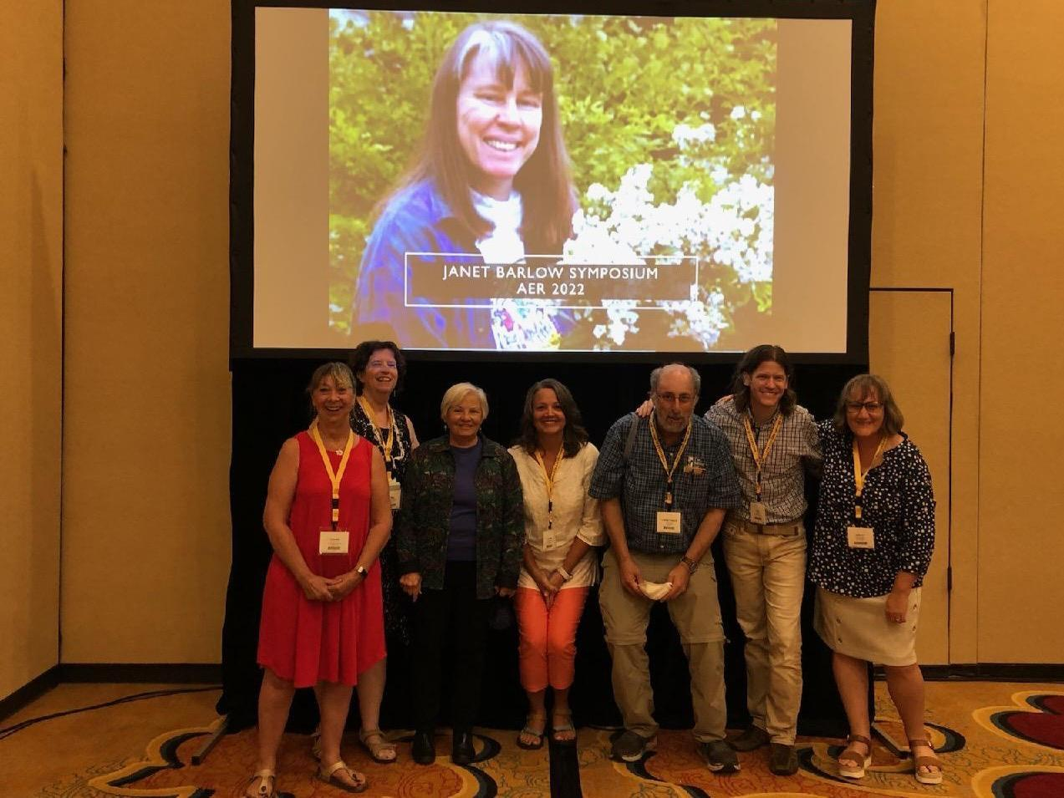
Photo is of EAC members who presented at the Janet Barlow Symposium. Starting from left to right: Claudia Libis, Meg Robertson, Linda Myers, Jen Graham, Lukas Franck, Alan Scott, and JoAnne Chalom, standing in front of a photo of Janet Barlow.

Members of EAC: Meg Robertson, Mass./New England/Nevada- EAC Chair: Mobilitymeg@aol.com, Beezy Bentzen, Alaska; Gene Bourquin, New York; Raychel Callary, Washington; JoAnne Chalom, Florida, Lukas Franck, New Jersey; MaryBeth Cleveland, Maryland; Jen Graham, Michigan; Melanie Hughes, Virginia; Claudia Libis, New Hampshire/New England; Linda Myers, California; Elizabeth Robertson, Colorado; Dona Sauerburger, Maryland
_____________________________________________________________

Orientation and Mobility Awards Ceremony

Nick Leon, O&M Awards Committee Chair
Committee Members: Ana Leffel, Justin Kaiser, Maggie Winn, Mary Kline, Tommie Roesch, and Tricia Sproles

Nick Leon’s (Edited) remarks at the Awards Celebration at AER O&M Division Event at the 2022 AER Conference.

“I am extremely grateful to be hosting the event for the first time, in person, after our remote ceremony in the chaos of 2020. Choosing award recipients among the many deserving nominations can be difficult, so thank you. Lastly, I would like to thank everyone who sent in nominations and all of you for being here. It’s humbling to look out into this audience and see so many of the professionals I look up to in this field. Many of us here have learned the majority of what we know about O&M from the people in this room. I doubt many professionals have the unique opportunity to go from studying curriculum at a university level to sitting at an event, like this, seated next to those who authored the curriculum. So, please, to those who are newer to the field, take advantage of this opportunity. And to all the incredible mentors in this room, you are truly some of the best people I have ever met. Your dedication and service to this field cannot be overstated, so thank you! As I mentioned, our last award ceremony had to be held virtually, but we are fortunate to have the award recipients from 2020 in the room today. So, I would like to take the opportunity to give them a “proper” applause for their incredible contributions to the field. Rod Haneline, who was awarded the Sandy Kronick Distinguished Service Award, Nora Griffin-Shirley, who was Awarded the Lawrence E Blaha Memorial Award. Thank you both for being here and everything that you do for the field of O&M

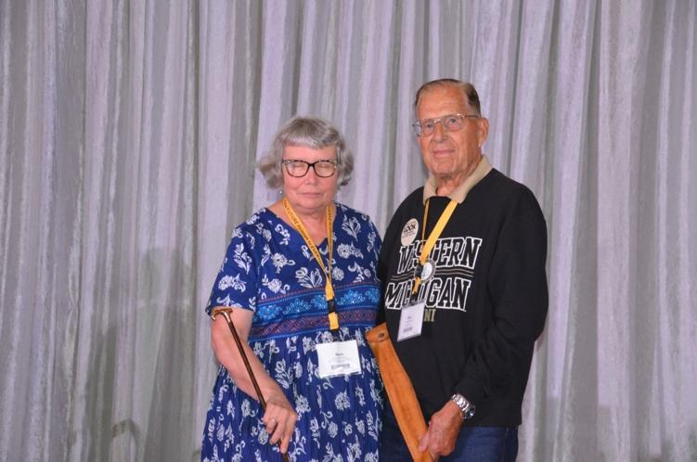
Photo of Dr. Nora Griffin-Shirley and Rod Haneline, 2020 award honorees.

The Sandy Kronick Distinguished Service Award was established in 1994 to recognize professionals who demonstrate distinguished service in O&M through a long-term commitment to direct service. Named after Sandy Kronick due to his lifelong commitment and dedication teaching O&M while continuing to be actively involved with numerous professional activities and committees.

The Sandy Kronick Distinguished Service Award 2022 Recipient is Susan Langendonk.

Marjie Wood presented the award to Susan with these (edited) remarks. “I think anyone who’s heard the name Susan Langendonk will be able to think of a specific topic or topics, memory, or situation to which she has been linked. For most of us, though, knowing Susan and her service to the profession could be described in terms of length, depth, and width. Susan first started teaching O&M in 1979 for the Lansing Michigan Public School and was the only O&M there for 20 years. From 2000-2010, she taught O&M for Ingham Intermediate School District. It was at that time that she advocated for using personal vehicles for being able to transport students off campus for O&M lessons. After 30 years, she retired but not for long as she came back when the area faced a critical shortage of O&M specialists.

Since 1979, Susan has been actively involved in state projects and held positions in the Michigan AER chapter. She worked with the Michigan Department of Education Low Incidence Outreach (MDE-LIO) O&M Task Force and facilitated MDE-LIO committees to develop what is widely known and has been used for years as the Michigan Severity Rating Scale as well as the O&M goal bank. Susan has been heavily involved in the Michigan AER chapter as their president 3 different times and has received 2 statewide awards.

With AER international, Susan has continued to serve in varying positions as secretary of AER. As chair of the O&M division, Susan started an email of past O&M chairs to increase communication amongst the group. She continues to volunteer to work on committees and projects to further benefit the O&M profession.

Since the beginning of the formation of the Orientation and Mobility Specialists Association (OMSA), Susan has served as treasurer and, during the pandemic in spring of 2021, would coordinate Mobility Mondays, in which O&M specialists could connect with one another to gather online and learn about specific issues concerning the profession. This coordination took a great deal of effort and time. Did y’all know that she also runs a horse farm with many boarders as well?

To quote Anne Zanger who wrote a letter of support, “Susan has been instrumental in helping many new professionals develop into excellent practitioners through supervising practicums and internships, mentoring, presenting at conferences, encouraging COMS to serve on boards and committees and being an example of a commensurate professional. Personally, Susan has made a monumental impact on my life. When I completed my bachelor’s degree and was unsuccessful in getting a job, she encouraged me to look at the O&M program at Western Michigan University. She saw potential in me that I was not aware of. Susan wrote me a letter of recommendation to WMU; she lent me many of the books that I needed for my coursework because the expense was often beyond my reach; and when I completed my coursework, she supervised my internship. Although she’s retired now, she continues to be the role model I strive to be. This generous spirit extends to so many people in and out of the field. If Susan feels she can help someone in need, she does not hesitate to do so.

Susan’s drive to support and grow people isn’t limited to helping develop O&M professionals, but she demonstrated this same connection with students and families she served. She was so helpful with one of her families that they named their baby after her. Her ability to instruct, encourage, and build functional skills with her students continues to be a goal that I strive to obtain as an instructor.”

If you ask Susan about her professional life and life in general, she describes herself as a MacGyver in solving the most challenging problems while her eyes light up. She humbly mentions that she was in the right place at the right time for so many opportunities.

Susan, it is such an honor to be able share you, your knowledge and accomplishments with the world and what you mean to all of us through this most prestigious award, the Sandy Kronick Distinguished Service Award.”

Susan’s Acceptance (Edited) Speech: “Thank you, Marjie for thinking of me for this award and for Anne Zanger to write a support letter. Thanks also to the Awards Committee for selecting me from several very worthy nominees. It’s much more in my character to be out doing something than standing in front of a crowd talking, but here I am and here goes.

When I told my husband I didn’t know what to say, he replied “they want to hear about you” I said “what? My accidental life? I didn’t plan a thing”. I’ve talked with a few people and have found that this isn’t necessarily unusual, but I’ve always felt there must have been something guiding me for things to have worked out so well.

I listened to the acceptance speeches over the past several days and thought about the passion and purpose of the recipients and it seemed they knew where they were going and what needed to be done next.

I’ve done a lot of reflection on the past as I prepared for this talk.
I want to tell you of just of few of the many things that I have to be thankful for…

Picking by chance an undergrad degree (TVI) that let me discover O&M. Realizing that, for my first job, being the sole teacher consultant for 2 counties in rural western NY state was not a good fit for me.

Attending an O&M program at a time when some of the founders of the field and the university program at WMU were still actively teaching. Stan Suterko, Bill Wiener, Donald Blasch, Butch Hill, Bob LaDuke, Marv Weesies. I’m sure I’ve left some out…. But they had a profound influence on me as a student and later as a professional.

Having an internship placement with wonderful role models who were passionate about what they were doing and helped me be ready to go out on my own.

Having new colleagues who were the definition of collaboration and teamwork,

Being able to give back to the field by working on projects like the MI SRS and the MI O&M Goal bank.

Joining the MI chapter of AAWB in the late ‘70’s that later became Michigan AER where I served as President, then a position on the AER board as secretary, chair of the O&M Division and again on the AER board. I became friends with people who would remain friends for decades.

And lastly working with colleagues to form the Orientation and Mobility Specialist Association and serving as its Treasurer for the past 4 years.

I’m also thankful for the students, clients and university interns that I was able to guide through all the years that I worked. You don’t always know how you influenced them, but sometimes you’ll get to hear from someone years later who needs to tell you what it meant to have you teach them skills to gain independence. This is one of the best gifts you’ll ever receive. The gift Anne gave me with her support letter is one I think of often.

I’d like to share a quote I found that I think really fits how I feel about receiving the Sandy Kronick award: Linda Fiorentino an actress in Men in Black said “In the end, it’s about the work, not the award you get for the work. “ But I still want to thank you for this award. I’m honored.

When Nick heard me talk about my present life where I spend almost all day working and taking care of horses, he asked something like “and why would you do that?” I didn’t have words at the time, but Nick, when faced with the challenge of my farm help quitting suddenly, I could not accept, not doing a good job and being beaten down by something I love doing. I felt the same way about my professional career. When the administration in my first job became impossible to work with and I saw there was nothing I could do, I left (sadly) after 20 years and went where my skills and professionalism would be appreciated. When faced with the challenge of not being able to transport students in my new job, I worked until I made it possible that I could do that.

So, my words to you are:
- Say yes to more things, you’ll find a way to find the time.
- There will be times you can’t fix things, but instead of letting it get to being able to follow my interest in horses and have the farm I always wanted, developing it into almost a second job once I get home. Probably the biggest thing I’m thankful for is having a great husband who has been a brick for almost 30 years of our relationship. He hates it when I say that because he always thinks I mean thick as brick, but I really mean the brick that is the foundation on which I could build the confidence in myself to be who I am today.”
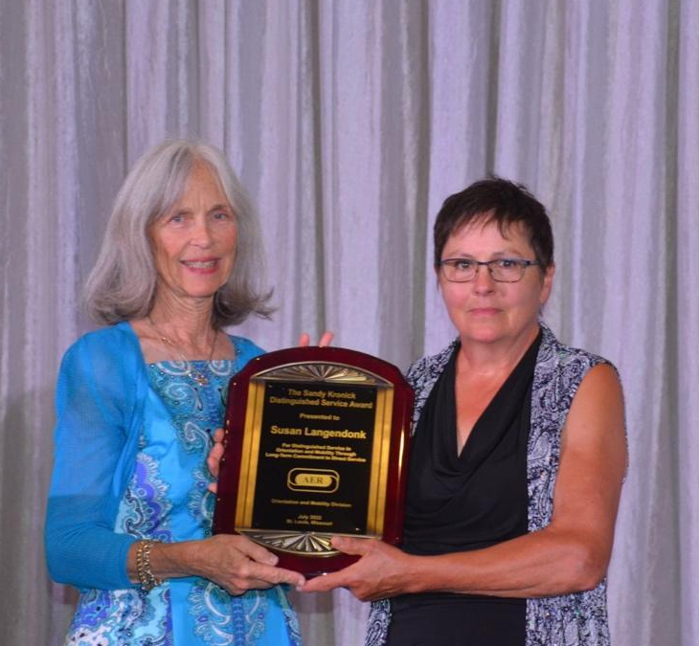
Photo above: Presentation of the Sandy Kronick Distinguished Service Award by Marjie Wood to Susan Langendonk.

The Lawrence E. Blaha Memorial Award:

Dr. Laura Bozeman was awarded the 2022 Lawrence E. Blaha Memorial Award.

The Lawrence E. Blaha Award was initiated in 1968 to honor people who have shown exemplary behavior in the field of O&M, made outstanding contributions to the profession, and shown dedication to serving people with visual impairments. It is the highest honor that the O&M Division can bestow.

This award was named in honor of Lawrence Blaha who was a pioneer in the field of O&M. He is remembered for his wit, athletic abilities, philosophy, technical skill and his high standards. He was an educator whose ideas are remembered and continued through this award. In 1948, he began his career working with people with visual impairments at the Central Blind Rehabilitation Center for Visually Impaired and Blinded Veterans, VA Hospital, Hines Illinois. He was one of a group of six individuals chosen for training to become the original O&M specialists at Hines. In 1961, he joined the faculty of Western Michigan University; from 1964 until his sudden death, he was Director of the O&M program at California State College, Los Angeles. The first Lawrence E. Blaha Award was given to him posthumously in 1968.

I should mention Sir Francis Campbell, whose cane handle was passed along to award recipients. He was an American expatriate who was knighted by King Edward VII. Campbell was born in Tennessee and accidentally blinded before he was six. He was educated at the Tennessee State Institute for the Blind and at the University of Tennessee. Campbell taught music at the Perkins School for the Blind. At Perkins, he was involved in early efforts to teach orientation and mobility.

Nora’s presentation (edited): “Having been in the field since 1974, Laura has many achievements that have made a significant impact on the field through her publications, teaching, and service. She has been at the forefront of the orientation and mobility (O&M) field, both at the national and international levels.

Laura has contributed significantly to our body of knowledge by authoring a book, twelve book chapters, fifteen journal articles/position papers/abstracts, and one non-refereed article. Many authors have cited Laura’s publications, which attest to the high quality of her work. Additionally, her presentations in the areas of personnel preparation, low vision, CVI, aging and vision loss, training students who are visually impaired to become orientation and mobility specialists, and self-defense, are some excellent examples of dissemination of her research and professional interests.

Since 2007, Laura has recruited many people to the O&M field by seeking and obtaining $12,440,000 in personnel preparation grants. This external funding has enabled a steady stream of individuals to be recruited into the field and graduate in the U.S. and abroad. In most cases, these graduates sought employment teaching people who were blind and visually impaired, thus helping to meet an international and a national shortage. Her preparation of professionals in the field of education and rehabilitation of individuals with visual impairments demonstrate her excellent teaching and leadership skills.
Laura’s service record is exemplary by her involvement on university committees, board memberships, and professional organization leadership roles and committee involvement. For example, she has served on many university’s search committees, faculty council, annual faculty review committees, and been the chair of the University of Massachusetts Boston’s School Personnel Committee, School for Global Inclusion and Social Development. Most importantly, from 2006 to present day, Laura has served as the University of Massachusetts Boston’s Graduate Program Director: Vision Studies. Laura also held leadership positions in professional organizations such as AERBVI and the International Mobility Conference (e.g., Chair: O&M: Rehabilitation and Practice: International Mobility Conference (IMC17); secretary of Executive Board of Directors of AERBVI; Chair of AERBVI’s Personnel Preparation Division. Laura has been actively involved in shaping this field since the 1980’s and has consistently served on a committee or on several at once since 1986.

Through her numerous consultative roles and leadership responsibilities in academe and our professional organizations, Laura has provided mentorship to many different constituents (e.g., university students, people who are visually impaired, colleagues, other countries).

Collaboration is an important part of what Laura does to promote and support both individuals and the field. Over the years, it is obvious from all her presentations and publications that she welcomes collaboration with other professionals. She has worked with professionals and doctoral students, both in and out of the field of vision rehabilitation and education. Laura appreciates different perspectives and by including people who are not in the field, she is not only learning from them but is exposing them to challenges and issues that are specific to people who are blind which they can carry on to their respective fields.

Dr. Amy Parker from Portland State University wrote: “As a leader, Dr. Bozeman is known for her generosity. She not only has helped grow O&M services in the United States, but she has also established international programs as well. This helped our field in understanding itself beyond the bounds of culture. As I once heard her express at a national meeting, the approaches and practices for safe and effective travel are universal, though they may be enacted in uniquely culturally relevant ways. Through her visioning of regional models of service delivery, she has helped build sustainability at the university level. Indeed, through her influence, Dr. Bozeman helped the faculty at Portland State University conceptualize a regional approach to serving states in the Pacific Northwest.

Through Dr. Bozeman’s long-standing efforts in program development, personnel preparation, and grantmaking, she has had a profound impact on bringing new professionals into the field. As a mentor, she has continued to help professionals develop by taking on new roles as instructors, writers, organizational contributors, and program creators. Most recently, Dr. Bozeman has been co-leading an effort to update a national plan for preparing and training personnel. In doing so, she has also been mentoring a group of faculty from diverse universities, including Dr. Cheryl Kamei-Hannan, Dr. Holly Lawson, Dr. Rachel Schles and me, to engage in systemic planning. Dr. Bozeman does this because she is dedicated to preserving, nurturing, growing, and sustaining the field of O&M.”
Dr. Rona Pogrund from Texas Tech University wrote: “One of the greatest strengths in Dr. Bozeman’s scholarship is her strong collaboration and engagement with others. Her inclusion of Micronesia in a federal grant project was extremely innovative and met a personnel shortage need for Guam, American Samoa, the Commonwealth of Northern Marina Islands, and the Federated States of Micronesia, places that do not have their own personnel preparation programs in visual impairment. She even presented this training model to the Project Officers in the Office of Special Education Programs in Washington, D.C.

The impact of her scholarship goes far, as her publications are used internationally along with her inclusion of many collaborative partners across the country and throughout the world. Dr. Bozeman has also done collaborative research with educators in Taiwan including an evaluation study of the pros and cons of collaboration between cultures in higher education.

In summary, Laura is an excellent ambassador for our profession. She listens, shares, and always has the best interest of individuals who are blind or visually impaired and the members of this field in mind. Thus, she is very deserving of the Blaha Award.”

Laura’s Acceptance Speech (Edited): “What an amazing honor to be standing here to receive an award named for Larry Blaha, a pioneer and one of the first O&M specialists in our incredible profession. Larry was determined and kind. Most of all, he was passionate about what this profession could be and dedicated to making it endure.
I am so blessed to have found this profession and, in turn, met each of you. I look at the previous recipients of this award and find it surreal to be recognized in the company of my mentors.
Thank you to the Awards Committee for their consideration. Thank you to my long-time friends Nora Griffin-Shirley and Anita Page for thinking I deserved this honor! Thank you to those of you who took the time to support my nomination: Marjie Wood, Amy Parker, John McAllister, Eileen Siffermann, Stacy Kelly, Chris Tabb, Rona Pogrund, Bill Wiener, Derrick Smith, Bob McCulley, and Jill Brown.
I was astounded as I read the letters because they made it seem as if I had done these things alone. Not one thing that has been mentioned was accomplished by me.
My faith, my family, my friends, and my colleagues every place I have worked throughout my 49 years in this profession made these accomplishments possible.
So many people have helped me throughout the years. I want to mention just a few:

- Marjie Wood: for reminding me that God is in control.
- Bob McCulley: for teaching me that sometimes it is better to ask for forgiveness rather than permission. We accomplished a lot with this approach.
- Brad Walker: for really teaching me to teach.
- Nora Griffin-Shirley: for teaching me that she was always there to listen and that I should take my time and do one thing at a time.
- Bill Weiner: for his quiet, calm support.
- To my husband, Ken: For his encouragement when I worked too much or was unsure about next steps.
- To each of you for the goal we share: To support the quality of life for children and adults with low vision and blindness.”

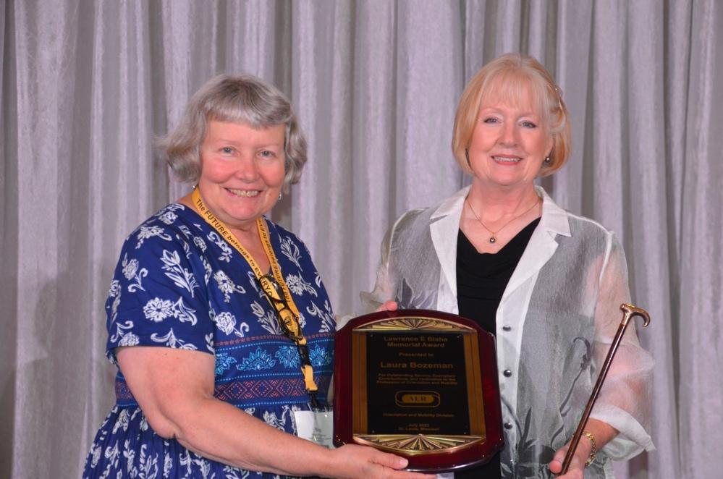
Photo: Dr. Nora Griffin-Shirley (Left) presenting the Blaha award plaque and Sir Francis Campbell Cane to Dr. Laura Bozeman (Right)

Presentation of Janet Barlow Environmental Access Service Award

Introduction remarks made by Nick Leone. “Our last award of the night is the Inaugural Janet Barlow Environmental Access Service Award, which is being awarded to Janet Barlow posthumously.

The Janet Barlow Environmental Access Service Award was established in 2021 to recognize professionals who demonstrate distinguished service in orientation and mobility through a long-term commitment to environmental access. The award was named for Janet Barlow because of her lifelong commitment and dedication to the field, her steadfast, practical, and strategic methods to address research needs, advocacy for greater accessibility to the built environment, and education of orientation and mobility specialists and transportation professionals such as traffic engineers and urban planners on issues relevant to both professional areas.
I would like to share with you an excerpt from a letter Billie Louise (Beezy) Bentzen wrote after her passing:

“Janet was a tenacious and deeply knowledgeable advocate for people who were blind and visually impaired. She was a mentor, a role model, and a leader, and we will miss her dearly. She cared deeply about so much and so many of us, consumers and professionals alike in transportation and in the blindness field.

We all leave holes in the lives of others when we pass, Janet leaves a crater in two professions, and in the lives of professionals throughout the United States and in fact the entire world. At the same time her monuments are making streets and sidewalks accessible across the United States and Canada. Janet’s competence, knowledge and work ethic were legendary. Her joy and passion for her chosen work and for her family and friends were a fire that warmed so many of us. Her contributions will live on, and we will miss, remember, and celebrate her as we travel through the environment that she helped to shape.”

Lukas Franck will talk more about the legacy of Janet Barlow and to present the award, which will be accepted by the Barlow Family.”

Lukas’s presentation: “Janet Barlow was a person with a royal heritage in the O&M field. She was educated in Orientation and Mobility at Florida State University by two of the historic figures in our Orientation and Mobility pantheon, Purvis Ponder and Everett “Butch” Hill. In fact, she participated in the effort that resulted in the publication of the first O&M techniques textbook, “Orientation and Mobility Techniques, A Guide for the Practitioner” that was originally published in 1976. Not only that, she updated and rewrote that seminal text with Diane Fazzi and came out with a new and much Improved “Guide for the Practitioner” in 2017, 41 years later.
Perhaps it was this heritage, but more likely it was her native drive, intelligence, critical thinking, passion, compassion and unbelievable work ethic that led her to make the difference she eventually did. In the mid nineteen nineties she noticed that infrastructure changes were making street crossings more challenging, sometimes impossible, for people who were blind or had low vision. This led her to make her initial contacts in the Traffic Engineering field in Atlanta.
Discovering the field of traffic engineering was, for her, somewhat similar to the experience of a shepherd discovering a crack in a hillside, exploring further and entering a cave, and then being astonished to discover an enormous cavern with a strange other civilization! Fortunately, Janet had a guide, and that guide was Beezy Bentzen, who had been exploring that strange civilization for many years before and was then chair of an early incarnation of the Environmental Access Committee.

Together they began to explore and infiltrate this unknown culture, and in so doing changed the landscape, or at least the streetscape of the United States forever. Their comprehensive survey of detectable warning surfaces conducted with the support of the US Access Board moved towards standardization of installation of DW surfaces across the US. Again, just as with the textbook, she bookended that effort with research in cooperation with the traffic engineering field on Tactile Directional Indicators, that you can see on the street just outside this hotel.

Her passion for solutions and access for blind and visually impaired people led to participation in research, as a partner in the innovative firm Accessible Design for the Blind, with traffic engineers, that continues to impact the independence of people who are blind or had low vision. Her advocacy and research led to the development of regulations that created a standard for a United States system of accessible information at street crossings. Further as a part of NCHRP 3-62 she led multiple workshops for engineers around the United States that has resulted in the proliferation, (still incomplete and imperfect) of APS around the country. She acted as an expert witness in a lawsuit that has resulted in a judgement in a NYC case that will force the city to install thousands of APS in New York City in the next decade. Sadly, this judgement came down just after her death.

Her attention soon shifted to another challenge the threatening impact of Roundabouts to intersection access around the country. Again, she contributed to research that led to recommended solutions to the problems posed to blind and low vision travelers at these intersections.

How did she do all this? Hard work, on the street, and in the endless hours sitting, quietly knitting, in the, often hostile, meeting rooms full of traffic engineers, until the moment came to ask the incisive question, make the statement that made the room pause, reconsider and ultimately… include!

And yet she made friends not enemies in those rooms, she was always respected, and often much more than that, by our sometimes-reluctant partners in traffic engineering. The grief that was so overwhelming for many in our community was matched by theirs.

The tributes on her death were very moving, here is one from Chris Rome, an Engineer in Atlanta: “Janet had a huge impact on my career very early on - when I was fresh out of school, I took an accessibility training she led and it completely changed my thought process on engineering design, as well as policy, planning, and funding. The training was really the first step in me having a multimodal focus for my career, after being schooled primarily in the ‘how to make cars go fast’ traffic engineering curriculum. I hope to share a fraction of her knowledge with others as the profession unfortunately moves on without her.”

The loss that we all felt at her sudden early and unexpected death was and still is palpable. Her impact on both of our professions was transformative. Her encyclopedic knowledge and boundless generosity with her time and energy, was a gift to us all, as was her warmth and humor. Her passing is a landmark event for all of us, it is a moment of torch passing in this great relay we are all involved in, a race to maintain the right of access to the built environment for people with visual impairments in this time of accelerating technological change. With her passing and the sense of loss comes the concern that the struggle for access for which she was such a warm, tough leader will now fail without her. It won’t.

Janet won the Lawrence E. Blaha award, the highest award in our field in 2008. Her work at that time was not even half done. Since her death numerous efforts have been initiated to honor her with eponymous workshops, seminars and joint initiatives between the traffic engineering community and our profession. On Wednesday we had the first Janet Barlow Seminar attended by over 40 professionals interested and concerned about changes in the travel environment. That workshop was ably taught by Janet’s successors at Accessible Design for the Blind!

Here tonight, in the presence of her family, Janet will be the first recipient of the Janet Morgan Barlow award. The fact that this award exists is a testament to the fact that Janet changed the game. It is a recognition that effective advocacy for access to the built environment is now a critical and central part of the work of the Orientation and Mobility Division of AER. It is a promise to the future that we will not quit our work for access because there will be future winners of this award who will work hard to provide improved access to independence for our clients, students and friends. To quote the current chair of the Environmental Access Committee, Meg Robertson: “Because of Janet’s efforts we have become advocates and partners with those who build the environment, to ensure that it is built the right way the first time.”

It is with much love, respect and admiration that we, -all of us - present this award to her as the first winner of the Janet Morgan Barlow award. In her absence I present it to her daughters Jen Watkins, Bekah Webb, and Tisha Barlow who are here with us today as well as to her husband Doug and twin sister Carole, who are not.”

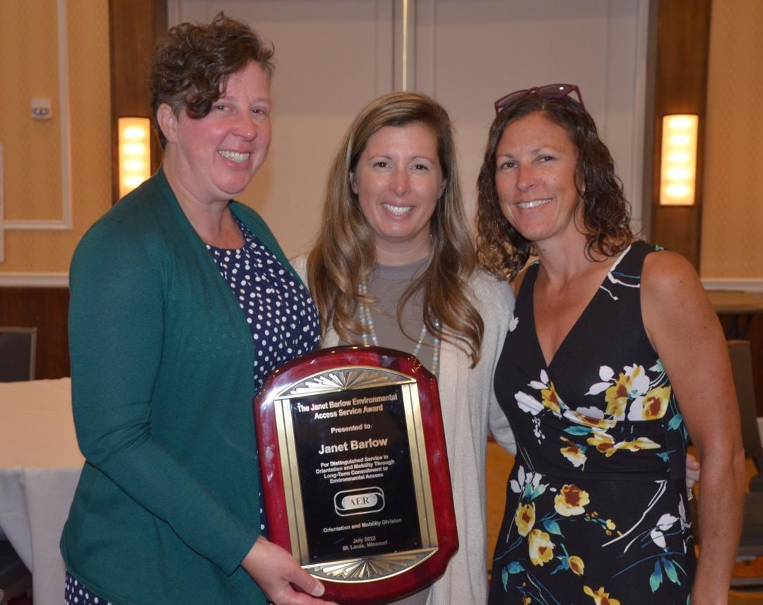

Above Photo of Janet’s daughters, Bekah, Jen, and Tisha, holding the Janet Barlow Award

To view photos from the O&M Awards Ceremony held in St. Louis, click on the below link (It may take a bit to load).
https://1drv.ms/v/s!AnMZ8WCeRL_s51s1iq45dOH1na6p?e=ciKxVY

__________________________________________________
2022 Donald Blasch Scholarship Committee Report
The O&M Division presents two scholarships in the amount of $1000.00, annually when funds are available to 2 outstanding students who are enrolled in AER approved university programs. Thank you to our panel of dedicated judges who read and scored our many submissions.
Margaret Winn, Blasch Scholarship Committee Chair
_______________________________________________________________
Visit the O&M website for a list of O&M Committees: https://aerbvi.org/oandmdivision
________________________________________________________________

Orientation and Mobility Updates

__________________________________________________________

White Cane Day Activities
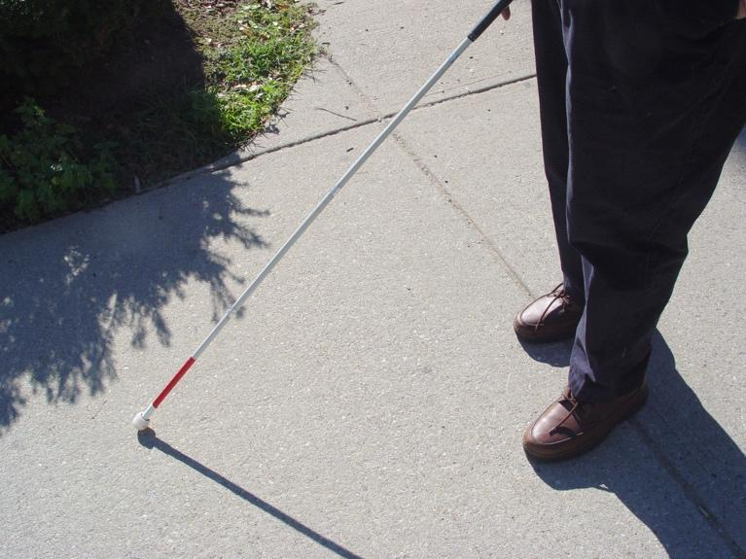

This newsletter is a good resource to submit your White Cane Activities and events. What are your plans for 2022? White Cane Day falls on Sat. October 15, 2022. Start planning now! Send ideas and plans for your region’s celebration to O&M Newsletter Editor.

Birmingham, Alabama will celebrate their 10th White Cane Day on October 15 from 1-5 at the Alys Stephens Center. Check out www.wcdal.org for more information.

Rhode Island’s White Cane Day will be celebrated on Oct. 15, at the Garden City Center in Cranston Rhode Island, 1-4 pm.

Massachusetts’ White Cane Day virtual event will take place on Friday October 14, 10am-11:30am. Contact O&M Director Ally Bull at Allyson.Bull@mass.gov for more information.

Wisconsin is selling t-shirts to fund their White Cane Day Activities. The theme “You’re Gonna Hear Me Roar” is based on Katy Perry’s Song “Roar”. For more information contact WisconsinWCD@gmail.com

Seattle, Washington will be having a White Cane Day Walk beginning at the Space Needle on Sat. October 15 at 10am. Contact Alice.klein@dsb.wa.gov for more information.

North Texas White Cane Safety Day will take place on Sat. Oct. 15 at 1pm in Fort Worth. For more information go to their Facebook page.
_______________________________________________________________

Moving On and Updates
New Staff Changes. (If you have an update on OM staff changes, or retirements please send them along to Newsletter Editor)

Congrats to Joanne Luro, who recently retired after being in the field for 46 years. She was the only TVI itinerant for 13 years in Chicago’s Catholic Archdiocese through Catholic Charities and later the Guild for the Blind and the citywide COMS itinerant for 33 years in Chicago Public Schools/CPS. She provided adult services through the Dept. of Rehab and was involved in the Parent Early Intervention program in CPS. She also was a volunteer for her local Lion’s Club during their special events.

Joanne graduated from NIU in 1976 and was certified both in Sped - as a TVI (3-22yrs) and an elementary teacher (K-9), becoming a COMS in 1989, in the first graduation class from NIU’s O&M program. Joanne is a member and served many times as an officer in IAOMS. She presented many times at the IAER/NCOMA conferences and was responsible for running the annual IAER O&M poster. White Cane Safety Day was her annual forte, involving all her students/schools. Joanne is a very strong advocate for all her students/clients and their families throughout her career and remains in contact with many of them today. She even took one of her former students skydiving in Sandwich, IL. Joanne will continue to be an active member of AER & IAOMS in her retirement and will provide private services.

Another retirement congrats to Grace Cummings, COMS who will be retiring this October after working 42 years at the Mass. Commission for the Blind. She began her career as a Social Worker, before moving on to the O&M Dept. after getting her O&M degree with the 1st O&M class at UMass Boston. She has been a valued member of NEAER, the O&M Department and the MCB Family.
____________________________________________________________________________________

This and That

Sept. 1 marks the start of National Preparedness Month. While preparedness is an ongoing effort, this month is an excellent time to encourage preparedness nationwide and evaluate your preparedness plans. Check out https://www.ready.gov/september for additional information to be better prepared for emergencies around your communities.

A Digital Bridge: Through a small grant, In Focus Mobility will establish a digital photo library of the built environment for parents of children with visual impairments, adults with visual impairments, and professionals in the field of blindness. Our mission is to inspire and accelerate access to the built environment-design with universal access in mind.

The goals of this digital library will enable consumers, professionals, and stakeholders to access materials related to access to the built environment. It will enable members to easily explain how components of the built environment impact people with visual impairments and total blindness. Materials could be used in presentations, to advocate at community meetings, and educate members of the public. All digitized materials would be accessible to individuals with visual impairments. Please contact JoAnne Chalom at jchalom@infocusmobility.com for more information on this project.

America Walks has announced the opening of applications for their Community Change Grant Program. This program supports the growing network of advocates, organizations, and agencies working to advance walkability. Grants are awarded to innovative, engaging, and inclusive programs and projects that create change and opportunity for walking and movement at the community level.
Applications for grants open in the fall and are awarded for the full calendar year following. The number of grants awarded varies each year, depending on available funds. Go to https://americawalks.org/programs/community-change-grants-2021/ for more information. Please pass this on to your local walking or pedestrian groups to spread the word.
More bike lanes in your communities? Check out these organizations Assoc. Pedestrian and Bicyclists Professionals/APBP, NACTO, the Vision Zero Network, Transportation for America, the League of American Bicyclists, and America Walks for webinars and information on the latest in research and federal legislation and policy that will impact bicyclist and pedestrian safety, equity, and accessibility. The League of American Bicyclists has produced Fast Facts fact sheets, which contain biking and walking data for each of the 50 states and 76 cities. Learn more at data.bikeleague.org.

Conferences/Workshops
Northern Rockies AER will be holding their fall conference October 19-21, 2022 in Great Falls, Montana. For more information go to https://aerbvi.org/event/2022-northern-rockies-aer-conference/

NE/AER Conference will be held in Westford, MA October 26-28, 2022.

Registration is open for Moving Together 2022, MassDOT's annual conference on pedestrian, cycling, and public transit topics, will be held in Boston on November 1, 2022. It will be held in-person and have a virtual option. For more information go to https://www.umasstransportationcenter.org/assnfe/ev.asp?ID=5055

SWOMA, The Southwest O&M Association Conference 2022 is scheduled for November 6-8, 2022 at Round Rock, TX at Austin Marriott. For more information go to http://swoma.org/conference.html

CAOMS Statewide Conference 2022 will take place at the Long Beach California on Saturday, December 3rd, 2022, for more information go to
https://www.facebook.com/groups/252989878064486

SOMA, The Southeastern O&M Assoc. 2022 Annual Conference, will be held on Dec. 10th-13th in Tampa Florida. https://www.somaconference.org.

There will be a special event taking place called the Janet Barlow Initiative. Registration will be limited for this event. Issues which will be addressed include: Have you-
  - Been perplexed by intersections impossible for your student to navigate safely?
  - Been consulted for your expertise to make local community projects accessible, and wished you knew more?
  - Wanted to learn from and establish a working relationship with a traffic engineer? -- click here to learn more and register.
Call for papers and registration is now open for the International O&M Online Symposium, being held on Jan. 25-27, 2023, https://orientationandmobilitysymposium.com

The International Mobility Conference IMC18 is accepting abstracts for the conference which will be held in Warsaw Poland May 22nd-26, 2023. Submission date is October 31, 2022. Check their website at www.imc18poland.com .

The Great Plains ADA Center is soliciting session proposals for the National ADA Symposium, in-person event scheduled for May 21 – 24, 2023 in Kansas City, Missouri, or the virtual event scheduled for June 12 – 14, 2023. The deadline to submit proposals is October 1, 2022, for the in-person event, and October 14, 2022, for the virtual event. http://www.adasymposium.org/call-presenters
_____________________________________________________________
Writers needed: The New RE:view–A Journal of Practice (TNR) is intended for professionals, people with visual impairments, their families, and anyone who works with them. Although The New RE:view is not specifically a research journal, articles considered for publication must demonstrate evidence that supports the author’s work.
If you have good ideas for learning but have never put them into writing, this is the time and the place! An Associate Editor working with reviewers from the field will provide feedback to ensure that your writing is effective. If your work is accepted for publication, the TNR editorial team will work with you in making your message clear.
Please consider sharing practices and topics to share with colleagues. Visit www.aerbvi.org to learn more and how you can become a contributor.
____________________________________________________________
The Janet Barlow Legacy Fund has been established by the Barlow Family to honor the legacy and work of Janet Barlow. This fund will carry on Janet’s work to further cooperation and mutual understanding between the orientation and mobility and the traffic engineering/urban planning professions. Donations are being accepted at usomsa.org.
___________________________________________________________
A newsletter needs news, so if you have something that you wish to share with the OM members, or feedback to improve this newsletter, please email Meg Robertson at Mobilitymeg@aol.com or at aeromdivision@gmail.com
Report any errors to the Newsletter Editor.
Next newsletter deadline: January 1, 2023 – submissions are welcomed at any time!

