Abstract
This toolkit identifies the multiple impacts of vision loss on every aspect of providing services to older adults
Aging and Vision Loss National Coalition (AVLNC) Service Provider Toolkit - 2026
AVLNC Access to Quality Services Committee rev 6-8-2026
Contents
Introduction 2
Understanding Vision Loss: Legal Blindness vs Low Vision 3
Types of Vision Loss 4
Effects of Vision Loss on Ability to Function 6
Blindness Etiquette 7
When Guiding an Individual Who Is Blind 8
Barriers Faced by People Who Are Blind or Have Low Vision 9
Breaking Barriers 11
Adaptive Recreation and Sports 11
Self-Advocacy 13
Employment 14
Data for Fundraising and Advocacy 14
Resources for Additional Information 15
National Resources Specific to Blindness and Low Vision 15
National Resources Generally Related to Older People 17
National Consumer Organizations 18

© 2026, Aging and Vision Loss National Coalition. This toolkit may be shared in its entirety but cannot be edited, updated, or amended without express permission from the Aging and Vision Loss Coalition. visionservealliance.org/access-to-quality-services

Introduction

This toolkit identifies the multiple impacts of vision loss on every aspect of providing vision rehabilitation services to older adults. Every plan for every older person will see improved outcomes when vision loss is identified and accommodations are included in treatment, whether it be in home health, residential services, hospital and hospital discharge planning, occupational or physical therapy, recreation, mental health services, retirement planning, insurance, legal/guardianship, and all manner of multi-faceted services.
Use this toolkit to facilitate best practices among all who work with older adults, which includes assessing their needs, abilities, and goals in order to develop an individualized service or treatment plan which leads to maximum quality of life.
The Center for Disease Control identifies vision disability as one of the top 10 disabilities among adults 18 years of age and older. Vision loss and blindness are a leading cause of disability in the United States (National Eye Institute, Vision for the Future 2021–2025 - currently being updated).
By 2050 we in the United States will have seen a 118% increase in the population of Older Individuals who are Blind – to 25 Million people.
***
© 2026, Aging and Vision Loss National Coalition. visionservealliance.org/access-to-quality-services

Understanding Vision Loss: Legal Blindness vs Low Vision


Legal Blindness vs Low Vision
“Legal Blindness” refers to a definition the government uses to determine eligibility for many different services. Legal blindness is based on either loss of visual acuity—how clearly a person can see—or on the loss of visual field—how far to the left and right a person can see when they are looking straight ahead. To be legally blind, a person has lost acuity to the point of needing to be 20 feet away from something to see something that a person with normal vision can see from 200 feet away. That is what the large E on the eye chart represents when the patient is sitting 20 feet away. Or a person might see very small print on that chart but still be legally blind if they have only 20 degrees of visual field or less. This is called tunnel vision and can be simulated by looking through a straw with one eye while closing the other eye.
Low Vision means that even with regular glasses, contact lenses, medication, or surgery, it is difficult for a person to perform everyday tasks, including walking, driving, reading, and recognizing people.

© 2026, Aging and Vision Loss National Coalition. visionservealliance.org/access-to-quality-services
The most important information you need to know when working with older people with vision loss is:
1. What types of vision loss are caused by different eye conditions;
2. How vision loss affects the ability of each older person to function.

Types of Vision Loss
The following list gives a brief description of common eye disorders that may lead to severe vision loss.

Cataract. Blurry, hazy, multiple images, glare sensitivity, diminished color perception, decreased night or low light vision. Most common in individuals over the age of 55.

Macular degeneration is the most common cause of vision loss in older people. Central vision and color perception become distorted or fuzzy, causing difficulty with reading and facial recognition. Treatments can slow the progression of the wet type of macular degeneration; there currently is no medical treatment for dry macular degeneration, but clinical trials are underway. The changes are permanent and slowly get progressively worse over time.

Glaucoma results in loss of side vision (peripheral vision), referred to commonly as tunnel vision. It also causes blurred central vision and seeing colored rings around lights. Glaucoma also impacts contrast sensitivity. To help, create strong contrasts such as black letters on white paper, dark placemats under white dishes, darker furniture on lighter carpets or vice versa, black light switches on light walls, etc.

Diabetic retinopathy produces patches of vision loss (blind spots), cloudy vision, glare sensitivity, and decreased night or low light vision.

Retinitis pigmentosa produces progressive loss of peripheral vision creating a tunnel in which a small portion of the central vision is usable.

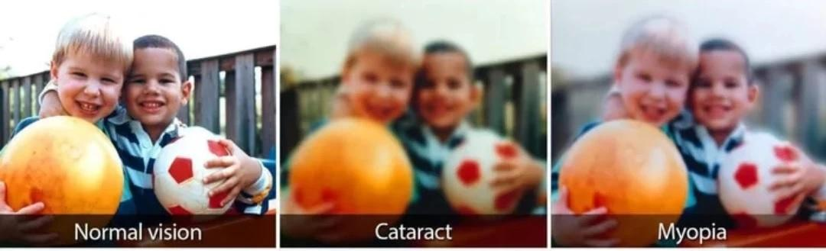
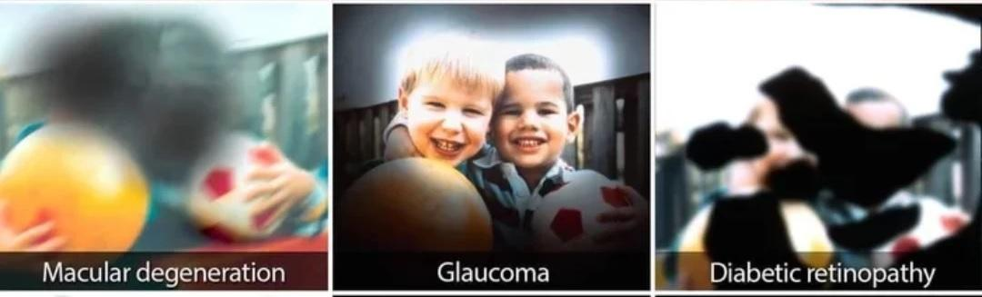
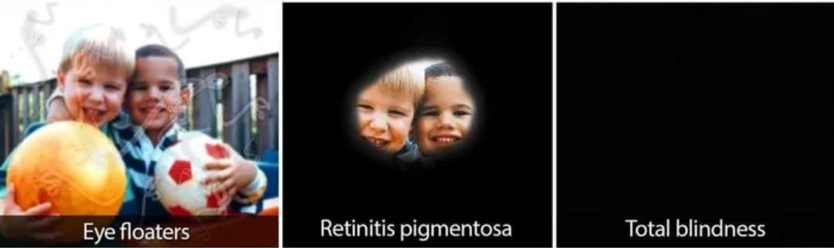

For additional information on common eye conditions visit: National Eye Institute – Eye Conditions and Diseases

© 2026, Aging and Vision Loss National Coalition. visionservealliance.org/access-to-quality-services

Effects of Vision Loss on Ability to Function

If you notice any of these behaviors, the first step is a good eye exam:
- Difficulty Reading and Writing. Deferring any writing task to a partner, friend or staff. Asking another person to read any printed text, such as menu selections or activity directions.
- Difficulty Recognizing People. Failing to recognize another person who they know or seeming to ignore a familiar person who is physically nearby.
- Bumping into furniture or another person or moving less confidently through the environment.
- Failing to locate visually while searching for common items such as food in a cafeteria line or items in a craft project. With severe tunnel vision, it can be hard to find keys, or other objects because only a small part of the object is within the field of view. It’s like having one piece of a puzzle and never seeing the “whole picture.”
- Withdrawing from participation in social or other activities they formerly enjoyed.
In 2020, a peer-reviewed research article published in the Journal of American Medical Directors Association showed that regular eye exams are vital, as untreated vision impairment can lead to increased social withdrawal and a higher risk of cognitive decline. Over 60% of residents in all age, sex, and race categories suffered from vision issues, with 14.1% experiencing outright blindness patients in Delaware nursing homes. Many of these vision issues were completely correctable by providing regular eyeglasses with updated prescriptions.
How many of the older people you meet are wearing the same eyeglasses they have used for many, many years?
Don't assume an older person is declining cognitively. It is more likely to be vision loss, and it may be correctable.

© 2026, Aging and Vision Loss National Coalition. visionservealliance.org/access-to-quality-services

Blindness Etiquette

- Always treat people who are blind or have low vision as individuals.

When interacting with someone who is blind or low vision:
  - Identify yourself, especially when approaching the person.
  - Speak directly to the individual.
  - Get the person’s attention by touching them on the shoulder or arm or use their name when addressing them. This lets them know you are speaking to them, and not someone else in the room.
  - Give specific directions like, "The chair is to your right," as opposed to saying, "The chair is over there."
  - Give an accurate picture when describing things to an individual with vision loss by including details--such as color, texture, shape--and landmarks that can be detected without vision such as ramps, changes in flooring (carpet to tile, etc.), announcement speakers regularly in use such as in the ceiling, air conditioner sounds, cash registers, receptionists/ringing telephones, smells such as from a store or restaurant or kitchen, etc.
  - If you see the individual is struggling, introduce yourself and ask, “How can I help you?”
  - Provide assistance if it is requested.
  - Respect the individual’s wishes if they decline assistance.

Printable Handout
Basic Etiquette:
Do's and Don'ts When Interacting with a Person who is Blind

© 2026, Aging and Vision Loss National Coalition. visionservealliance.org/access-to-quality-services

When Guiding an Individual Who Is Blind

A person who guides an individual who is blind or low vision is called a Sighted Guide or a Human Guide. The latter is preferable, but you will hear both terms used.
Allow the person you are guiding to hold your upper arm, near the elbow. You will be walking slightly ahead of the person you are guiding, making it easy for them to follow you as you turn, or stop. More hints:
- In tight spots such as narrow aisles or through doorways, move your guiding arm behind your back when approaching the narrow space so the person you are guiding can step behind you and follow single file.

- Stop at a curb or at the beginning of a flight of stairs. Inform the individual there is a curb or stairs, and whether you will be stepping up or down.
  - Worth repeating: Always inform the individual if the steps go up or down.
- Allow the individual to locate the handrail and the edge of the first step before proceeding.

- Use words such as "straight ahead," "we are going to turn left," "on your right," when describing information about the environment.

Resources
Video by Signal Centers Inc
Video on Human Guide Technique
7 1/2-minute video on Sighted Guide Technique. In this video a Certified Orientation & Mobility Specialist (COMS) teaches you how to walk comfortably with a companion who is blind or visually impaired.
Sighted Guide Handout from APH Connect Center:
Meeting, Guiding and Orienting a Person Who Is Blind or Low Vision
Short Handout from NY State Office of Children and Family Services:
Human Guide Handout from NY State

© 2026, Aging and Vision Loss National Coalition. visionservealliance.org/access-to-quality-services

Barriers Faced by People Who Are Blind or Have Low Vision

LIGHT—too much or too little. Controlling light is an important need.
For some, too much light from windows or overhead lights can reduce vision. Light sensitivity and glare can make it impossible to use residual vision. An individual may wear sunglasses to increase comfort in an area where there is too much bright light, both inside and outside. Some may choose to sit with their back to a light source. Others may wear a hat with a visor to reduce the effect of too much light.
On the other hand, most people with vision impairment need good task lighting. That means, a light that is about 10-inches off a work surface and positioned so it’s not shining in the eyes.
A task light enhances whatever is being done on the work surface, which could be a craft project, a large print flyer, a card game, or a dinner plate. The color of the bulb in the task light is also important. Some with vision impairment prefer a soft, yellow bulb; others prefer a bright, white bulb.

HEARING LOSS. Many older adults with vision loss may also have hearing loss, which is exacerbated by not being able to see expressions or read lips.
A large space may create an echo-like environment, making it hard for people to hear others. Some with vision and hearing loss depend on sitting face-to-face with another person so they can see lips and changes in facial affect. Try to match the space to an activity that keeps all comfortable.

ISOLATION. When a person with a disability cannot fully participate in an activity, they feel unwelcome and inadequate. They withdraw, and their increased isolation brings depression as well as a reduction in overall physical health.
Almost all activities can be made safe and accessible.
A policy of not allowing a family member or friend to freely accompany a person with vision impairment on outings can reduce a person’s comfort level in choosing to go on outings.
A practice of having committee or board meetings in the evening and not on a public transportation route might eliminate a person from signing up to serve.
Not offering print materials in large print or alternate forms such as phone recordings (“press 5 to hear how to join our upcoming activities”) significantly reduces participation by persons with vision loss.
Recommended: Place general accessibility statements on event flyers or in web-based materials which state reasonable accommodation or assistance is available upon request.

COMMUNICATION BARRIERS—print, phone, technology.
The weekly menu or monthly activity sheet should be available in 16-point font (or even better, 18 point). Same goes for large print calendars of events and flyers.
If a website is used to register for activities, it needs to be easy to use both with screen readers and magnification software. An option for high contrast black background/white text is recommended.
If a group phone meeting is offered, consider using a service that dials the numbers of the participants, instead of requiring the participants to dial the phone to attend.
This service charges $20/month per dedicated phone line: https://www.dialpad.com/ai-meetings/. Consider using a line for “anyone who wants to come” and another “for specific invited guests” only.

HEALTHCARE BARRIERS—doctor’s offices, hospitals, pharmacies
Ophthalmologists should refer patients with conditions that can lead to blindness to the patient's local agency serving the blind or the State agency for the blind. This step is a best practice adopted by the American Academy of Ophthalmology but is rarely implemented by ophthalmologists or their staff. The same expectation should be met by Optometrists.
Hospital personnel and medical professionals still fall short of knowing how to serve people with vision loss. Nurses and doctors need to address the patient who is blind or low vision by name, introduce themselves by name, and tell patients what they are going to do and why, before they touch the patient. A sign above the patient's bed should alert anyone entering the room that the patient is blind.
Assistants need to read the menu aloud to the patient and check the meal options selected by the patient.
Dog guides are legally entitled to be in any place a patient can go in the hospital (excluding sterile environments or specific protective isolation units), or the doctor's office.
Hospital Discharge Planners need to understand the self-care skills and resources the patient already has and not presume a nursing home is the only option. Nursing home administrators should not assume the patient is necessarily long-term.
For further details click here: Best Practices Guide for Hospitals | American Foundation for the Blind
Accessible Pharmacy is a resource that should be shared as part of a discharge plan or prescription written by a doctor. Accessible Pharmacy

Breaking Barriers

Adaptive Recreation and Sports
One path to happiness and good health is by “imperative movement.” Just like we need water, oxygen, and food, we also need to move our bodies on our own power, EVERY DAY!
Leisure: Think outside the box. Consider adding to your program:
- Game Nights: If Bingo is an activity that you do in your senior program you can make or purchase large print or Braille bingo playing cards.
- Many other popular games are also available in other formats from UNO to Cards Against Humanity for minimal cost.
- Movie Nights: If you hold movie nights for participants consider choosing movies that have audio description. These can be purchased or streamed through subscription services such as Netflix. Using this service gives full access to the action and allows individuals who have difficulty seeing the screen to be equal participants in the movie night. It also demonstrates that your organization is sensitive to community needs.

A list of audio-described media can be found at the Audio Description Project, an initiative of the American Council of the Blind.
Audio Description Project
Virtual Events:
✓ Accessible platforms for virtual events need to be considered when developing remote and hybrid options. To obtain more information on options reach out to a local blindness organization or contact the regional ADA Disability and Technical Assistance Center. Both will be able to provide you with tips and information on which platforms work better than others, as well as accessibility information to assist your participants.
Call 1-800-949-4232 (V/TTY) to reach your regional center.
✓ Find your State Blindness organization: Older Individuals who are Blind: Technical Assistance Center (OIB-TAC, Mississippi State Univ NRTC) Time to Be Bold
Recreation and Sports:
✓ Tours, shopping trips, crafts, and sports can be made accessible by training staff and volunteers in blindness etiquette and human guide so they can assist participants in the activity.
Examples are a participant who may need hand under hand assistance in completing an art task, or a participant who may need a sighted guide to assist in navigating the local venue being toured.
Other options may include self-threading needles, table mounted magnifiers, high contrast materials, sorting crafts components in separate cups by color or order of use.
Sports, recreation and physical activity for people who are blind and have low vision of all ages and abilities can increase quality of life and life satisfaction as it allows for social interaction and provides health benefits that help buffer the adverse effects of stressful, busy lives. From blind babies, to children, adults, and seniors, some of the many benefits include improved cardiovascular function, gross and fine motor skills development, better ability to sleep, improved self-esteem, increased stamina, and decreased stress levels. Each of these benefits may not only improve quality of life but can also have a positive effect on the individual’s other daily activities.
Resources for Adaptive Recreation and Sports
American Council of the Blind ACB Community Events | American Council of the Blind. Open to everyone; membership in ACB not required.
Blind Sports and Recreation Resources Blind Sports and Recreation Sources
Institute on Aging Friendship Line—a 24/7 Lifeline for Older Adults and Caregivers Feeling Isolated, Overwhelmed, or Alone Institute on Aging Friendship Line
415-750-4111 or toll free at 800-971-0016
Move United https://moveunitedsport.org/sports/adaptive-sports/ Plug in a location and this link will populate with adaptive programs nearby. While this list is not specifically for individuals with vision loss, many of these organizations are inclusive of all abilities and have experience with blind athletes.
OIB-TAC: Lesson 17- Recreation- A Must in Everyone's Life 2025.04.09_0.pdf
Sports and Exercise Tips Sports and exercise tips for people who are blind or visually impaired
Virtual Senior Center—allows older and homebound adults to connect and engage with others in virtual and hybrid classes. Virtual Senior Center
Vision Loss and Sport Fact Sheet on Suitable Sports for Blind-Low Vision People

Self-Advocacy
When working with older adults you may have to help them understand how they can become better self-advocates.
Many may have a basic understanding of the term “self-advocacy” but still may need guidance to better define it. At the heart, self-advocacy is the ability to communicate individual needs and wants. Self-advocacy fosters independence and empowers individuals to find solutions to problems that others might not be aware of.
Self-Advocacy includes:
- Awareness of personal preferences, interests, strengths, and limitations.
- Self-confidence.
- Creativity (such as creating other accommodations that help support the needs of the individual)
- Problem-solving skills.
- Ability to differentiate between wants and needs.
- Ability to make choices based on preferences, interests, wants, and needs.
- Ability to consider multiple options and to anticipate consequences for decisions.
- Ability to initiate and act when needed.
- Ability to evaluate decisions based on the outcomes of previous decisions and to revise future decisions accordingly.
- Ability to set and work toward goals.
- Finding a balance and striving for independence while recognizing interdependence with others.
- Ability to self-regulate behavior.
- Self-evaluation skills.
- Independent performance and adjustment skills.
- Ability to use communication skills such as negotiation, compromise, and persuasion to reach goals.
- Polite persistence.
- Ability to assume responsibility for actions and decisions.
Individuals with vision loss may often learn self-advocacy skills in incremental steps. They may start by just understanding one of their challenges. Or they may be able to say that something is wrong but do not know what would help. This is self-advocacy, too.
Discussion Guide:
- What is the decision you need to make?
- What decisions could you make?
- Evaluate each choice. What are the pluses and minuses of each choice?
- Describe which choice is best for you?
- Did you make the best choice for you?

Employment
There is a false assumption that older people with vision impairment cannot work or are not interested in working. In fact, earning an income may be critical for an individual older person’s well-being. Every State has Vocational Rehabilitation Services for people with disabilities. Explore this topic with the older person and make appropriate referrals. Don’t forget to consider National Industries for the Blind which have attractive options for meaningful careers for individuals with a wide range of employment histories and experience. www.NIB.org

Data for Fundraising and Advocacy

VisionServe Alliance, the Aging and Vision Loss National Coalition (AVLNC) and The Ohio State University College of Optometry collaborated to create user-friendly, highly accurate data set on the rate of blindness and low vision among people over 65 at the national, state, and county levels.
The Big Data Report Project
• The Big Data Project reports are the only studies that, in one document, provide comprehensive descriptions of older people with vision impairments at the national, state, and county levels. Data sets included in the project are the Behavioral Risk Factor Surveillance System (BRFSS) and the American Community Survey (ACS).
• In addition to the National Big Data Report, 30+ page state reports have already been published for many states, with added state reports coming soon. See the links below for the National and published state reports.
• Policymakers and advocates can use Big Data Project briefings to develop programs designed to improve the lives of older people with vision loss.
• The data provides a powerful tool for agency and organizational leadership, and their development and marketing teams, to quantify state and local needs and strengthen funding outreach by employing powerful statistics and current needs-based data.
• Link to National and State Big Data Project Reports: View the Published Big Data Reports
• Link to view the Big Data Project Webinar: Big Data Project Webinar

Resources for Additional Information

National Resources Specific to Blindness and Low Vision

Mississippi State University National Research and Training Center on Blindness and Vision Loss
T.I.P.S. for helping people with vision problems. A free virtual course that offers practical strategies to enhance the everyday lives of individuals who have trouble seeing. Through real-life scenarios, you will gain valuable insights into fostering a supportive atmosphere where every person feels included, comfortable, and in control of their daily lives. The course will address best practices for creating a safe and accessible environment that promotes independence and dignity for individuals with vision difficulties. TIPS for helping people with vision problems
Time to Be Bold. Find your State Blindness organization providing services to people who are blind or low vision, and many other resources. Time to Be Bold

OIB-TAC and National Research and Training Center on Blindness and Low Vision (NRTC)
Older Individuals who are Blind/Technical Assistance Center – OIB-TAC
Listings on Multiple Topics related to eyes, vision loss, careers, assessments, etc.
OIB-TAC Library Listings by Categories
National Eye Institute Speakers Guide in English and Spanish. Speakers guide in English and Spanish
Courses that will benefit you and your staff, and provide continuing education credits, are available here from the National Research and training Center on Blindness and Low Vision. All types of free courses from Anatomy and Physiology of the Eye to Teaching Art.
Lessons that share tips for how to safely and efficiently complete daily life activities. Tips can be downloaded in print or audio and in English or Spanish.
Lessons for Living - Older Individuals Who Are Blind Technical Assistance Center Lessons for Living
American Printing House for the Blind (APH) Connect Center APH Blindness and Low Vision Support Resources
ConnectCenter brings together trusted services, programs, and practical resources for people who are blind, have low vision, or are living with other vision-related conditions.
Support is available through state and local agencies that serve individuals across the full vision spectrum. We encourage you to explore the links below to find help with education, employment, independent living, and family life.
VisionAware APH Connect Center--VisionAware
Free, easy-to-use information source for adults with vision loss, their families, caregivers, healthcare providers, and social service professionals.
VisionSupport America www.visionsupport.org

Association for Education and Rehabilitation of the Blind and Visually Impaired (AER)
AER e-Learning
AER has put relevant courses at your fingertips - enabling you to keep abreast of new trends in the field - all while qualifying for continuing education hours!
Hadley https://hadleyhelps.org
800-323-4238
Three ways to learn: workshops (quick, practical advice from experts), audio podcasts (recorded audio talk shows), and discussion groups (listen live and chat with others who share your interests).
Connect to Support | Hadley Peer-to-Peer support groups, help with daily living, help with emotional impact of vision loss, etc. Over the phone or via mail.
International Low Vision Support Group—an Outreach Program of Macular Degeneration Support International Low Vision Support Group--for Macular Degeneration

Lighthouse Guild E-Learning for Professionals in Medicine-Education-Rehabilitation
eLearning educational programs for professionals and others to provide the very best care and services for people with vision loss.
Lighthouse Guild Tele-Support for Adults Lighthouse Guild Tele-support For Adults
Living Well with Low Vision Living Well With Low Vision--Prevent Blindness
Includes “A Self-Help Guide to Non-visual Skills”, 21 categories of daily activities, along with the alternative nonvisual senses that can be enlisted to accomplish each activity.
National Deaf-Blind Equipment Distribution Program (NDBEDP), National Deaf-Blind Equipment Program, NDBEDP, also known as iCanConnect, provides equipment needed to make telecommunications, advanced communications, and the Internet accessible to low-income individuals who are deafblind.
National Industries for the Blind National Industries for the Blind, employment opportunities for people who are blind or low vision.
National Library Service for the Blind and Print Disabled—Library of Congress, National Library Service National Library Service is a free braille and talking book library service for people with temporary or permanent disability.
Foundation Fighting Blindness, Foundation Fighting Blindness, has videos and webpages on various conditions and diseases causing blindness, and on living with vision loss.
Prevent Blindness Adult Vision Screening Certification Course Adult Vision Screening Certification Course
This course provides participants with a three-year, nationally recognized certificate based on current national guidelines and best practices for evidence-based vision screening tools and procedures. Currently offered only in Ohio and Wisconsin.

National Resources Generally Related to Older People

ElderCare Locator Elder Care Locator
The ElderCare Locator is a national resource program connecting you to services for older adults and their families.
1-800-677-1116.
Regional 211 Programs Information Lines - Connecting You to Your Community
211 is an easy to remember telephone number assigned by the Federal Communications Commission to streamline access to health and human services. These services are available on a 24-hour basis to connect residents to a wide variety of human services or social services in their area.

Accessible Pharmacy - Medication management for people with Disabilities. Accessible Pharmacy

National Consumer Organizations

American Council of the Blind (ACB) American Council of the Blind
800-424-8666
A consumer group for people with vision loss. You’re not alone in your journey through vision loss and blindness. ACB welcomes and accepts you. Guided by its members, ACB advocates for equality of people who are blind and visually impaired, inspires community, and connects you with education, resources, and each other to support your independence.
ACB Radio - events are available by phone.
ACB Radio – Variety Programming for your listening pleasure
Are you looking for late-breaking information from a blindness perspective? Are you wanting to hear creative blind broadcasters present music from dozens of music genres? Do you love old-time radio shows? If so, tune in to ACB Radio.
National Federation of the Blind (NFB) National Federation of the Blind
A consumer group for people with vision loss. The National Federation of the Blind knows that blindness is not the characteristic that defines you or your future. Every day we raise the expectations of blind people, because low expectations create obstacles between blind people and our dreams. You can live the life you want; blindness is not what holds you back. NFB had a free white cane program.
NFB Newsline NFB Newsline
NFB-NEWSLINE is a free audio news service for anyone who is blind, low-vision, deafblind, or otherwise print-disabled that offers access to more than 500 publications, emergency weather alerts, job listings, and more.

***
© 2026, Aging and Vision Loss National Coalition. This toolkit may be shared in its entirety but cannot be edited, updated, or amended without express permission from the Aging and Vision Loss Coalition. visionservealliance.org/access-to-quality-services

