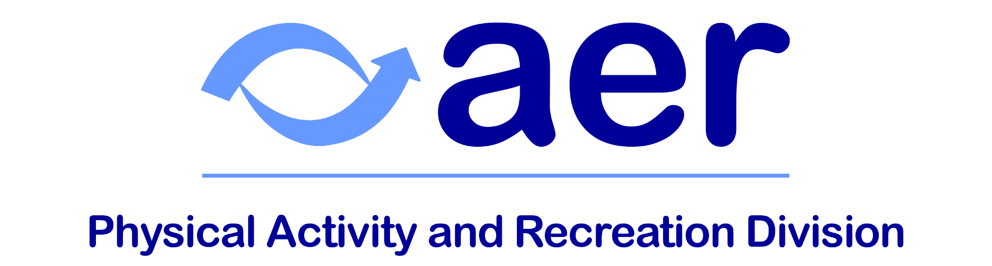

AER Division 19 Newsletter, Winter 2025
“The purpose of life is to live it, to taste experience to the utmost, to reach out eagerly and without fear for newer and richer experience.” – Eleanor Roosevelt

Hello, Division 19!
Welcome to the Winter edition of the Physical Activity and Recreation Division’s newsletter.

While there are fewer camps and conferences this winter, it’s a great time to begin planning for next spring and summer’s events, including AER’s biennial International Conference in Louisville, Kentucky, USA. Many camps are already seeking staff for the summer as well.

As always, we always welcome suggestions for improving the division. Please email us with your interest in becoming more involved, thoughts, comments, and questions at aerbviphysicalactivity@gmail.com.

Cheers,
Katie Ericson, Ph.D., TVI/COMS
Secretary

Division Business
As a reminder, board meeting minutes can be found on the division website.

Questions & Suggestions
As a member of D-19, you are welcome to reach out to the board with concerns, questions, and suggestions: Past Chair, Adam Pennell; Chair, Erin Weaver; Chair-Elect, M. Ally Keene; Treasurer, Lauren Lieberman; Secretary, Katie Ericson.

To help grow D-19 membership, please remember to promote AER and D-19 during your presentations and trainings.

Online Seminars
Division 19 would like to host your APE-related online seminar/webinar. Please send your presentation suggestion/submission to Erin.

Conferences and Meetings
State/Regional AER Meetings
Dates Vary
Many state and regional AER chapters are holding meetings in the coming months. This is a great opportunity to meet others in your area and share your knowledge. See AER’s website for dates and more information.

It’s never too early to start planning for conference travel:
- The SHAPE America Conference will be held in Kansas City from March 17-21, 2026. More information can be found on the conference website.

- The next AER Biennial Conference will be held in Louisville, KY, USA from July 29 to August 2, 2026 at the Marriott Louisville Downtown. More information can be found (as it becomes available) at the conference website.

- The next North American Federation of Adapted Physical Activity (NAFAPA) Conference will be held in Hawaii from July 28-31, 2026.

- The 2027 International Symposium of Adapted Physical Activity (ISAPA) will be held in Amman, Jordan from June 21-25, 2027. More details to follow.

- The next International Symposium on Physical Activity and Visual Impairment or Deafblindness will be in Rochester, NY at the end of June 2027.

Sports and Camps
Congratulations to both the U.S. Men’s and Women’s goalball teams for taking home the bronze in the IBSA Goalball Americas Championships!

All of the camps listed below offer opportunities for children and youth with visual impairments. Many are also actively recruiting staff and coaches.

- CABVI’s Winter Session of Camp Abilities will take place January 16-19, 2026. Registration information can be found on their website.
- Camp Abilities Delaware will hold their annual Winter Camp on Presidents’ Day Weekend, February 14-16, 2026 in Lewes, DE. (They will also hold their annual summer camp August 2-7, 2026.)
- Camp Abilities New Jersey at Rowan University will hold a Spring Family Camp, with dates TBD. Their summer camp will be June 26-28, 2026.

- Camp Abilities Pennsylvania will host their camp May 22-25, 2026.
- Camp Abilities California will host multiple camps between June 8 and June 26, 2026. See their website for more information.
- Camp Abilities Brockport will be hosting their annual summer camp June 28-July 4, 2026. Registration will open January 1, 2026.
- Bravo Nantahala Adventure Camp will be held in North Carolina from July 12-16, 2026.
- Camp Webber, located in Chugiak, AK, will host their annual camp July 13-18, 2026. Volunteers will need to arrive by July 11th.
- Camp Abilities Florida will host their camp July 16-19, 2026.

Other Opportunities

Focus on…
Camp Abilities Iceland
Now in its second year, Camp Abilities Iceland, sponsored by the Iceland Association for the Blind, hosted 14 athletes from across the country, as well as coaches from four universities. Athletes had the opportunity to participate in golf, archery, judo, rock climbing, swimming, showdown, gymnastics, and goalball. Camp Abilities Iceland will return next year!

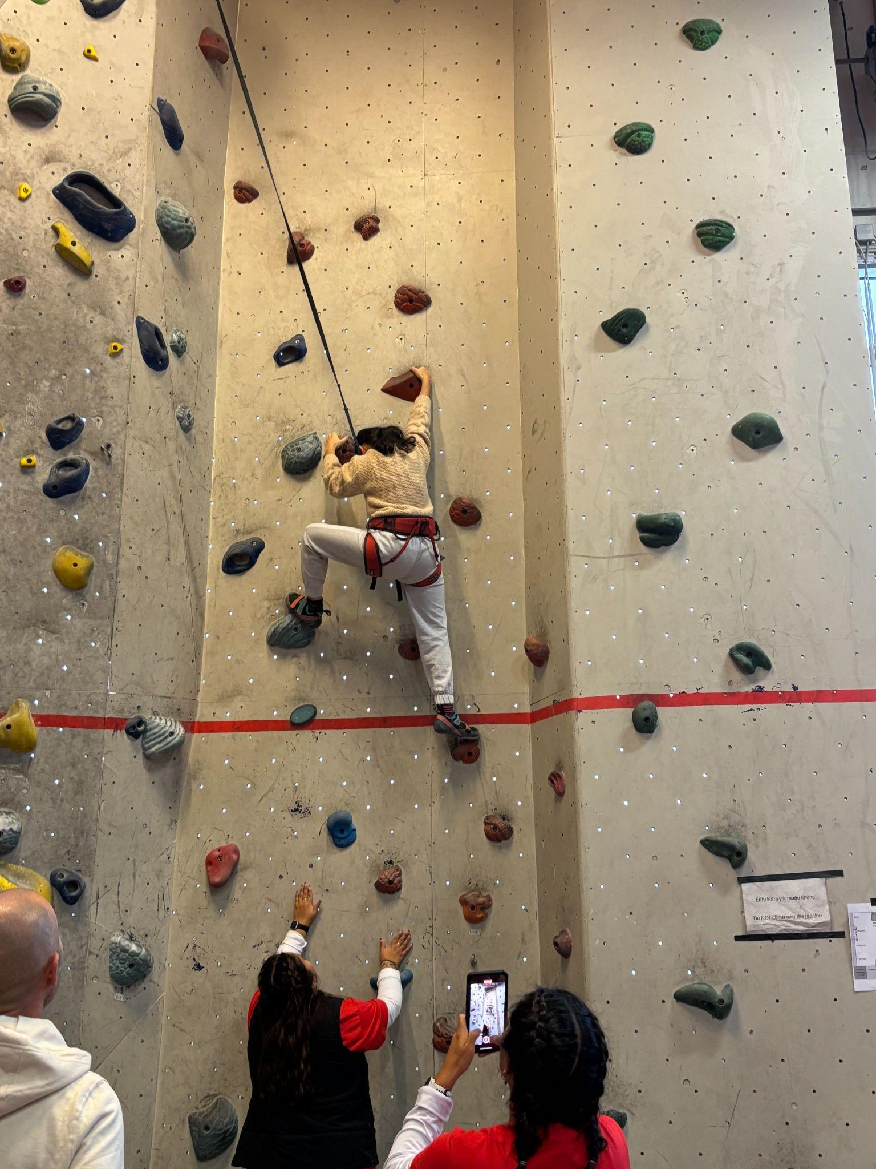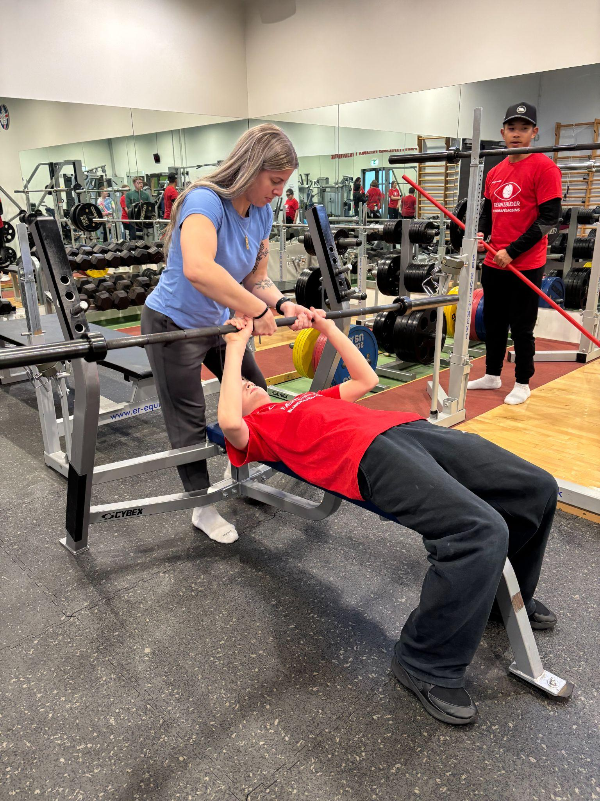

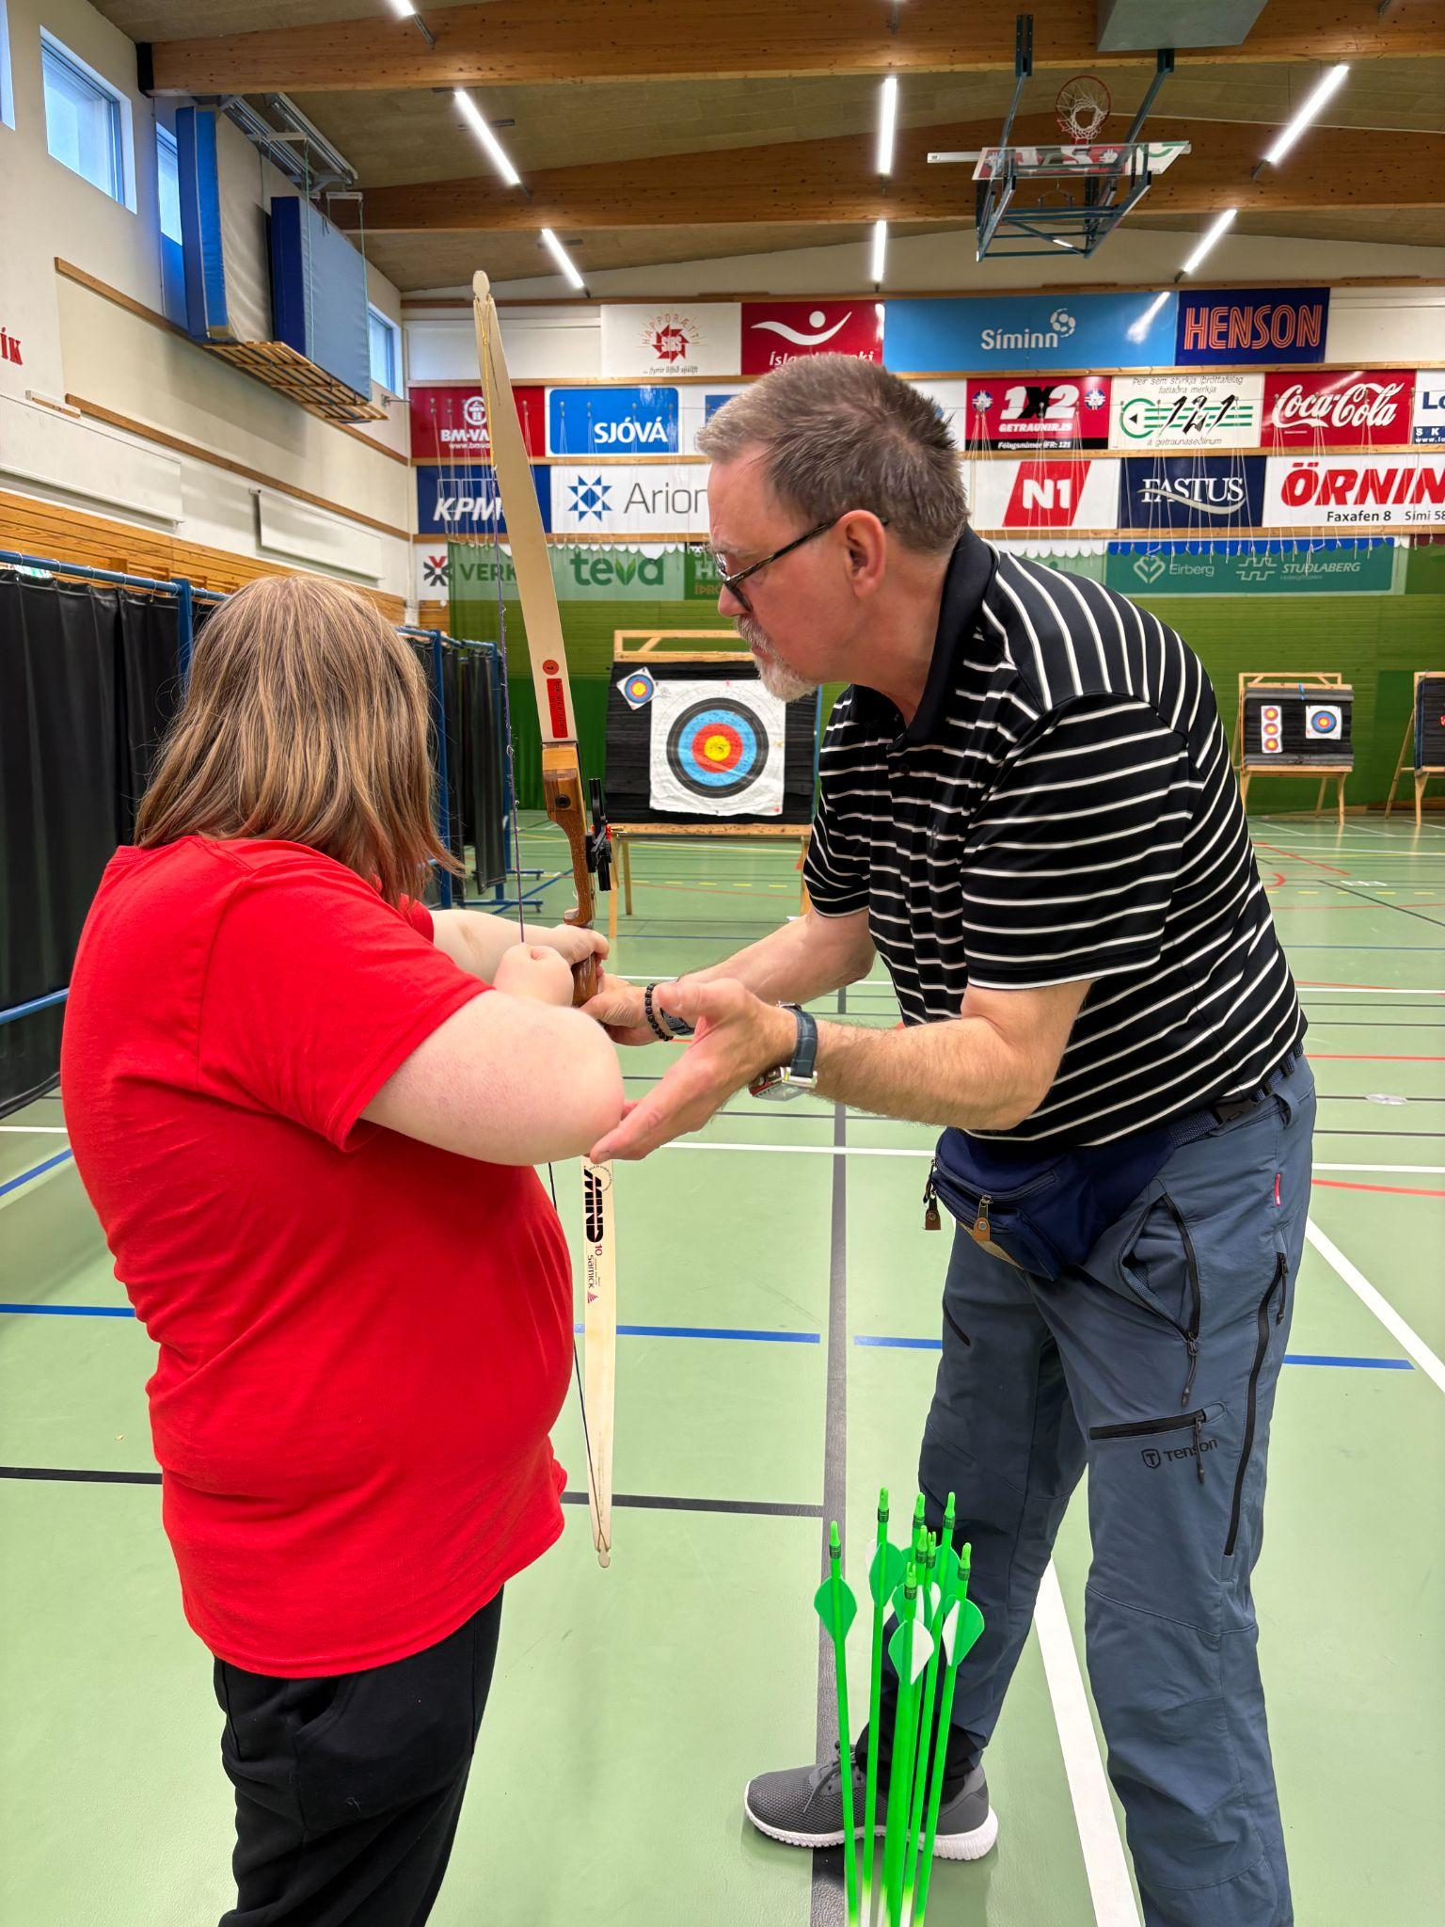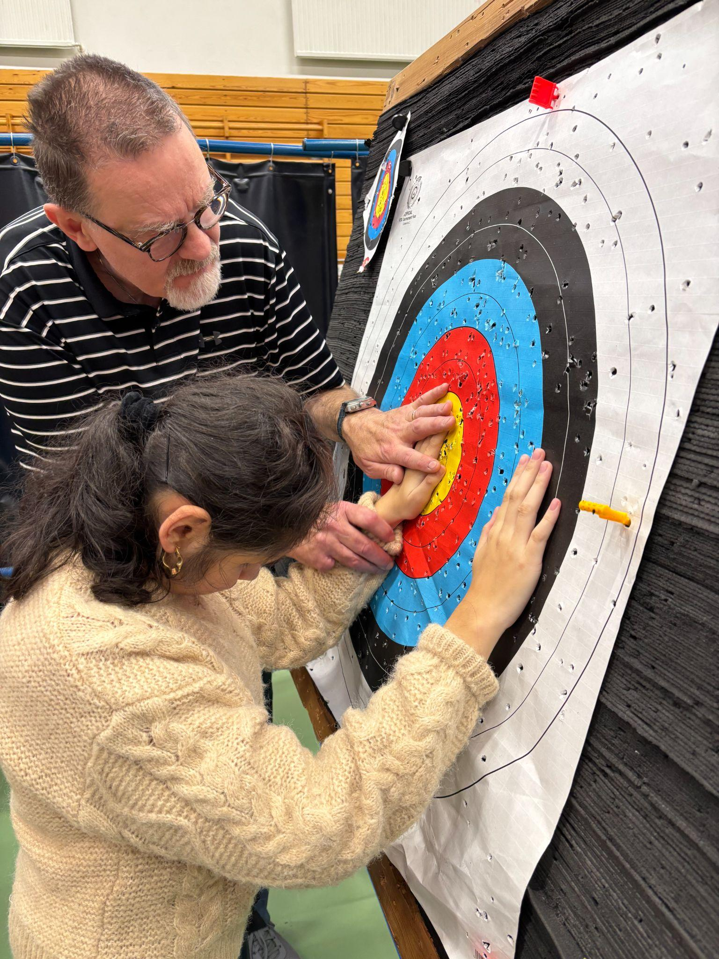

Educational Aids for Sports
Tactile Graphics for Sports
APH offers free templates for good tactile designs to help facilitate communication between those involved with the design and execution of tactile graphics. The Tactile Graphic Image Library’s categories are divided into core and expanded core curriculum areas. Download Options are Original (PDF), Thumbnail, and Preview (opens in browser to view, JPG). If you don't see what you are looking for, please send an email at tgfeedback@aph.org.

Teaching Blind Tennis
Thanks to a grant from the U.S. Blind Tennis Association (USBTA) and the Gibney Family Foundation, Dr. Ginny Orzel (SUNY Brockport), Dr. Emily Gilbert (SUNY Cortland), Dr. Jennifer Roth (Carlow University), and Dr. Lauren Lieberman (SUNY Brockport) created a video on how to teach blind tennis. You can watch the video here: https://youtu.be/LAq1vr9r63k.

Publications
Books
The 2nd edition of Physical Education & Sport for Individuals with Visual Impairment or Deafblindness: Foundations of Instruction was published this May through APH Press! It’s available in print and digitally on quota funds online.

Articles & Chapters

Acharya, Y., Garrels, V., & Kafle, B. D. (2025). Invisible on the field: Experiences of students with visual impairment in physical education in Nepal. European Physical Education Review, 0(0). https://doi.org/10.1177/1356336X251378404

Arroyo-Rojas, F., Martinez Rivera, S., Ball, L., Vazquez, W., & Lopez Morales, A. J. (2025). The experiences of Latina and Latino blind and visually impaired students in physical education: A retrospective study. European Physical Education Review, 0(0). https://doi.org/10.1177/1356336X251377271

Ball, L., & Lieberman, L.J. (2024). Blind and visually impaired sport (V. Girginov, & L. Misener, Eds.). Routledge Resources Online: Sports Studies https://doi.org/10.4324/9780367766924-RESS115-1

Castiglioni, G. C., Hirn, G., Lippolis, M., & Porro, M. (2025). Assessment of gross motor skills performance in Italian children with and without visual impairment. Children, 12(9), 1197. https://doi.org/10.3390/children12091197

Echague, E. T., & Gomez, M. G. A. (2025). Feel the movement: Adaptive circuit training for people with visual impairment. In Emerging Pedagogical Practices in Physical and Sport Education. IGI Global Scientific Publishing.

Fesemyer-Ayers, J., Haegele, J. A., & Wilson, W. J. (2025). Defining ‘inclusion’: scholars’ use and operationalization in major physical education journals. Sport, Education and Society, 1–14. https://doi.org/10.1080/13573322.2025.2572409

Flynn, L., Peltz, J., Perreault, M., Lieberman, L., & Beach, P. (2025). The relationship between sleep and physical activity for children with visual impairments: A scoping review. Journal of Visual Impairment and Blindness.

Forbes, A. S., Lowery, M. K., Block, M. E. Adapted physical education teachers' perceptions toward parents of children with disabilities. Adapted Physical Activity Quarterly. https://doi.org/10.1123/apaq.2024-0183.

Grenier, M., Klavina, A., & Dombrovska, L. (2025). Teacher practices that enhance students’ sense of belonging in marginalized populations. Curriculum Studies in Health and Physical Education, 1–15.

Guerriero, M. A., Moscatelli, F., Messina, G., Grosu, E. F., Maniu, E. Á., Enache, V. A., Grosu, V. T., Polito, R., Monda, M., Messina, A., Casella, C., Vasco, P., & Mancini, N. (2025). School-based proprioceptive and plyometric training improves balance in students with visual impairment: A 12-Week controlled study. Disabilities, 5(4), 101. https://doi.org/10.3390/disabilities5040101

Hazzan, A. A., Lieberman, L. J., Beach, P., & Ferrer, J. (2025). Caregiving for children and youth with CHARGE syndrome: Impact of family caregiver quality of life and coping strategies. Future, 3(3), 13. https://doi.org/10.3390/future3030013

Li, C., Haegele, J. A., & Smith, B. (2025). Quality participation of physical activity matters for quality of life and subjective wellbeing in people with disabilities. Psychology of Sport and Exercise, 0(0). https://doi.org/1016/j.psychsport.2025.102976

Lieberman, L.J., & Beach, P. (2025). Deafblindness and physical activity. T. S. Hartshorne, M. J. Janssen, & W. Wittich (Eds.). Learning, education, and support of deafblind children and adults: An interdisciplinary lifespan approach. Oxford Press.

Lieberman, L.J., Perreault, M., & Beach, P. (2025). Barriers to physical activity for children with CHARGE syndrome: A descriptive study. Palaestra.

Lytle, B., Ericson, K., Lieberman, L. J., Beach, P., & Parker, A. T. (2025). The impact of an orientation and mobility internship program at a summer sports camp for children who are visually impaired: A qualitative study. British Journal of Visual Impairment, 0(0). https://doi.org/10.1177/02646196251359019

Nowland, L. A., Haegele, J. A., & Zhu, X. (2025). Examining the differences in physical educators’ self-efficacy to teach students with disabilities across instructional placements. Journal of Teaching in Physical Education (online first). https://doi.org/10.1123/jtpe.2024-0473

Sim, J., Yun, S., Park, J., Jin, J., Yli-Piipari, S., & Kirk, T. N. Experiences of individuals with visual impairments in adapted and nonadapted group exercise programs. Adapted Physical Activity Quarterly. https://doi.org/ 10.1123/apaq.2025-0007

Zehr, K., Beach, P., Lieberman, L., & Perreault, M. (2025). The impact of physical activity on quality of life in youth with visual impairments. British Journal of Visual Impairment, 0(0). https://doi.org/10.1177/02646196241308742

Miscellanea
NWABA Resource Library
We’re excited to reintroduce our video resource library with a fresh new look as Blind Athletes Academy, brought to you by the Northwest Association for Blind Athletes (NWABA)! This YouTube channel offers a growing collection of over 70 instructional videos that break down individual skills, providing valuable resources for teachers looking to make physical education and sports instruction accessible for blind and low vision students. You’ll find videos covering a wide range of topics, including racket sports skills, locomotor skills, object control skills, and perspectives on blindness etiquette. Each video is paired with comprehensive manuals and tactile diagrams to support inclusive teaching. Be sure to check back often for new videos and innovative teaching tools! Explore the channel here: Blind Athletes Academy.

APH Resources
The American Printing House for the Blind (APH) offers a variety of resources for educators.

International CHARGE Syndrome Conference
Several of our members attended the International CHARGE Syndrome Conference in Phoenix, AZ, USA. Dr. Beth Foster presented on balance, while Dr. Pam Beach and Dr. Lauren Lieberman presented on motor skills training. The conference was also filled with physical activity sessions. The highlight was a Family Sports Festival, where families and children with CHARGE Syndrome learned how to access and play volleyball, basketball, soccer, corn hole, frisbee, and parachute activities. You can watch video of the festival here: https://www.youtube.com/watch?v=sojKn2T06nc.

New TV series highlights Paralympians
For those in the United States, Peacock is now streaming a documentary TV series called “Adaptive.” The series focuses on the experiences of four Paralympians and their journey to the Paris Paralympics. Check out the trailer here: https://www.peacocktv.com/watch-online/tv/adaptive-paris/6615826746536447112.

Accepting Spring 2026 AER D-19 Newsletter Submissions
Send your news, stories, events, bragging rights, recruitment efforts, and suggestions. The deadline is February 2, 2026.

