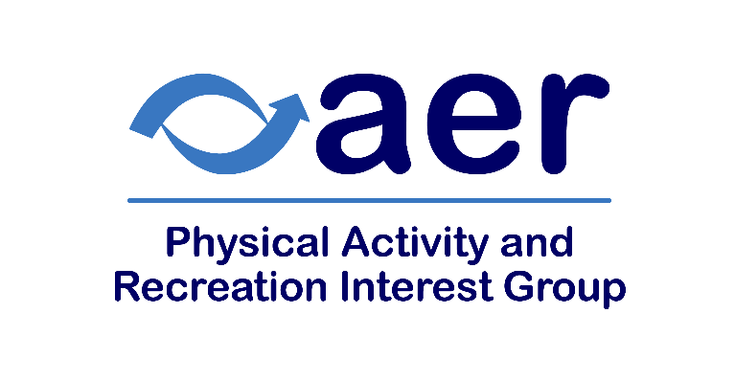

AER Physical Activity and Recreation Interest Group Summer/Fall 2026 Newsletter

“Every day I make the choice to show up and see what I’ve got, and to try and be better. My advice: keep showing up.” –Des Linden

Hello Physical Activity and Recreation Interest Group,
Welcome to the Summer edition of the Physical Activity and Recreation Interest Group’s newsletter. We’ve had a busy summer, with board members attending the AER Conference in Louisville and hosting summer camps for student athletes. While things will slow down this fall, we still have plenty to look forward to. There are fall camps for athletes, and we’ll be hosting a webinar (tentatively) on October 29th. Also, as we transition to an interest group, we’ll be electing new officers; ballots should be sent out soon.

As always, we always welcome suggestions for improving the interest group. Please email us with your interest in becoming more involved, thoughts, comments, and questions at aerbviphysicalactivity@gmail.com.

Cheers,
Katie Ericson, Ph.D., TVI/COMS
Secretary

Division Business
As a reminder, board meeting minutes can be found on the division website.

Membership
We are now officially an interest group! With official status, the next step will be conducting elections. Ballots should be going out soon.

Questions & Suggestions
As a member of the Physical Activity and Recreation Interest Group, you are welcome to reach out to the board with concerns, questions, and suggestions: Past Chair, Erin Weaver; Chair, M. Ally Keene; Chair-Elect, Peter Rifenburg; Treasurer, Lauren Lieberman; Secretary, Katie Ericson.

To help grow the Physical Activity and Recreation Interest Group membership, please remember to promote AER and the Physical Activity and Recreation Interest Group during your presentations and trainings.

Online Seminars
The Physical Activity and Recreation Interest Group would like to host your APE-related online seminar/webinar. Please send your presentation suggestion/submission to Ally.

Conferences and Meetings

State/Regional AER Meetings

Dates Vary
Many state and regional AER chapters are holding meetings in the coming months. This is a great opportunity to meet others in your area and share your knowledge. See AER’s website for dates and more information.

Upcoming Conference Dates:

- The 2027 International Symposium of Adapted Physical Activity (ISAPA) will be held in Amman, Jordan from June 21-25, 2027. The call for proposals is now open on the ISAPA 2027 website.

- The International Symposium on Physical Activity, Visual Impairments, and Deafblindness will be July 5-8, 2027 in Rochester, NY. The call for proposals will open in October, and more information can be found at the official website.

Sports and Camps

For more information on camps, please visit the Camp Abilities World website.

Educational Aids for Sports

Tactile Graphics for Sports
APH offers free templates for good tactile designs to help facilitate communication between those involved with the design and execution of tactile graphics. The Tactile Graphic Image Library’s categories are divided into core and expanded core curriculum areas. Download Options are Original (PDF), Thumbnail, and Preview (opens in browser to view, JPG). If you don't see what you are looking for, please send an email at tgfeedback@aph.org.

Publications

Books/Journals

Articles & Chapters

Acharya, Y., Garrels, V., & Kafle, B. D. (2026). Teacher agency in including students with visual impairment in physical education in Nepal. Physical Education and Sport Pedagogy, 1-19. https://doi.org/10.1080/17408989.2026.2708311
Acharya, Y., Garrels, V., & Vasques, D. G. (2026). Ableist imaginaries and silent exclusions: Parents’ perspectives of inclusive physical education for students with visual impairments in Nepal. Sport, Education and Society, 1-14. https://doi.org/10.1080/13573322.2026.2704081
Aldhahi M. I., Bin sheeha B. H., Alothman N. I., Basuodan R. M., Alabdulwahab, R. A. (2026). Advancing inclusion in sports for students with disability: A mixed-methods study on awareness and perspectives toward adaptive sports. PLOS ONE 21(5), e0349033. https://doi.org/10.1371/journal.pone.0349033
Bittner, M., Pitchford, E. A., Pennell, A., Welk, G., Larson, K. R., & Featherston, K. A. (2026). Physical Education Professionals’ Opinions, Practices, and Confidence to Administer the Brockport Physical Fitness Test. The Physical Educator, 83(4). https://doi.org/10.18666/TPE-2026-V83-I4-12979
Brian, A., Lieberman, L., Childs, R., & Beach, P. (2026). Exploring the psychometric properties of the Physical Activity Self-Advocacy Inventory for use among youth with visual impairments. British Journal of Visual Impairment, 0(0).

De Luna Vazquez, W., Columna, L., & Shapiro, D. (2026). “They can coach themselves essentially”: Goalball coaches’ perspectives on athlete-centered coaching with youth athletes with visual impairments. Frontiers in Sports and Active Living, 0(0). https://www.frontiersin.org/journals/sports-and-active-living/articles/10.3389/fspor.2026.1926809/abstract

Gandawidura, R. G. G., & Ikeda, Y. (2026). Relationship between the type of visual impairment and balance among adults in Jakarta, Indonesia: A cross-sectional study. Physiotherapy Quarterly, 34(2), 46-51. https://doi.org/10.5114/pq/209431

Gaspar, R. C., Bouten, B. R., Haegele, J. A., Furtado, O. L., & Silveira, S. R. (2026). Factors influencing exercise among adults with visual impairments in Brazil and the United States: A cross-cultural qualitative study using the capability, opportunity, motivation-behavior model. Adapted Physical Activity Quarterly, ahead of print. https://doi.org/10.1123/2026-0023

Godman, M., Blackwell, A. L., & Hicks, E. (2026). Physical activity coaching for caregivers of children with visual impairments: A case study. Palaestra, 40(3). https://doi.org/10.18666/PALAESTRA-2026-V40-I3-13859

Hiemstra, M., & Matthews, C. R. (2026). Surveying Guided Sports–Understanding Practices and Experiences of Blind, Partially Sighted and Deafblind Sportspeople, and Sighted Guides, European Journal of
Adapted Physical Activity, pre-print.
https://doi.org/10.51224/SportRxiv.991

Hollis, J., Narayan, R., Beukes, E. W., Lindsay, R., Bharwani, A., Mughal, U., Yaqoob, I., Haegele, J. A., Muirden, S., & Allen, P. M. (2026). The Relationship Between Physical Activity, Sleep, and Hallucinations in Adults with Charles Bonnet Syndrome. Vision, 10(3), 40. https://doi.org/10.3390/vision10030040

Jamaleddine, K., Gad El Sayed, M., Novak, D., Goodman, A., Helms, J., & Schlechter, J. (2026). Visual impairment and the incidence of concussions among youth football athletes. Orthopaedic Journal of Sports Medicine, 14(5). https://doi.org/10.1177/23259671261440185

Leivers, H. K., Allen, P. M, Timmis, M. A., Winckler, C., Ramos, B. L., Lima-Trigo, E. Sanghavi, E., & Runswick, O. R. (2026). Classifying footballers with a visual impairment: The relationship between visual function and technical performance. Journal of Science and Medicine in Sport, 0(0). https://doi.org/10.1016/j.jsams.2026.06.006

Marcos-Rivero, B., Ortuondo, J., Haegele, J. A., Reina, R., Ascondo, J., Becerril-Atxikallende, I., & Yanci, J. (2026). Impact of inclusive education training programmes on in-service and preservice physical education teachers: A systematic review. European Journal of Special Needs Education, 1–21. https://doi.org/10.1080/08856257.2026.2680128

Piekarz-Porter, E., Schermbeck, R. M., Leider, J., Perna, F. M., & Chriqui, J. F. (2026). State laws supporting adapted physical education access and quality for students with disabilities. The Journal of School Health, 96(10), e70228. https://doi.org/10.1111/josh.70228

Theobald, U., Nauschutz, T., Knapp, J., & Giese, M. (2026). Professionalization processes of coaching elite-level athletes with visual impairments: A qualitative study. Frontiers in Sports and Active Living, Sports Coaching: Performance and Development. Online first.
https://www.frontiersin.org/journals/sports-and-active-living/articles/10.3389/fspor.2026.1962810/abstract

Miscellanea

NWABA Resource Library
The Blind Athletes Academy, brought to you by the Northwest Association for Blind Athletes (NWABA) offers a growing collection of over 70 instructional videos that break down individual skills, providing valuable resources for teachers looking to make physical education and sports instruction accessible for blind and low vision students. You’ll find videos covering a wide range of topics, including racket sports skills, locomotor skills, object control skills, and perspectives on blindness etiquette. Each video is paired with comprehensive manuals and tactile diagrams to support inclusive teaching. Be sure to check back often for new videos and innovative teaching tools! Explore the channel here: Blind Athletes Academy.

Camp Abilities (Brockport) offers instructional materials, including instructional videos, manuals, and tipsheets. Explore the website here: Camp Abilities Instructional Materials.

Old Dominion University Resources and Recommendations for PE Teachers of Blind Students
The information on the website is the result of a collaborative effort between blind individuals with first-hand experience of K-12 physical education (Nina Marranca, Julia LaGrand, and Andrew Mead-Colegrove) and a researcher and former Physical Education teacher (M. Ally Keene). Together, they co-developed resources and recommendations aimed at helping physical education teachers enhance physical education for blind students.

Accepting Fall 2026 AER Interest Group Newsletter Submissions
Send your news, stories, events, bragging rights, recruitment efforts, and suggestions. The deadline is November 8, 2026.

